Equipment Type: Vegetable Slicer
Brief Description of Product:
We intend to make a variety of pickled vegetables, including cucumbers, carrots, and bell peppers. The vegetable slicer is needed for the processing step of slicing the vegetables into uniform shapes and sizes, ensuring even pickling and optimal texture.

Picture of Equipment:
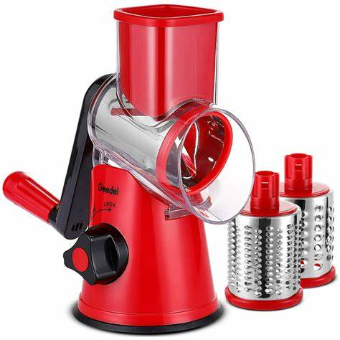

Generic Name of Equipment: Vegetable Slicer

Specifications:

Model: SliceMaster Pro 2000
Capacity: Up to 500 pounds of vegetables per hour
Cutting Thickness: Adjustable from 1mm to 10mm
Material: Stainless Steel
Power: 1 HP Electric Motor
Dimensions: 24" L x 12" W x 18" H
Weight: 50 lbs
Safety Features: Interlocking safety switch, non-slip rubber feet
Warranty: 1-year manufacturer warranty
Source and Price:

Source: Kitchen Supply Co.
Price: $1,499.99
Justification:
The SliceMaster Pro 2000 vegetable slicer is the ideal choice for our pickling operation due to its high capacity, adjustable cutting thickness, and durable stainless-steel construction. With the ability to process up to 500 pounds of vegetables per hour, it will significantly increase our efficiency and productivity. The adjustable cutting thickness allows us to customize the size of the vegetable slices according to our recipe requirements. Additionally, the safety features such as the interlocking safety switch ensure the well-being of our employees. At a price of $1,499.99, this slicer offers a good balance of performance and affordability for our business needs

