13 Profitable Food Business Ideas To Start Now (2023)
- by Evan Ferguson Find an Idea Nov 28, 2022
- 33 minute read
Few industries are more vital than food. Tastes may change from person to person, but one thing’s for certain: everyone needs to eat.
The astronomically high volume of food lovers means there are a lot of potential customers. And a wide variety of product offerings means that no matter how many food retailers enter the market, there’s always room for one more.
If you’ve decided to get into the food business as a first-time merchant, it’s a great choice—but you’re probably left wondering what comes next. With so many possibilities, the options are endless, but we’ve put together a few ideas to get you started.

Table of Contents

Food Business Ideas
- Food truck
- Ice cream shop
- Cooking classes
- Personal chef
- Coffee shop
- Meal kits
- Baked goods
- Sauces
- Pre-packaged snacks
- Baby food
- Homemade jams and jellies
- Organic foods
- Wine, beer, and spirits

Food business ideas: 13 products and services you can sell
Every food business has advantages and disadvantages, so there’s no single “best” idea for everyone. This could become your full-time job, so you’ll want to consider your own interests and what you’re able to commit to, and choose the food business idea that’s best for you.
If you’re looking to get in to the food industry, here are 13 ideas for products and services you can use to get started:

1. Food truck
Food trucks have become an especially popular way to get into the food business. Right now, growth in food trucks is outpacing that of traditional restaurants, and it’s not hard to see why.
A food truck business can give a chef the same opportunity that they’d get with a restaurant to develop their own unique menu, but with the added benefit of mobility.
Getting customers through the door can be one of the biggest challenges that comes with owning a restaurant, so why not bring the restaurant to your customers?
Benefits
- Mobility: with a food truck business, startup entrepreneurs can go where their customers are.
- Creative control: for aspiring chefs, a food truck provides an opportunity to create your own one-of-a-kind menu at a much lower cost than owning a restaurant.
Challenges
- Legal learning-curve: most cities and towns have unique zoning laws that outline where and when you’ll be able to sell your product legally, so you’ll need to familiarize yourself with the laws in any jurisdiction in which you’ll be selling.
Get inspired: Callie’s Hot Little Biscuit
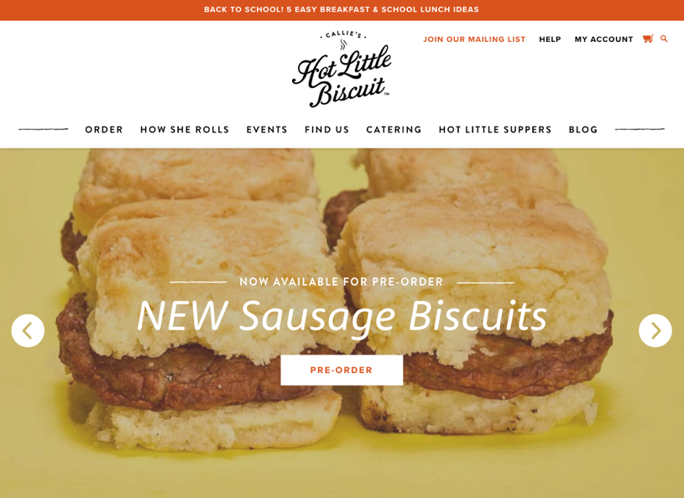
Callie’s Hot Little Biscuit is a grab-and-go eatery with locations in Charleston, Atlanta, Charlotte, and a food truck that travels all over the southern United States. Using its social media presence, it’s built a following of dedicated online fans.
One of the great things about a food truck is that it doesn’t have to be the only source of income. Aside from keeping its followers informed of its event schedule, Callie’s Hot Little Biscuit also offers catering services and sells custom gift baskets online.


2. Ice cream shop
Ice cream is one of the world’s most beloved deserts. In fact, the ice cream industry is expected to be worth $65.8 billion worldwide by 2026, meaning the industry is set to become increasingly profitable over the next couple of years.
Ice cream can be served alongside just about any other dessert and comes in a wide variety of styles, including frozen yogurt, sorbet, gelato, and frozen custard. With endless recipe ideas, ice cream is great for niching.
Benefits
- Creative control: ice cream lends itself to endless flavour combinations, making it great for especially inventive entrepreneurs.
Challenges
- Seasonal downtime: while it’s hugely popular in the summer, sales can slow down in the winter. Luckily, ice cream is versatile enough that there’s a wide array of seasonal varieties⁠—like pumpkin spice in the fall or candy cane during the winter holidays.
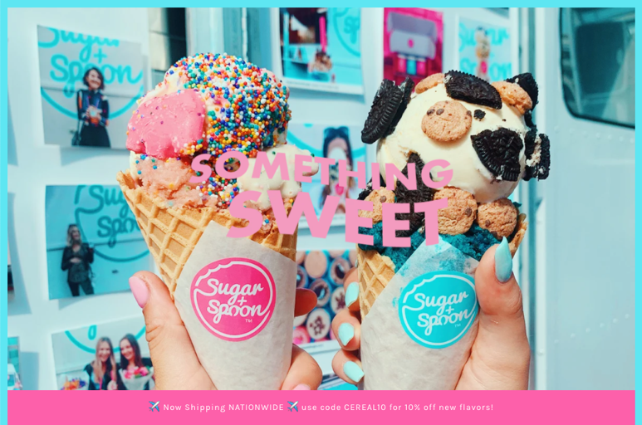
Get inspired: Sugar + Spoon
When recent University of Washington graduates Ivana Orlovic and William Hubbell developed an edible, egg-free version of cookie dough, they knew they were on to something. Sugar + Spoon creates rich, creamy treats by combining cookie dough and ice cream with a number of toppings and flavors.

Sugar + Spoon maintains a strong online following and sells out of its storefront in Seattle, as well as at pop-up shops, food truck events, and online. It even offers DIY ice cream packs, letting customers combine their favorite flavors into a single purchase.

3. Cooking classes
If you’re into a more hands-on personal approach to the food industry, then cooking classes could be just what you’re looking for. Teaching can be an extremely rewarding experience, and there’s no shortage of options when it comes to how you approach it.
You could offer online courses or in-person classes. You might pre-record your courses and allow students to watch at their convenience, or do live one-night-only events for an online audience.
No matter your skill level, teaching others is a great way to hone your cooking skills and build personal relationships with your audience.
Benefits
- Scalability: cooking classes tend to be especially scalable because of the personal connection students will have to your brand. Selling products or services in addition to your classes could be a great way to leverage those relationships.
Challenges
- Exposure: you’ll need to be front and center if you’re promoting yourself as a cooking teacher, so business owners who are less extroverted might prefer a business idea that provides more distance between their brand and their personal lives.
Get inspired: Nonna Live
Each week, 84-year-old Nonna Nerina welcomes her audience into her kitchen in a small village in Italy via online video conferencing. When viewers tune in to Nonna Live, they’re transported directly to an authentic Italian kitchen and taught recipes that have been passed down for generations.
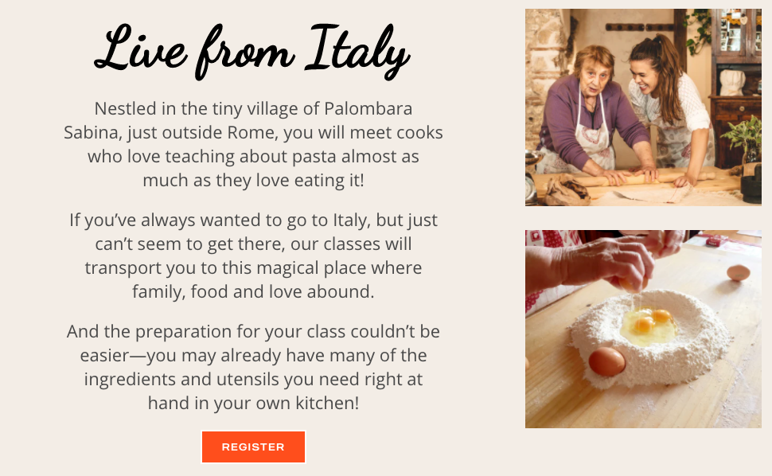
In Nonna Nerina’s online store, customers select a date and time and reserve their spot in a number of online classes. They’re provided a list of ingredients and supplies, and when the time comes, all of Nonna’s students gather for a live hands-on cooking lesson.

4. Personal chef
If you’ve ever been in sales, you know the skills needed to build a personal relationship with your clients. If you’re looking for something in the food industry that offers that chance, then becoming a personal chef might be right up your alley.
Personal chefs are trained cooks hired to provide at-home meals for their clients, who often may have special dietary needs or preferences. They can be employed by individuals, families, or caterers, or for special events.
Benefits
- Relationship building: being a personal chef is a great option for entrepreneurs with sales experience who understand the importance of maintaining client relationships.
Challenges
- High barrier of entry: Being a personal chef typically requires more skill and experience than other food businesses, since these things will be your primary selling points.
- Unpredictable hours: your hours may be less flexible than other types of food businesses, as you will need to work around customers’ schedules.

5. Coffee shop

Coffee is a vital part of our morning routines, so it should come as no surprise that the industry is expected to reach revenues of $155.64 billion by 2026. Coffee beans are widely available from dropshippers as well, meaning overhead costs can be kept low.
There’s also a small-business advantage for first-time merchants who decide to sell coffee.
Since it’s a widely available product, customers tend to value exclusivity when it comes to coffee, meaning they’re more receptive to new brands.
Benefits
- Small-brand advantage: the high volume of customers puts an emphasis on branding, giving the advantage to smaller brands.
- Low barrier of entry: with plenty of drop-shipping options available, startup costs can be kept low. And since your product is coming from a third-party, you can focus on branding your product rather than developing it.
Challenges
- Harder to market: coffee is widely available, which puts more importance on a brand’s ability to carve out a niche and set itself apart from competitors. If brand development isn’t your strongest attribute, selling coffee could be more of a challenge.
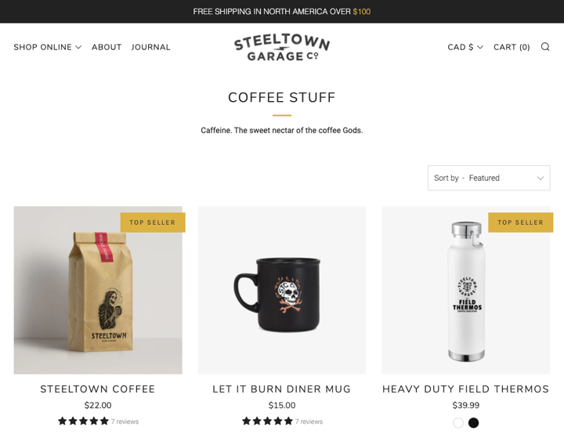
Get inspired: Steeltown Garage
Steeltown Garage is a Hamilton, Ontario–based retailer of premium apparel and specialty coffee. At the start, Steeltown Garage sold graphic tees built around its freewheeling lifestyle brand. As the brand grew, so too did its products.
Steeltown Garage now sells a wide range of premium motorcycle-riding gear, grooming products, vintage art, posters, and, of course, coffee. Branding is vital when selling coffee, and Steeltown Garage understands this.
Despite all of the products it sells, Steeltown Garage’s collections are harmonized around a brand that resonates with its audience.

6. Meal kits

Meal kits are a type of food delivery service offering pre-portioned ingredients and recipes for creating high-quality dishes at home. They’ve grown increasingly popular over the last couple of years, aiming to combine the convenience of fast food with the quality of at-home cooking.
Meal kits can be sold on a subscription-based model, wherein retailers provide customers with a new meal on a recurring basis. Or you might create a collection of meal kits and sell them à la carte.
Benefits
- Niching opportunities: meal kits are a relatively young business, so there’s plenty of room for new brands and a lot of niches for specific foods that remain untapped.
Challenges
- Shipping perishables: spoilage might be a bigger concern when it comes to meal kits, as fresh foods can only be stored for a limited time and it might be harder to keep items refrigerated in shipping.
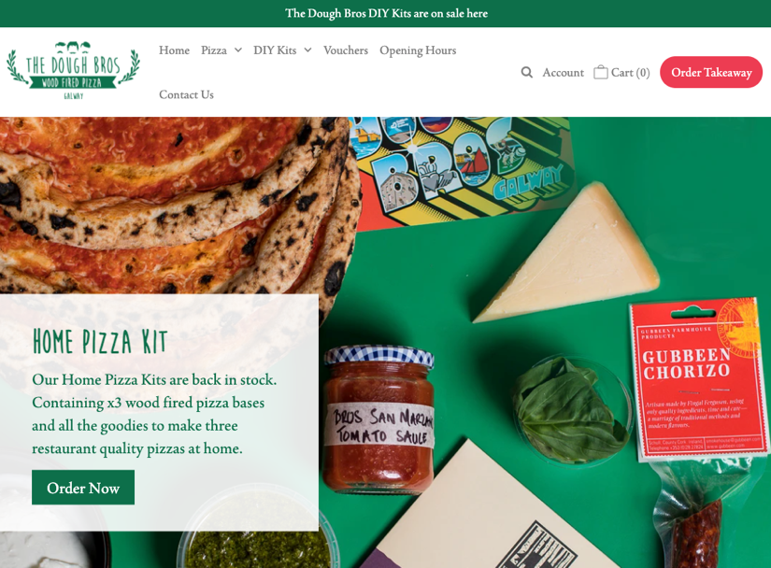
Get inspired: The Dough Bros
The Dough Bros is a wood-fired pizza restaurant operating out of Galway, Ireland. For customers that can’t make it to the restaurant, tThe Dough Bros offers ready-made pizza kits that come with all the toppings and sauces to make the brand’s signature slices at home.
When it comes to meal kits, large brands may have more name recognition, but what they don’t have is a specialty.
The Dough Bros’ branding works because it takes the beloved dish of pizza, enhances it with the meal-kit model, and immediately sets itself apart from larger brands.

7. Baked goods

Bakeries are one of the oldest types of food businesses. Baked goods have become a staple of holidays and special events, making them popular year round. Perhaps that’s why the baking industry generates more than $30 billion annually.
Selling baked goods can open a lot of other doors for your brand. You could sell baked goods for specific dietary restrictions, or specialize in something more specific, like bread, cookies, cakes, pastries, or pies⁠.
Benefits
- High-demand for specialty bakeries; finding baked goods that cater to specific dietary needs is still a challenge for a lot of customers, meaning there’s a high demand for them and plenty of room for newer brands.
Challenges
- Time-consuming: baking can take longer than other types of cooking and on a retail-scale, is often a job for more than one person. You may need to hire more staff than you would for other food businesses.
- Higher-costs when scaling: renting commercial baking space and running high-energy ovens can become costly very quickly, so it might take some time before you’re able to scale your business.
Get inspired: Katz Gluten Free
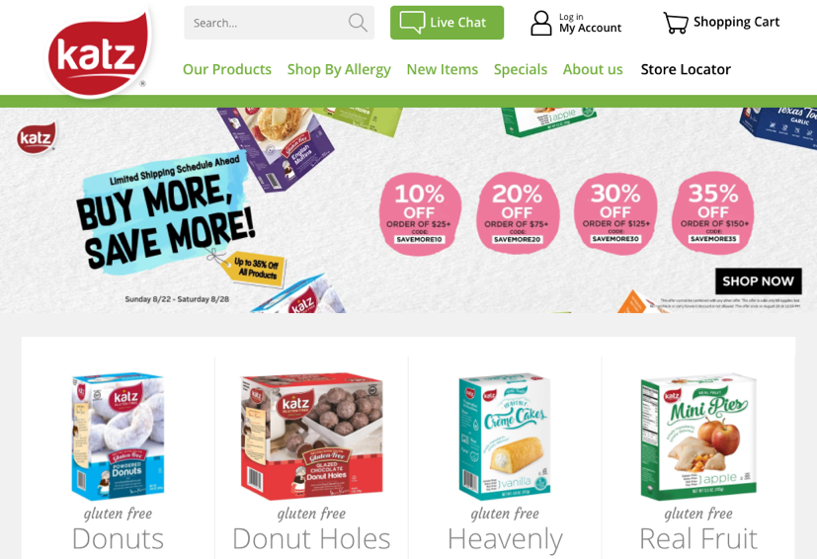
Katz Gluten Free specializes in baked goods for a wide range of allergies and dietary restrictions that might be harder to find in a grocery store. Katz’s variety is extensive⁠—selling items such as whole wheat bread, cream-filled cupcakes, and apple fritters.
Despite the selection of products, Katz is laser focused when it comes to its branding. Dietary restrictions can make shopping hard, but Katz stands out as a brand because it does everything in its power to make it easy. Katz’s website even has a special, “shop by allergy” tab that lets visitors quickly and easily filter out any products they might be allergic to.
Learn more: How to Write a Bakery Business Plan: Your Recipe for Success

8. Sauces
Sauces can be a great product to sell for first-time merchants. Food aficionados are always looking for new tastes to try, so they tend to be more receptive to less familiar brands when it comes to sauces.
On top of this, sauces have a tendency to grow cult followings⁠—think of the popularity of sriracha sauce or the communities built around extremely hot hot sauces. Sauce is versatile. That means if customers grow a taste for yours, they’ll want to try it on everything.
Sauces are a feature of nearly every cuisine. They’re relatively easy to adapt to any dietary restrictions. They can be savoury, sweet, spicy, or all three.
And sauces don’t just have to be a feature of dinnertime. Dessert sauces like custard, butterscotch, hot fudge, and fruit-flavored sauces are equally popular.
Benefits
- Customer loyalty: when food-lovers find a taste they like, they tend to stick with it. Repeat purchasers are more common when it comes to sauces, because the product’s versatility makes it adaptable to many dishes.
- Adventurous clientele: new customers are more receptive to unfamiliar brands when it comes to sauces, especially if they have unique branding.
Challenges
- Getting the right taste: the appeal of sauces is in their uniqueness, but people also tend to be drawn to familiarity when it comes to taste. Striking the right balance of flavors can sometimes be challenging.
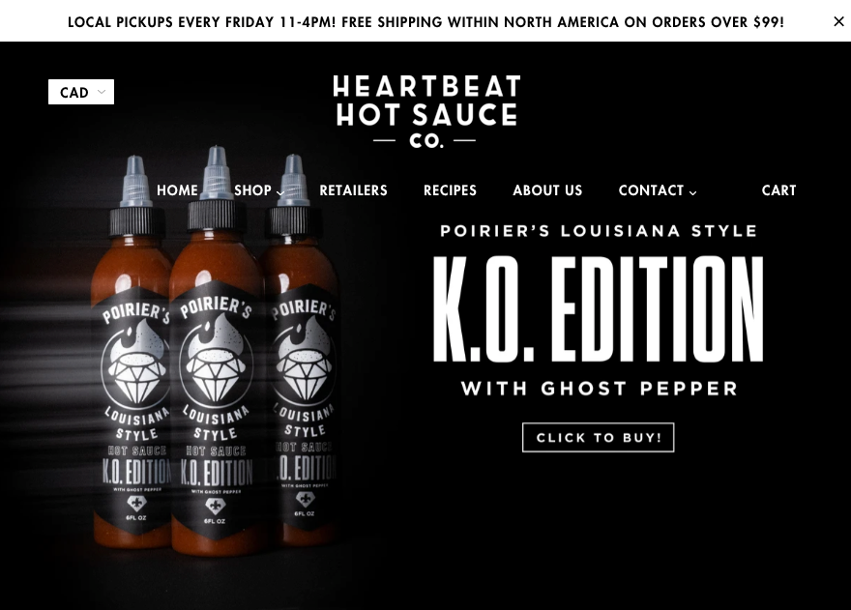
Get inspired: Heartbeat Hot Sauce
Based in Thunder Bay, Ontario, Heartbeat Hot Sauce develops, cooks, bottles, and distributes its own signature line of hot sauces. Heartbeat Hot Sauce offers staples like piri piri and Louisiana-style hot sauce, alongside more unique flavor combinations like pineapple and blueberry habanero.
The flavors in Heartbeat’s line of hot sauces hit all the right notes, blending familiarity with novelty. The brand also maintains a huge online community via Instagram, helping to build a stronger relationship with its audience.

8. Pre-packaged snacks
Chips, nuts, pretzels, popcorn, granola bars, or maybe a mixture of all of them⁠—pre-packaged snack products come limitless varieties.
Pre-packaged snacks are a staple of both adventurous outdoor excursions and monotonous late-night cravings⁠—and nearly all of us have a fondness for them.
The market for savory snacks in North America is expected to reach $59.25 billion by 2028, meaning there’s a lot of room for new merchants with a unique product.
Benefits
- Wide product variety: a large selection of food and flavor possibilities, combined with a uniquely labelled package, make it easier to differentiate your brand from the competition when it comes to pre-packaged snacks.
Challenges
- Competing with large brands: the snack-food industry does have a lot of established brands, so your biggest challenge will be differentiating your products from your competitors.
Get inspired: Snaffling Pig
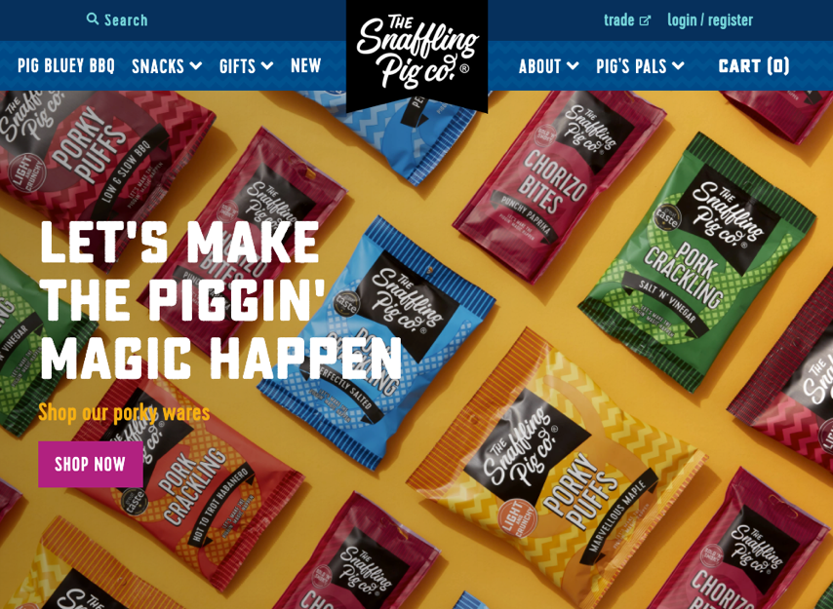
Based in the United Kingdom, The Snaffling Pig Co. sells all kinds of pre-packaged snacks, but its signature is its pork crackling⁠—a chip-esque snack made from dried pork meat and seasonings.
The Snaffling Pig also sells nuts, pork rinds, chorizo bites, and even beers and ciders, flavored to compliment its snacks.

What brings these elements together is the Snaffling Pig’s branding, which aims to recreate the flavors of casual pub food, drawing on its own nostalgic memories to create a sense of camaraderie with the brand.
So far, it appears to be a huge success. Snaffling Pig was named one of the UK’s fastest-growing food businesses in 2021, posting a compound annual growth rate of 35% over the past two years.


10. Baby food
Every parent wants to give their child the best, most nutritious food there is. Why not cater to this huge market? Baby food is one of the easier things to make and sell and can be a great first-time home-based business.
There’s also growth potential. Doctors recommend different types of foods for babies of different ages⁠—starting with formula for newborns, mashed foods after about six months, and finally, softer solid foods for toddlers.
This opens up a lot of opportunities for cross-marketing and creating repeat buyers of those with growing children. With the global baby food market on track to grow to more than $277 billion by 2025, there’s lots of new customers on the way.
Benefits
- Repeat purchases: baby food lends itself well to obtaining repeat customers and building brand loyalty, since trust is so important.
- Market availability: right now, there’s a large market for organic baby food and baby food made for various dietary restrictions, giving new merchants the opportunity to carve out a niche.
Challenges
- Building trust: parents are very cautious about trying new brands when it comes to food items for babies. Gaining the trust of new parents over brands that have more name recognition will likely be your biggest challenge.
Get inspired: Fragola
Fragola is a baby food brand based in Innisfil, Ontario. Fragola offers both one-time orders and baby food subscriptions that offer a new combination of flavors each week.
Fragola’s branding puts a lot of emphasis on nutrition and the freshness of its products. The first page of its order form breaks down the nutritional value of its products, and on-page copy often explores their reasons for selecting certain foods over others.
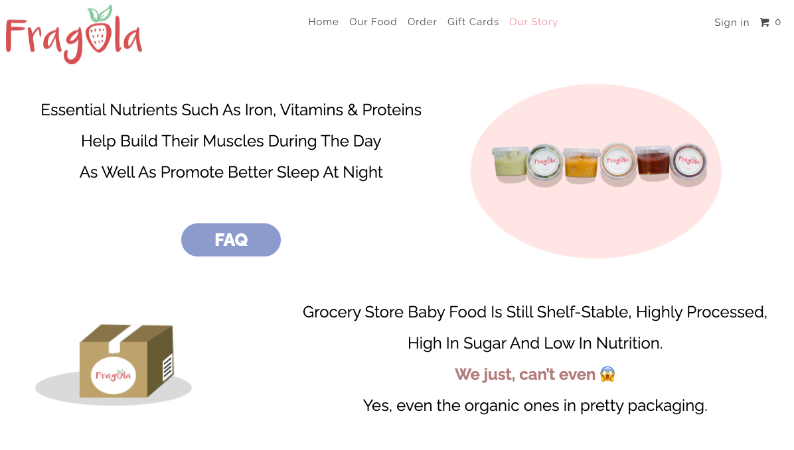
Fragola understands that it needs to establish trust with its customers right away. Parents are immediately made aware of the care put into selecting the best ingredients, which already helps set it apart from larger brands.
But what really helps set Fragola apart are simple acts of kindness. When the covid pandemic hit, Fragola rallied its social media followers into helping less fortunate parents, asking them to purchase gift cards that would be matched with a family in need.
Customers don’t forget generosity like this. Giving back to the same community that helps your business thrive goes a long way in establishing meaningful relationships.

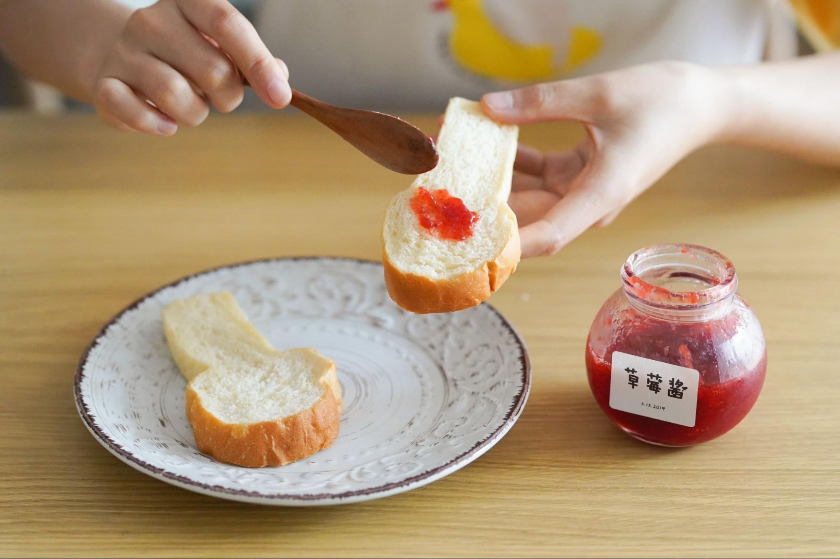
11. Homemade jams and jellies
Jams and jellies are a great low-cost business to start for entrepreneurs interested in growing their own fresh produce. At-home jam jarring machines are relatively inexpensive, and growing your own ingredients will add a personal touch to your brand that will resonate with customers.
On top of this, farmer’s markets are a great place to meet potential customers in person. While the volume of customers might be smaller than online, face-to-face sales opportunities tend to provide more value in terms of customer loyalty and word-of-mouth sales.
Benefits
- Small-brand advantage: when it comes to jams, customers tend to view products from larger brands as being less nutritious and containing more preservatives, which gives an advantage to smaller brands.
Challenges
- Time-management: growing produce can take a lot of time and is especially dependent on the changing of the seasons, meaning precise planning will be more important than with other food products.
Get inspired: Fruits of the Forage
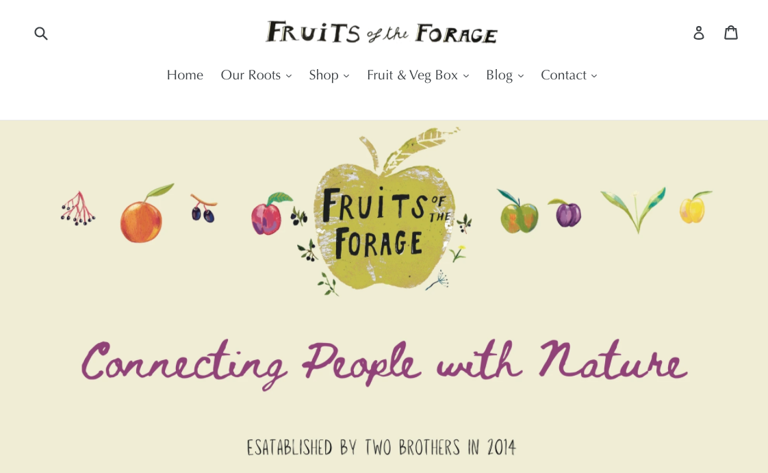Fruits of the Forage is a UK-based retailer of jams, jellies, marmalades, sauces, and other fresh preserves.
Alongside its line of products, Fruits of the Forage offers a fresh fruit subscription service, where a new variety of fresh-grown fruits and vegetables are shipped out to subscribers every week.
For smaller brands, setting yourself apart from your larger competitors is crucial. That’s why Fruits of the Forage bases its branding around the freshness of its ingredients and the championing of local produce, highlighting what makes the brand different.

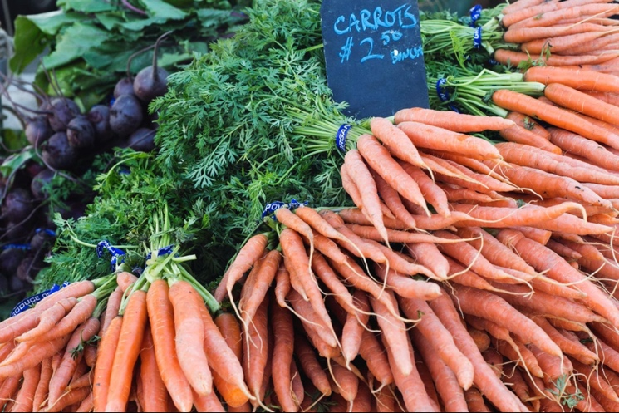
12. Organic foods
Organic foods are foods produced using natural fertilizers, as opposed to chemical pesticides. Official standards can vary between organizations and regions, but they all place emphasis on the recycling of resources, ecological balance, and long-term sustainability.
Organic foods have grown incredibly popular in the past decade as the safety of pesticides has become an important concern for a lot of customers.
You could sell raw, organic produce or use organic ingredients in your food products.
Benefits
- Fresh branding: organic products have become especially popular among customers, so the use of organic ingredients can be a positive highlight in your branding.
Challenges
- Harder to source: depending on your product, it may be challenging to source some organically grown ingredients.


13. Wine, beer, and spirits
Socializing over alcoholic beverages is a common pastime. They’re popular year round but still lend themselves well to seasonal promotions, with plenty of opportunities to test out new products.
Like with jams and jellies, selling wine can give you the opportunity to grow your own fresh ingredients, and wine-tasting events can be a great way to establish meaningful customer relationships.
With beer, craft breweries (sometimes called microbreweries) have become increasingly popular in the past couple of years, so beer connoisseurs place a lot of value in exclusivity⁠—something that gives smaller brands an advantage.
Benefits
- Thirst for new products: when it comes to alcoholic beverages, buyers place a higher value on novelty and exclusivity, so they’re more open to trying new products.
- In-person promotion opportunities: alcoholic beverages are common at events featuring large gatherings of people, providing in-person opportunities to build relationships with your customers.
Challenges
- Legal complications: there are a lot of laws governing the sale of alcohol and they can differ greatly between jurisdictions, so you’ll need to spend a lot of time familiarizing yourself with the laws in any location you plan on selling in or shipping to.
Get inspired: Haus
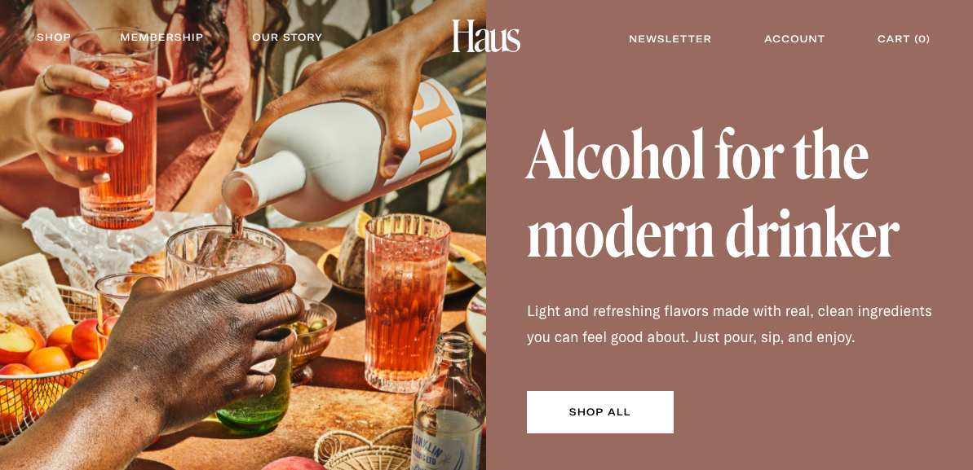Haus is a California-based brand specializing in apéritifs⁠—alcoholic beverages that are rich in flavor, lower in alcohol, and meant to be served before a meal.
Haus isn’t shy about emphasizing the freshness of its products, using only natural ingredients, like locally sourced fruits, herbs, and botanicals.
Haus also keeps a vibrant community alive via Instagram, where it posts recipes and serving suggestions that keep its audience engaged. Content like this is great for building brand awareness and picking up new customers via social media.

