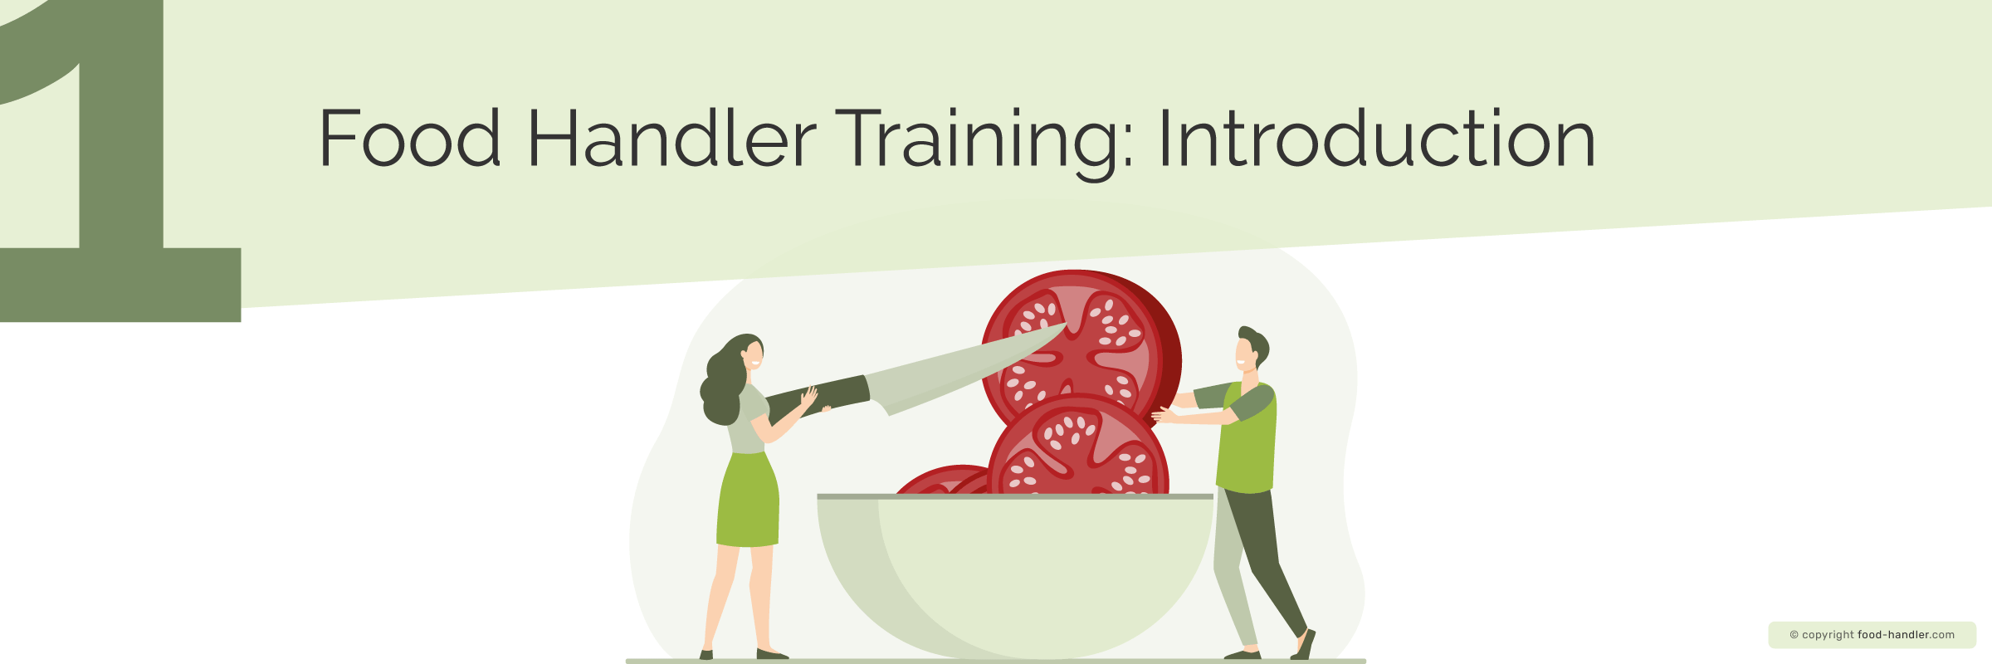
A food handler is anyone who, through their work activity, has direct contact with food during any of its phases until it reaches the final consumer. This includes preparation, manufacture, processing, packaging, storage, transport, distribution, sale, supply and service.
It is important to know and comply with hygiene rules during the handling of food, because this way we can guarantee food safety and prevent food-borne diseases. Most of the time, the food handler is the one who intervenes as the vehicle of transmission of these diseases, so it is important that we take into account the great role we play in prevention.
The food handling course will enable you to perform food handling functions, such as the different factors that can cause food alteration or contamination and the possible consequences they can have on the health of consumers (allergies, illnesses, etc.), and you should be responsible with this information, as the health of many consumers depends on you.
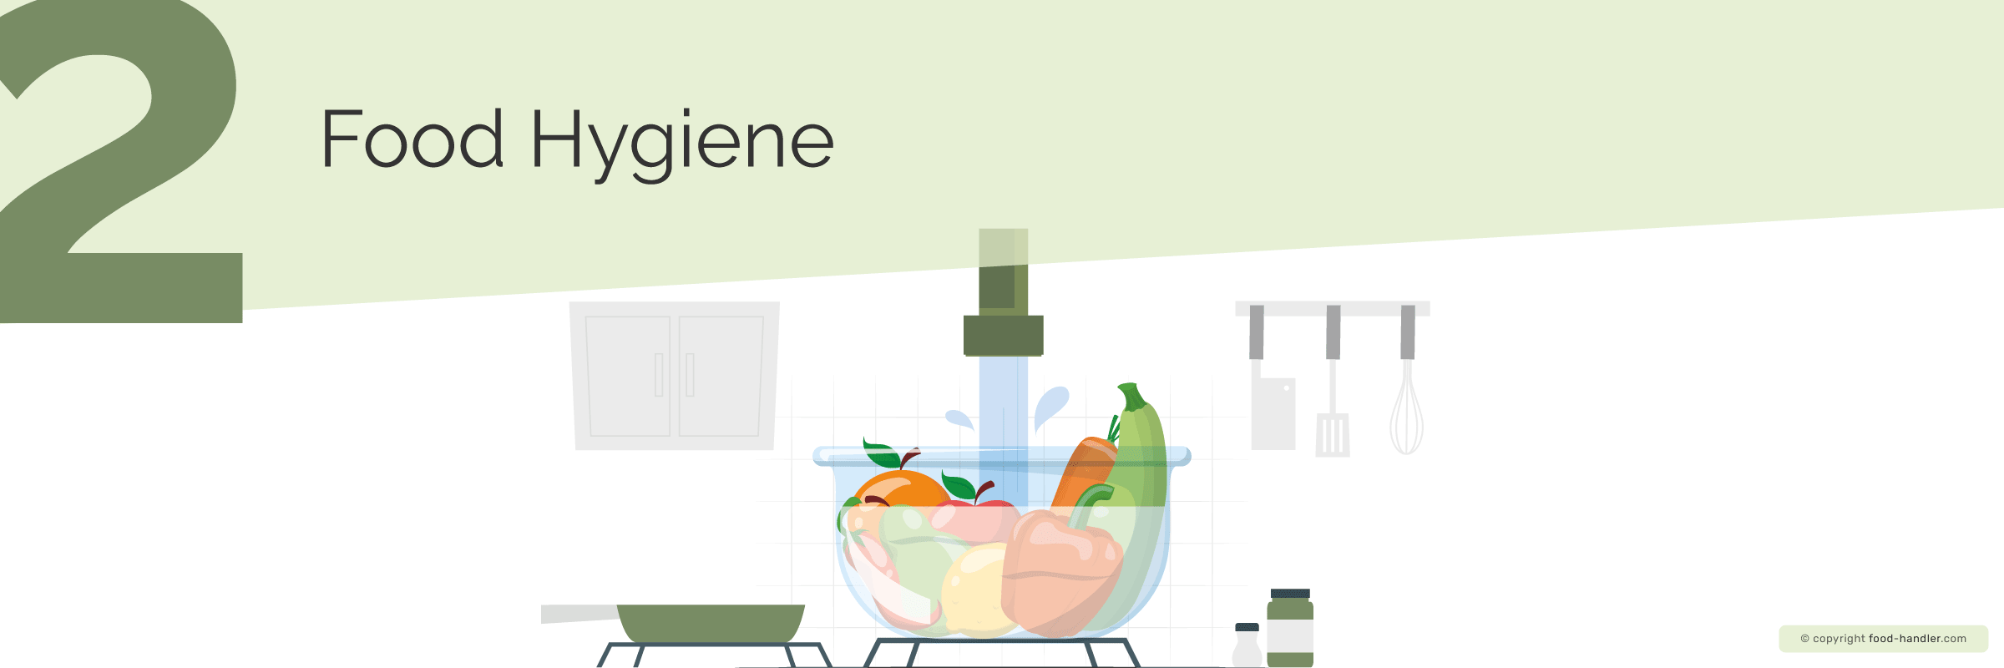

Food hygiene is all the measures that necessary to ensure the safety of food at all stages of the production chain in the food industry, from farm to table, that is, from the moment they are obtained until they reach the final consumer.
According to the World Health Organization (WHO), health is a complete state of physical, mental and social well-being, and not just the absence of physical discomfort or illness.
Therefore, we define food-borne disease as any disease caused by consuming contaminated food.
It is important to maintain good food hygiene, as it will lead not only to a safer handling of food, but also to a good reputation for the company, increased customer satisfaction, and also prevent possible penalties from health authorities.

Most common bacteria in food
The bacteria and viruses that most commonly contaminate the food we eat are:
Salmonella | It is one of the most common causes of food poisoning. It is found in eggs, raw poultry, beef, and sometimes unwashed fruits and vegetables
Escherichia coli | Found in the digestive system in animals and humans. In food, it is found in raw or undercooked beef, contaminated water, raw milk and fresh products.
Listeria monocytogenes | Found in ready-to-eat cold meats, refrigerated meat-based pâtés, raw dairy products, refrigerated smoked seafood or raw sprouts.
Campylobacter jejuni | Found in raw or undercooked poultry meat, unpasteurized milk, or contaminated or untreated water.
Staphylococcus aureus | It is found in foods rich in cooked proteins (cooked ham, poultry meat), dairy products, salads and pastry products (especially those made with pastry creams).
Shigella | Found in dairy products, beef and chicken, raw fruits and vegetables, raw oysters, and contaminated or untreated water.
Yersinia enterocolitica | Beef, fish, raw seafood, dairy products, contaminated or non-potable water and in fresh products.

At what temperature do bacteria die in food?
In order to ensure proper food hygiene, it is important to know the temperature at which bacteria die in food. One of the most effective methods of killing bacteria is cooking at 75°C for at least two minutes, although temperature and time requirements depend on the food and the microorganisms it may harbor.
In cooking methods such as boiling, temperatures reach around 100ºC, while in frying, temperatures range between 180 and 300ºC. The temperature of both methods is generally adequate to eliminate most microorganisms and thus ensure safe consumption. However, the temperature of frying oil decreases when the food is introduced and therefore, depending on its thickness of the food, care must be taking that the internal temperature reaches above 75°C.

Recommended food temperatures
Temperature is one of the most important factors to take into account when it comes to food preservation. Certain temperatures prevent the proliferation of microorganisms, so the correct control of the temperature of food, both in the refrigeration and cooking process is a key element to prevent the emergence and development of pathogenic bacteria.

Cooking temperatures:
It is recommended to cook food at a temperature of 75 ºC for a minimum of two minutes.

Conservation temperatures:
Fresh food should be cooled to a temperature of 0-5°C, which prevents the growth of pathogenic microorganisms. The lower the temperature, the slower the proliferation of microorganisms, so freezing at -18ºC is the safest, because although it does not eliminate pathogenic microorganisms, it keeps them in a latent state in which they do not multiply.
However, not all foods need to be refrigerated or frozen. Some foods, such as oil, cookies, nuts, pasta, rice, etc. can be stored at room temperature as their properties (absence of water) also control bacterial growth.

Hygiene of the most common foods
For proper hygiene, a number of food handling rules must be followed. A common guideline for all types of food is that when cooking or handling any food, you should first make sure that the work area, utensils, and tools are well cleaned and disinfected.

Fish | Before cutting or cooking, make sure that it is kept in a fit condition. To do this, make sure that the scales are firm, the gills are reddish and the eyes are bulging and shiny. Cooking at a minimum temperature of 65°C is recommended.
Chicken | If it has a soft, sticky film, a greenish colour or unpleasant smell, it is no longer suitable for consumption. Recommendations for handling chicken include using only a designated chicken board, wearing gloves when handling chicken, planning for consumption and thawing at least 24 hours, and avoiding contamination of other foods with chicken blood or meat fluids. It is also recommended to cook the chicken at a minimum temperature of 75ºC.
Beef | Ensure it still retains its original characteristics and is fit for consumption. Other recommendations include wearing gloves when handling meat, and making sure the meat is not in contact with other products. The recommended cooking temperature is 75°C. Do not to keep the meat in the freezer for long periods, as this will cause a change in colour and lose of nutrients.
Pork | Follow the same steps as for beef, unlike the cooking temperature, as in this case the recommended minimum is 64ºC.
Seafood | Seafood is particularly fragile in terms of contamination, so for safety reasons, it is necessary to ensure that the cold chain is not broken in food handling processes. The recommendations for handling seafood are to chill cooked seafood in an ice bath and to eat frozen seafood with head as soon as possible, as the head causes faster deterioration of the seafood even if it is frozen.
Milk products | Avoid exposure of milk products to room temperature for more than two hours (30 minutes for cheese). Milk products should be kept in the refrigerator for a maximum of 3 days.
Vegetables and fruits | Fruits and vegetables are among the most easily and quickly contaminated foods. As with all other foods, the first recommendation is to observe that the qualities of the food are preserved. In the case of fruits and vegetables, it is important to eliminate those specimens that begin to deteriorate in order to avoid the spread to the rest. It is also important to wash and possibly disinfect these foods before consumption or processing. These foods require particularly careful handling, as damage accelerates their decomposition. It is recommended to use a knife and specific board for cutting fruits and vegetables.

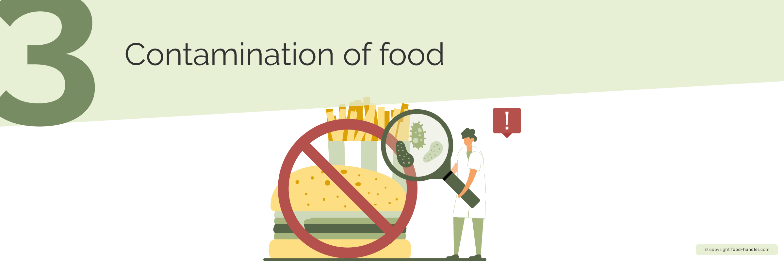
Contaminated food is any food that contains any agent foreign to the food itself that may be harmful to the health of the consumer.Therefore, a contaminant or a food hazard is any foreign agent to the food that is capable of causing a negative effect on the health of the consumer.
According to their origin, the contaminants or hazards can be classified as:
- Physial hazards: bones, shells, plastics, personal effects, band aids, etc. They pose a danger to the consumer as they can cause cuts, choking, etc
- Chemical hazards: toxic substances, cleaning and disinfection products, insecticides, air fresheners, heavy metals etc. They can reach the food by chance, or due to incorrect handling.
- Biological hazards: caused by living beings such as insects, rodents, birds, parasites (e.g. worms or weevils), or microorganisms (bacteria, viruses and molds).
The main food contamination sources or pathways are:
- The environment (contaminated or not potable water, dust, soil, air, or the effect of environmental toxins, agricultural pollutants or livestock products at origin)
- The food handler him/herself (lack of hygiene or transmission of a sickness)
- Utensils and premises (poor hygiene)
- Other foods (cross-contamination is the transfer of contaminants from one food to another, caused e.g by mixing raw and cooked foods, or using the same utensils for different foods without cleaning them first.)
- Pests
- Garbage
The food handler is often poses the major risk factor for food contamination because he or she is in constant contact with food. For this reason, good food handling practices are necessary to minimize risks of contamination as much as possible. General hygiene is essential, both in the workplace, in utensils and in personal hygiene. Handler's diseases, such as colds, can also be transmitted to food by coughing or sneezing.

How to know if a food is contaminated
Contaminated food does not always show obvious signs of spoilage. In packaged foods, it is essential to accept or reject the food based on the expiry date indicated on the package. If the food is out of date, the safest option is to discard it, since although it may appear to be in good condition, it may have begun its natural deterioration process.
Meat | The most obvious signs of contamination in meat are green or brown discoloration, rotten smell or slimy texture. In the case of poultry, it is most common to observe a slimy film on the skin and meat, accompanied by an unpleasant smell.
Fish and seafood | Fish that has lost its freshness has dark, brownish gills, sunken, opaque eyes, and detached or easily removable scales in parts.
Eggs and milk products | Open each egg into a separate container first avoid contamina to be able to check its freshness and avoid contamination of the other ingredients. If the egg is fresh, the yolk will remain whole and centered in the egg white. Rotten eggs have a strong unpleasant smell, the yolk and the eggwhite are runny and the yolk has lost its glossy orange color. Larger quantities of eggs can be checked by immersing them in salt water: if they sink, they are fresh, but if they float, they are in poor condition.  Milk in poor condition has a sour or bitter taste and start to disintegrate (form lumps and release whey). Cheeses in poor condition have a green or brown colour, an unpleasant smell and a slimy layer. They may also have fungi that are not typical of a variety of cheese.
Fruits and vegetables | Signs of contamination present in fruits can be mold growth, pieces too soft or with a part of the piece too soft compared to the rest, presence of flies or maggots, or the fruit/vegetable is covered with a slimy film.

Acrylamide in food
In recent years, there has been growing concern about acrylamide. This chemical forms naturally in foods rich in carbohydrates and starch after cooking at temperatures above 120ºC, as reached during frying, roasting and toasting. The more burned a food is, the more likely it is to contain a larger amount of acrylamide.
The European Food Safety Authority (EFSA) states that acrylamide consumption in humans potentially increases the risk of cancer. In November 2017, the European Union published the UE 2017/2158 Regulation in order to establish measures for operators with the aim of reducing the level of acrylamide in food.
The usual foods in which acrylamide form are: potato fires and crisps, roast coffee, bread, cookies, and cereals. It is therefore recommended to avoid frying or baking above 120ºC, and when possible to choose steaming or boiling instead.
Recommendations for fried potatoes:
- Store them outside the refrigerator in a dark and cool place.
- Wash them well before frying.
- Prefer coarse cutting instead of fine cutting.
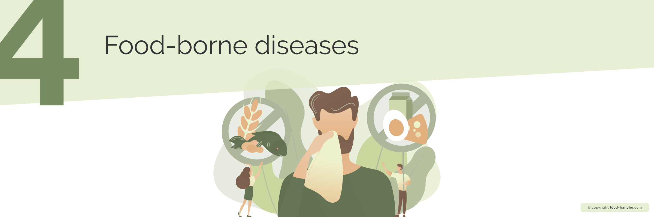

Food-borne illness is caused by eating contaminated food or drink. Most of these diseases are caused by bacteria, viruses and parasites. The most frequent symptoms of food-borne diseases are usually gastrointestinal in nature, like general discomfort, diarrhea and abdominal cramps and pain, vomiting, and fever. Some can cause serious illness and even death.
Microorganisms are a food hazard as they often act as a source of infection or food-borne disease. Microorganisms (also called germs or microbes) are living beings so small that they are invisible to the human eye. Bacteria, parasites and viruses appear, inhabit and reproduce in food when food safety conditions have not been adequate. Knowing the factors that favour the appearance of contaminants in food is key to preventing and detecting them, thus minimising the risks of contamination and contracting food-borne diseases.
Microorganisms are categorized as:
- Beneficial, when they are used in food processing (e.g. fermenting bacteria)
- Disruptive, they cause a change of the odour, colour, flavour and normal texture of the food and are responsible for the decay of food.
- Pathogens do not change the food properties at first glance and are mainly responsible for food-borne diseases. This is why it is so important to maintain proper prevention and hygiene in food handling.
Most food-borne diseases are due to bacterial contamination. However, viruses cause some microbial diseases; the most common one is norovirus, a highly contagious virus, which causes acute gastroenteritis. Unlike bacteria, viruses cannot multiply outside their host organism (animal or human), and their spread depends on contamination by the host. Although virus populations do not increase on the food, they are mostly resistant to disinfection and heat. Therefore, personal hygiene of the food handler is crucial to avoid viral contamination.
Parasites also depend on animals or humans as hosts. They are also transmitted from one host to another by the consumption of contaminated water or food or by surface contact with faeces of infected animals or persons. The most common diseases transmitted by parasites are trematodiasis, echinococcosis, toxoplasmosis, trichinosis, taeniasis, cysticercosis, giardiasis, crypto or cyclosporiasis.
Which factors modify the proliferation of microorganisms?
- Microorganisms need a nutrient/energy source (e.g. food)
- Microorganisms need a certain moisture/water content level to survive and multiply. Dehydrating or drying foods helps to preserve them, as microorganisms cannot grow.
- Microorganisms multiply fastest at certain temperature ranges (usually between 10°C and 60°C). At temperatures below -18°C, microorganisms become ‘inert’, which means they do not die but can no longer move or multiply. In refrigeration (between 0°C and 5°C), their multiplication rate is slowed down. Only through heat above 75°C can microorganisms be killed.
- Microorganisms prefer a certain pH range. They do not usually survive in acidic environments. That is why lemon juice or vinegar can be used for preservation.
- Most bacteria need oxygen, but some are anaerobe, meaning they grow without air, like Clostridium Botulinum, which can develop inside cans.
- Microorganisms multiply exponentially, therefore, the longer the food remains unprotected the more they multiply and the greater the risk.

Foods prone to food-borne diseases
Any food can be susceptible to contamination, but some foods pose a higher risk, because their nature, composition or form of culinary preparation make them perfect for bacteria to multiply. Among these foods are:
- Egg-based dishes: mayonnaise, salad, etc (use of raw eggs is prohibited, instead use pasteurized egg or egg products.)
- Minced meat, as the surface of meat in contact with air is much greater than a whole piece, and therefore more likely to become contaminated.
- Poultry
- Fresh fish, seafood and molluscs
- Raw products
- Pastry or bakery products: especially those containing cream

Conditions that can lead to foodborne diseases:
- Poor hygiene is one of the most common factors causing food contamination
- Cross-contamination
- Unsanitary conditions like improper slaughterhouse practices where livestock faecal matter is mixed with meat, or if fruits and vegetables are fertilized with raw manure or irrigated with contaminated water. Both meat and vegetables are associated with outbreaks of Escherichia coli.
- Unsafe packaging: Homemade canning can pose a risk that can be prevented by sterilising empty jars, hot-packaging and using self-sealing lids.
- Inadequate storage: bacteria multiply rapidly in a short time, so it is important not to leave food outside the refrigerator for more than two hours. It is recommended to eat or refrigerate raw foods such as creamy salads immediately.

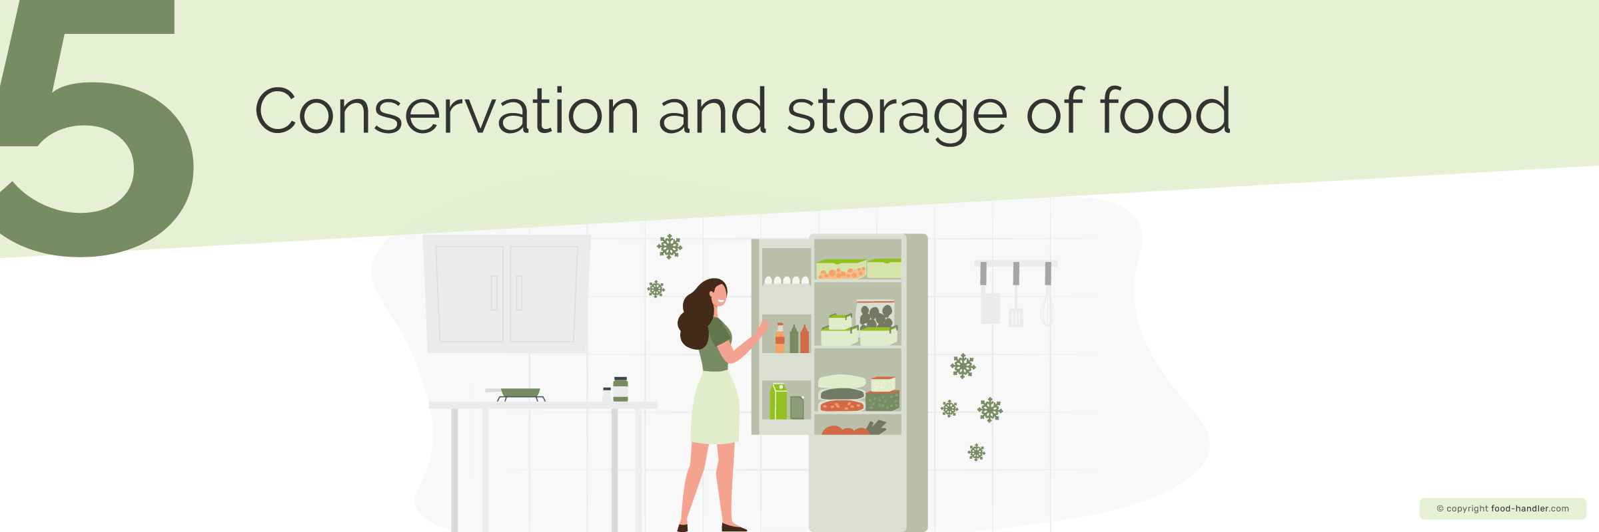

Preserving food consists of preventing the action of contaminating agents that can contaminate it and alter its original characteristics (smell, taste, appearance).
The maximum time a food retains its organoleptic, nutritional and health properties is called shelf life. The most frequent and traditional conservation systems used are:

Refrigerated storage
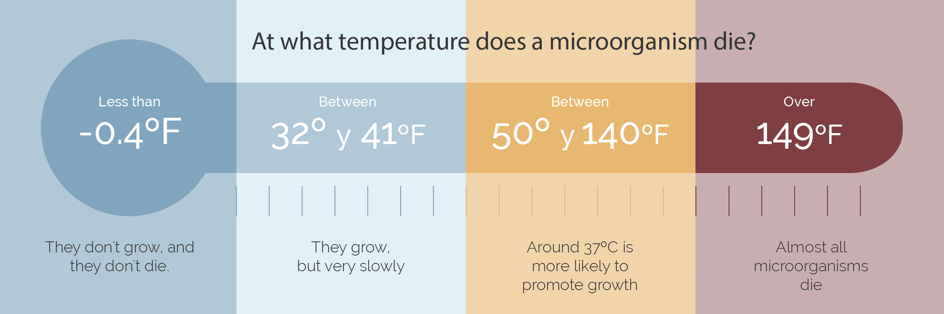
Cooling or refrigeration consists of keeping the food at low temperatures without it freezing (between 0°C and 5°C). At this temperature, microorganisms will multiply very slowly.
Freezing means subjecting the food to temperatures below the freezing point and storing it at a temperature below -18°C. This process causes some of the water in the food to form ice crystals, so that the microorganisms have no longer access to the moisture that they need to grow. In this process, it is important that freezing take place in the shortest possible time so that the original characteristics of the product are not affected.
Ultrafreezing: consists of subjecting the food to a temperature of between -35 °C and -150 °C, a, for a short period. The ice crystals formed during the process are smaller and do not damage the food tissues, causing less damage to the food characteristics.
The cold or cool chain must be maintained throughout production, transport, reception, storage, and sale to the consumer.

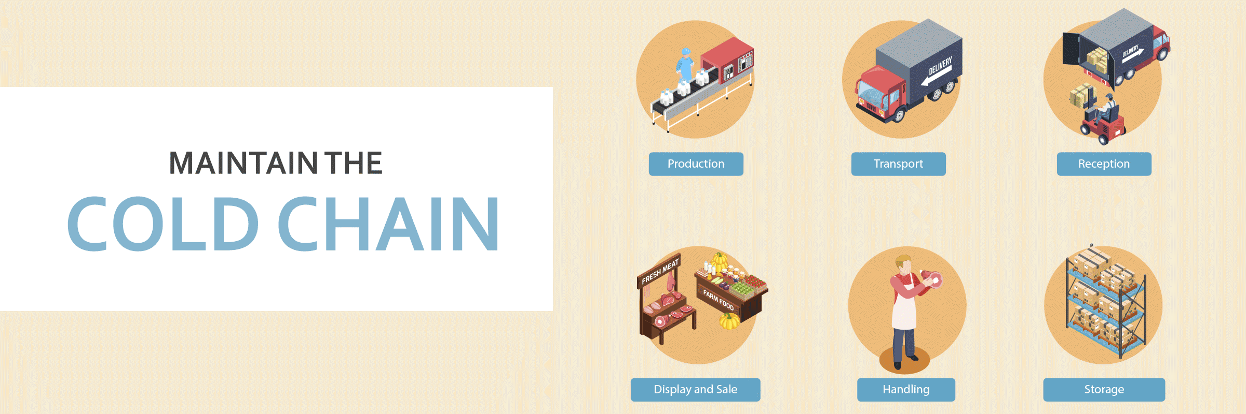
- Removing part of the water from the food by drying, salting, curing, sugaring, or smoking.
- Pickling, fermenting, or the use of preservatives.

Preservation by heat
Heating above a temperature at which microorganisms are destroyed. Common methods are pasteurization, cooking, sterilization and ultra-pasteurization.
Pasteurization consists of subjecting the food (e.g. milk) to temperatures close to 80°C. This destroys many microorganisms, but not all, so it is important to keep pasteurized foods refrigerated, to keep the microorganisms that may be left "at bay". The shelf life of the food is low.
Cooking means bringing food to a boil at about 100°C. With this method, we eliminate most of the microorganisms but not their spores. Cooking also modifies a food’s properties, making it more digestible in many cases more appealing to the consumer.
During sterilization the food is subjected to temperatures close to 120°C, thus destroying all microorganisms, including their spores.
Uperization (UHT) is a system where high temperature is applied for a very short time, just long enough to eliminate all microorganisms and their spores, and make the food suffer as little as possible by this heat treatment. UHT milk can be kept outside the fridge.

Chemical preservation
Chemical preservation consists of the addition of substances that chemically modify the food, for example by lowering its pH.
- Salting is the addition of common salt to prevent the growth of microorganisms. The food that has undergone this process changes in taste, smell, colour and consistency.
- Sugaring is the addition of sugar in high concentrations to protect food (e.g. jam) from microorganisms and thereby increasing its shelf life.
- Curing: this method uses, in addition to common salt, curing salts, nitrates and potassium and sodium nitrites. This process not only helps to preserve and protect against harmful microorganisms, but also stabilizes the color of the meat.
- Smoking is a process that uses the smoke resulting from the combustion of materials with a low content of resins or smoke flavourings. This method gives food a particular taste, and is mostly applied to meat and fish.
- Acidification means reducing the pH of food, thus preventing the development of microorganisms. This is done by adding acidic substances such as vinegar to the food.

Preservation by dehydration
- Drying is a partial loss of water under natural environmental conditions or by applying a gentle heat source and air currents.
- Concentration means the partial removal of water from liquids like juice.
- Lyophilization (freeze-drying) consists of the drying of a previously frozen food. This process allows for the maximum conservation of the original quality of the food and its nutritional value.

Preservation through the use of additives
These additives can be of:
- Natural origin, like vinegar, oil, salt, sugar, alcohol, etc.
- Industrial origin, the most commonly used food preservation techniques. It is used with the sole purpose of improving food characteristics such as lengthening shelf life, improving flavour, colour or texture. They are not used to fortify food with nutrients.

Conservation by irradiation
It consists of the application of ionizing radiation on the food (under strict control). It is a very effective method, as it prolongs the shelf life of food in the best conditions. Foods that have undergone the preservation process by irradiation must be labelled as such.

Food packaging and labelling
Once the food product is preserved, it must be protected from possible external contamination (from the environment, from the handler, from other foods, etc.). This is done by packaging, which provides a physical barrier against contamination.
The materials directly in contact with the food and with which it will be packaged depend on the type of product. Containers that are in direct contact with the food must be made of food-grade (non-toxic) materials, not transfer substances from the container to the food while it is being stored and contain a label to give information about the product to the consumer.They can be plastic, glass, tinplate or aluminium.
Packaging, in addition to protecting the food, also has the function of facilitating distribution and use (dosage). The labels of the products must inform us of everything related to the food it contains, and although depending on the type of food this label may vary slightly, they usually must contain certain mandatory information:
- Denomination (the name)
- Ingredients, what makes up this product, in descending order by quantity
- Alcoholic strength (if applicable)
- Weight or units. Net and gross quantity should be indicated if it contains liquid.
- Instructions for care and use, either of these three:
  - Keep in a cool and dry place.
  - Keep refrigerated.
  - Keep frozen. Do not refreeze once thawed (re-freezing a product that has already been thawed once is prohibited).
- Expiration or shelf life expiration date
- Company name or name of manufacturer or packager and address
- Lot (code with which we can «track» that product in case of problems with it). These are products that are manufactured or packaged under similar circumstances. The lot is very important, because it is related to the traceability of a product. By traceability we mean the ability to trace or reconstruct the life of a food from its origin to its sale to the final consumer. This means knowing where the food has passed at all times, and if there is a problem, being able to remove the products in time, so that there is no outbreak of a foodborne disease.
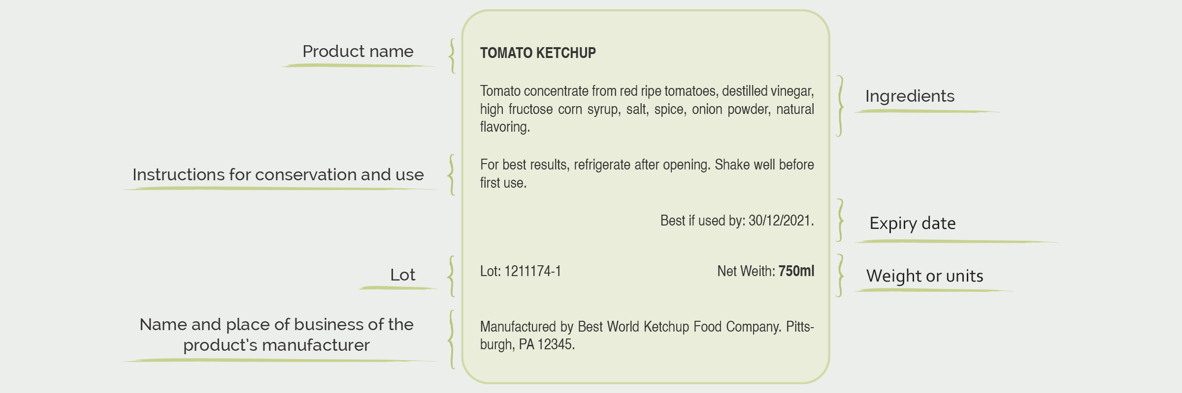
It must be ensured that the consumer will see the label, that it will not be changed, and that products will not be sold without labels. There are practices, such as re-labelling products is prohibited and considered fraud.

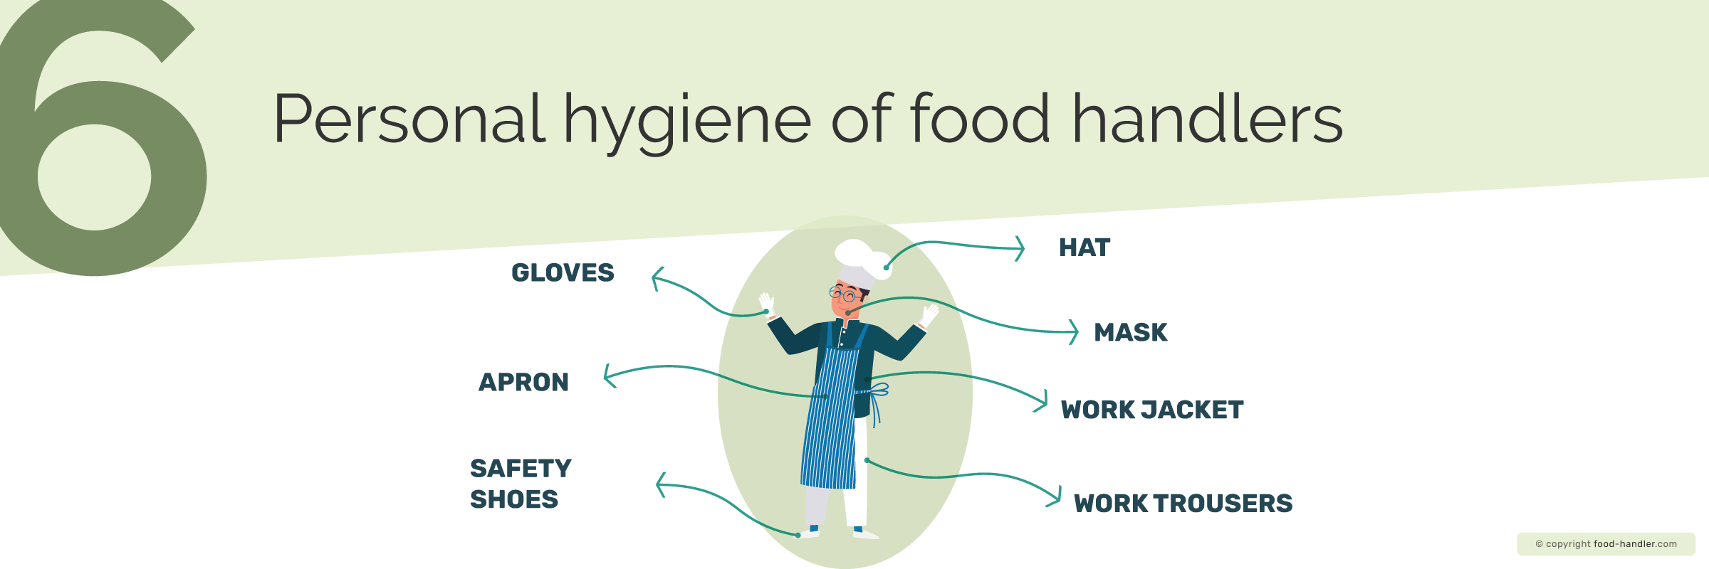
In order to avoid risks, food handlers have to be careful with:
- Own health: In case of illness, notify your superior as soon as possible (If you have nausea, vomiting, diarrhoea, fever, skin rash, etc.).
- Personal hygiene: Maintain a high degree of personal hygiene.
- Workwear: Work clothes should be exclusively for work and food handling, and should preferably be light-coloured. They should be clean and neat, and should not be taken out on the street or in places where it may become contaminated.
- The cap or hairnet should cover the hair completely to prevent it from falling on the food.
- It is not allowed to wear personal items (pendants, earrings, rings, piercings…).
- If gloves are required for work, they should be kept clean and unbroken. Even if you wear gloves, you should also wash your hands.

Things to keep in mind when handling food
To avoid the risks that may arise, food handlers must carry out certain preventive activities like maintaining proper food hygiene and handling at the workplace as well as personal hygiene, working only when healthy, wearing appropriate apparel and protective gear, and maintaining hygienic habits when handling food.

Take care of your health
They should take care of their health, and if they are ill they should inform their superior as soon as possible, so that they can determine whether or not their seriousness may affect the food.
If we have nausea, vomiting, fever, diarrhea, severe skin conditions, or symptoms of a food-borne illness, we will not be able to perform our job on a temporary basis until you are fully recovered, and it is important that you be advised of this as soon as possible.
If you have cuts or wounds on your hands, they should be disinfected and then covered with waterproof bandages (or strips) that we will cover with gloves, so that they cannot fall off and into the food. This will prevent the microorganisms in the wound from contaminating the food.

Personal hygiene
The most frequent sources of transmission of microorganisms are through the hands, mouth, mucous membranes, and intestine.
Therefore, a high degree of personal hygiene must be maintained, which includes at a minimum having a shower before work, having clean hair, brushing your teeth, and keeping your nails short and clean.

Appropriate work clothing
Work clothes should be exclusively for work and food handling, and should preferably be light-coloured. They should be neat and clean, and should only be worn inside the food processing facility. In the case of leaving the workplace, work clothes should be exchanged for street clothes in and kept in the changing room.
A hat or hairnet should cover the hair completely to prevent hair from falling on the food. It also prevents touching the hair and then touching the food. Both men and women should wear a hat or hairnet.
It is not allowed to carry personal items while handling food, so jewelry, earrings, watches, pendants, bracelets, rings, piercings, have to be removed before the start of the working day. Wearing long, painted or decorated nails is not appropriate. Firstly, such objects can accumulate dirt that can be transferred to the food, can also fall into the food and reach the final consumer, but can also cause accidents at work.
If gloves are needed for work, they should be kept clean and unbroken. Even if you wear gloves, you should also wash your hands before putting them on, and be as careful as if you did not wear them.

Hygienic habits when handling food
Hygienic habits: smoking, chewing gum, eating, coughing, sneezing or blowing on food, and talking on food are prohibited in the workplace, as it might cause microorganisms in our saliva to fall on the food.
- Correctly wash food with plenty of water, especially fruits and vegetables, where it is recommended to wash them with specific products when they are to be consumed raw to ensure that bacteria and chemicals used in the growing process are eliminated.
- Do not leave food at room temperature for more than two hours.
- Prepare food shortly before eating or freezing.
- Reheat the plates to high temperature to eliminate possible bacteria.
- Eat the fish always cooked or after freezing.
- Eat the minced meat on the same day you buy it.
- Freeze food by portion to avoid freezing and thawing food several times.
- Wash knives and cutting boards thoroughly.
- Do not mix raw food with cooked food in the refrigerator.
- Do not thaw food at room temperature; it is best to thaw it overnight or the day before in the refrigerator or use the microwave to thaw food.
- Do not touch or scratch your hair
- Do not wear cloths hanging at the waist.
- Do not try food with your finger.
- Do not introduce dirty spoons of a different food.
- Do not use utensiles that have only been rinsed with water to taste the food
- Do not leave the cloths on the worktables.
- Do not leave utensils inside the recipients.
- Do not dry hands on apron or pants.
Hand washing
One of the most important habits when working as a food handler is the correct and frequent hand washing. We have a large number of bacteria on our hands, which we can "pass" on to food, so if we wash our hands well and at the right time we will avoid a large number of food-borne diseases.Wash your hands with warm water and antibacterial soap, rubbing well between your fingers, and with a hand brush between your nails. Then dry your hands with single-use paper.
Hand washing will be frequent and there are times when it is mandatory to wash your hands:
- At the beginning of each working day and every time you interrupt work.
- After handling raw food (to avoid cross-contamination).
- Before handling cooked food (to avoid cross-contamination).
- After going to the toilet.
- After handling garbage or food waste.
- After using a tissue to cough, sneeze, or blow your nose.
- After we eat.
- After charging the customer.
- After smoking.



Hygiene standards for a catering or food-handling facility
Correct food hygiene and handling is essential in all catering or food handling premises, so it is essential to follow a correct cleaning and disinfection protocol. We clean because it can be dangerous due to the appearance of microorganisms, but we also do it to avoid the appearance of pests, since areas with bad cleaning favour the appearance of these animals.
All cleaning and disinfection is carried out to eliminate microorganisms and to avoid the appearance of pests.
We have previously advanced the most frequent ones: birds, insects, rodents... and for this reason we, as manipulators, can control that different PREVENTIVE MEASURES are fulfilled so that they do not appear:
- Grilles in the drains: check that they are well placed and that no animals can enter through them.
- Window screens and mosquito nets: they are there to prevent the entry of birds and insects, we must check that they do not have holes or are broken.
- Bug zappers: Fluorescent lights that attract insects, attract them to it and destroy them. They must be on.
- That all the doors are properly closed and have no small holes through which animals can enter.
- Clean garbage cans and change the bag frequently.
- Do not leave doors or windows open, without protection, to prevent the entry of birds, insects...
- Order and cleanliness in the warehouses (disordered areas can act as shelters for animals). Never placing food directly on the floor.
- Carefully inspect the incoming merchandise to ensure that no animals are being transported.
But if, despite these measures, we find any animal, we must notify external companies, approved by the competent authorities, so that they can destroy these pests. Under no circumstances will we be able to use products that we "find" to deal with this problem, since special methods and products must be used for each establishment and each animal.
With regard to the management of waste and residues, different aspects must be taken into account so that this area, which, a priori, will always be dirty, even if it is as clean as possible. This area is a major source of pollution that can attract pests, so to avoid risks, all waste bins:
- Buckets must always be closed, except when used.
- They will not be in areas with high temperatures or in the sun, to avoid the fermentation of the residues it may contain.
- They should be used exclusively for garbage and be easily cleaned.
- They will have a lid to prevent animals from entering (insects, rodents, etc.).
- They must be opened manually (with a pedal to open them), and never by hand.
- They should carry a single-use plastic bag, which should be evacuated at least once a day (in many cases more than once a day).
- ALWAYS WASH HANDS after handling garbage or waste.

Food handling equipment and utensils policy
In order to maintain proper hygiene in premises where food is handled, we must take into account hygienic practices for equipment and utensils:
- All utensils placed in contact with food should be easily washable and have no areas where dirt can accumulate. Therefore, all wooden utensils are prohibited (boards, ladles....), they could also chip and fall into the food, which would pose a danger to the consumer.
- Clean and disinfected utensils should be stored in sterilizers, they should not be left in the environment, as they will be recontaminated.
- The use of cloths or rags is not permitted, disposable papers must be used.
- All parts of the machines we use must be easily removable (so that they can be cleaned and no dirt or food remains can accumulate).
- As for the cleaning of the facilities, dry sweeping is not allowed where food products are present, as it can raise dust and cause it to fall into the food and contaminate it.
- Cleaning products may not be stored near food.
- The use of household cleaning products is not allowed, special cleaning and disinfection products according to our industry or establishment will be used instead.
- It is not permitted to keep pets in handling areas, warehouses or areas where foodstuffs may be present.

Cleaning and disinfection of utensils
Cleaning and disinfecting are not the same, they are two complementary actions. They are two different actions that must be taken together, and in this way we will obtain a correct sanitation in everything that surrounds the food.
Cleaning is the removal of all visible residues that may serve as food for microorganisms. If we just clean up we are not going to eliminate the microorganisms, which could grow on those surfaces.
In general, we would try to remove everything we can see, using hot water and detergents (according to the area to be cleaned, as each industry needs a specific type of cleaner). To do this, we will use utensils that will help us to remove this dirt (scourers, brushes, etc....).
Disinfection must be carried out after cleaning, eliminates or greatly reduces microorganisms that may be present, up to limits that do not pose a risk of contamination of food.
The correct sanitization is determined by cleaning and disinfection programs, where a written control of all this will be carried out. To disinfect we will use chemicals such as bleach, water vapor with other products.
Steps of a good cleaning and disinfection:
- Cleaning away everything we see (food scraps, various residues, etc.) first dry and then with hot water.
- Application of the detergent or product according to industry, rub until all the visible dirt is removed.
- Rinse
- Application of the disinfectant.
- Rinsing (although some products must be left until the next day to work, and then rinsing, before starting work).
- Drying (with disposable paper)
With regards to the handling of waste and residues, different aspects must be taken into account so that this area, which is usually a dirty area, is not a source of pollution that could attract plagues. Appearance of plagues must be monitored regularly and preventive measures must be taken to protect the facility, such as mosquito nets, grids, insect collector, rodent traps, etc.
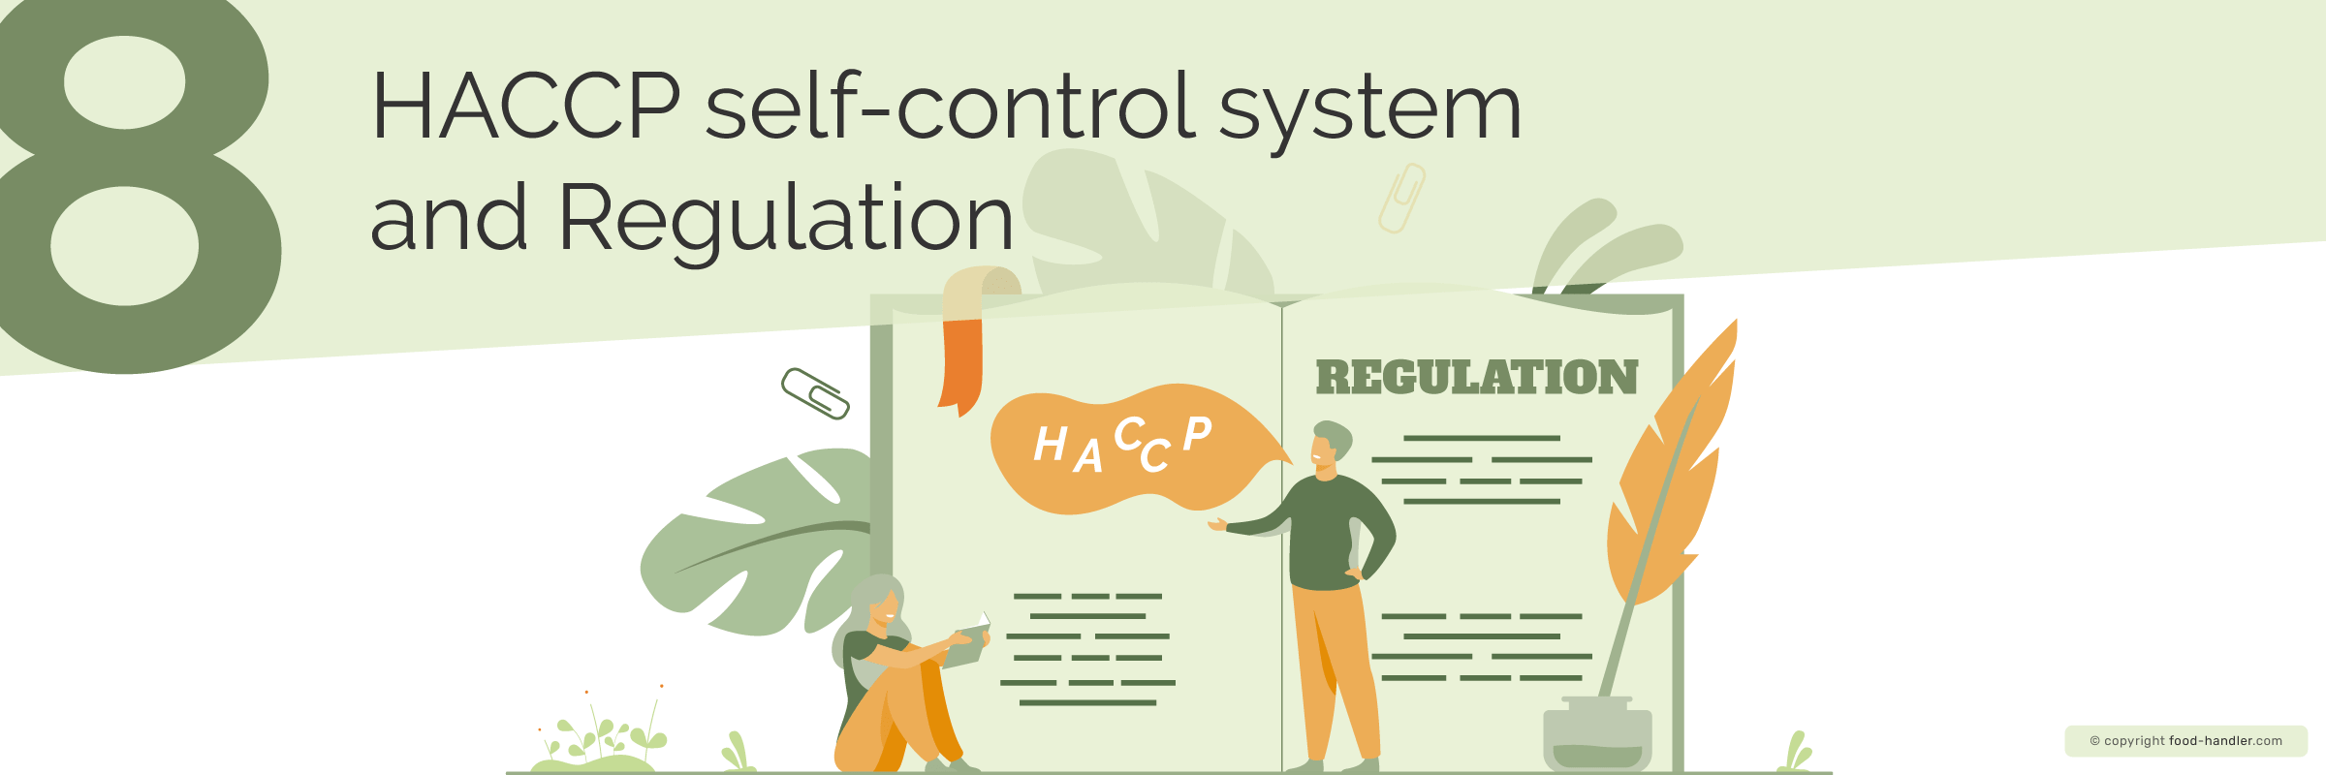
The HACCP self-control system corresponds to the acronym Hazard analysis and critical control points.
This system allows us to anticipate problems, it is a prevention system, and if problems arise, it also specifies what we should do. Its purpose is to obtain safe food for the health of the consumer.
HACCP is specific to each food business, however the steps for its correct implementation in the company are similar: creating a HACCP team, describing the product, identifying the expected use, developing a flow chart and complying with the principles of HACCP.
The PRINCIPLES of HACCP are identify hazards, set preventive measures, critical limits, monitoring system, corrective measures, control system or recording.

What is the Hazard Analysis and Critical Control Point system?
Each HACCP process will be specific to each food company, as it will be different depending on the food products to be handled or processed in the establishment.
The success or failure of HACCP in food safety depends mainly on the involvement of all those involved in food handling. It is important that everyone is aware of its usefulness and knows what to do at each stage. The previous steps to follow for a correct execution of the system are: to form a HACCP team, to describe the product, to identify the expected use, to develop a flow diagram and to comply with the HACCP principles.

HACCP principles
Before starting to elaborate the HACCP process, a few STEPS must be followed for its correct implementation in the business:
- Form a HACCP team: a multidisciplinary team of people, trying to have people from all areas of the company, related to food safety.
- Describe the product: each industry or establishment is different, and we must know perfectly the product we have and define how it is, including from its ingredients, how it is prepared, which consumers it is aimed at, organoleptic characteristics, storage characteristics, etc.
- Identify the expected use: identify the target end consumer, and how it will be used.
- Develop a flowchart: Once the product is defined it will be easy to make a flowchart summarizing the phases or stages it goes through.
- Comply with the principles of the standard HACCP.
To better understand the HACCP system we are going to assume that we are in an establishment selling products to the consumer, supermarket, hypermarket, and we are going to define the phases through which our food would pass:
Raw materials reception -> Storage -> Exhibition -> Sale.
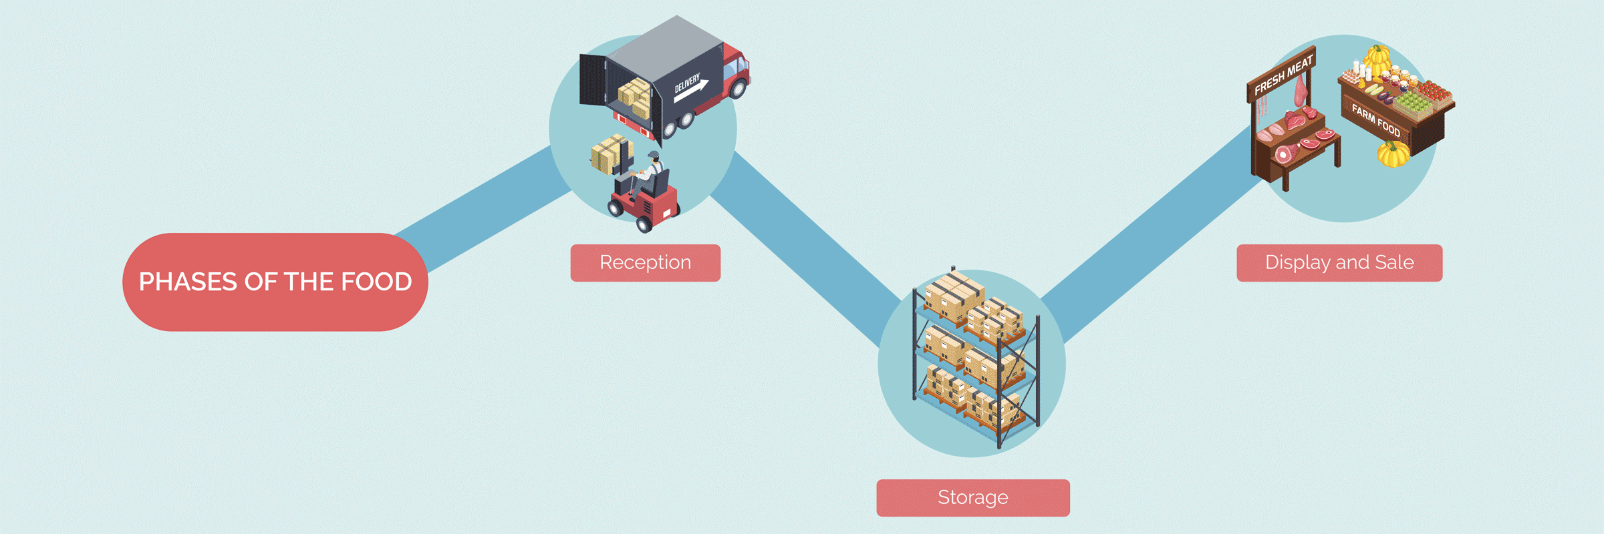

Steps for implementing a Hazard Analysis and Critical Control Points system
Complying with the HACCP plan will allow us to obtain safe food and the process will be carried out with fewer errors. In this way, we will also improve the use of the processes and make economic savings. The principles of HACCP in the hospitality industry are to identify hazards, apply preventive measures, establish critical limits, a surveillance system and a control and registration system.

Identify the hazards of each phase
Hazards can occur at every stage of the process. We must know what can happen in order to avoid it as much as possible. This way we would say which are the PCCs (critical control points) in our process.

Apply preventive measures
We must put in place measures that will prevent the emergence of dangers. E.g. in the storage of refrigerated food: always keep it refrigerated (0-5ºC), do not leave open doors in cold rooms for long periods of time, do not exceed the storage capacity...

Establish critical limits
We must know what is the limit that we consider to be valid and from when this process has become a danger. E.g.: refrigerated food will have a temperature of 0-5ºC (that is the limit), if we have a chamber at 6ºC it will no longer be valid.

Establish a monitoring system
Check that the preventive measures are carried out correctly.

Establish corrective measures
Even if we do everything right, there may be a danger, and we must know what to do about it, and how to remove it as soon as possible. E.g. in the frozen food store we see that the temperature is -10ºC, it is not correct, and the food is bad.

Control and registration system
Everything that happens, or that we monitor, should be recorded to keep a record of what happens, and taken as proof that the controls have been carried out.

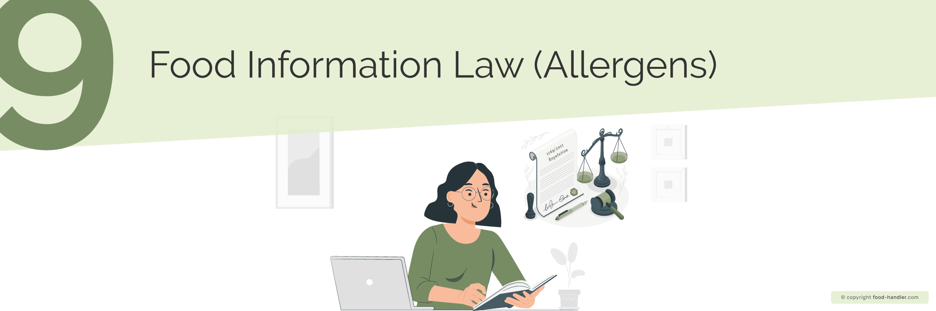

According to the 1169/2011 regulation, known as the Food Information Law (Allergens), since December, 2014, every food operator is obliged to report on the allergens present in its products through a system that allows them to be clearly identified. This is meant to provide consumers with all the information on the 14 major allergens to keep them safe. Possible options for the format in shich this information is provided include information leaflets, posters, icons on the menu, etc. Food processors must indicate this directly on the labelling of the product itself. Although it is not mandatory, it is recommended to inform about the possibility of traces or possible cross-contamination of allergens in your products.

Who must comply with the Food Information Law (Allergens)?
- Restaurants.
- Bars.
- Caterings.
- Hotels.
- Public canteens (schools, hospitals, etc.).
- Vending machines.
- And similar businesses.
Although there are many possible allergens, only those containing any of the following 14 elements* are required to be reported:
- Cereals containing gluten (wheat, rye, barley, oats, etc)
- Crustaceans and products thereof
- Eggs and products thereof
- Fish and products thereof
- Peanuts and products thereof
- Soyabean and soyabean based products
- Milk and products thereof (including lactose)
- Nuts (almonds, hazelnuts, walnuts, cashews, etc.)
- Celery and products thereof
- Mustard and products thereof
- Sesame seeds and products thereof
- Sulphur dioxide and sulphites
- Molluscs and products thereof
- Lupin and products thereof
* This list can be modified or extended by the European Union according to its own criteria, so it is necessary to be informed and updated about possible changes in this list.

Labelling requirements
The European standard establishes the correct labelling regulation, indicating that it must be clear and legible. To this end, a minimum font size for the mandatory information of 1.2 mm is set. However, if the maximum surface area of a container is less than 80 cm², the minimum size is reduced to 0.9 mm.
If it is less than 25 cm², nutritional information is not mandatory. For packages with a larger surface area of less than 10 cm², there is no need for nutrition labelling or ingredient listing.
However, the name of the food, the presence of possible allergens, the net quantity and the date of minimum durability must always be indicated, regardless of the size of the package.
Similarly, it is also necessary to indicate allergens present in unpackaged foods sold to the final consumer.

Non-mandatory nutritional information
Unprocessed products that include a single ingredient or a single category of ingredients are not required to incorporate nutrition information on the label.
- Processed products whose only transformation has been to be cured and which include a single ingredient or a single category of ingredients.
- Water intended for human consumption, including water whose only added ingredients are carbon dioxide or flavourings.
- An aromatic plant, a spice or a mixture of them.
- Salt and salt substitutes.
- Sweeteners.
- Coffee extracts and chicory extracts, whole or ground coffee beans and whole or ground decaffeinated coffee beans.
- Herbal and fruit infusions, tea, decaffeinated tea, instant or soluble tea containing no added ingredients other than flavours that do not alter the nutritional value of the tea.
- Fermented vinegars and substitutes therefor, including those whose only added ingredients are flavourings.
- Flavours.
- Food additives.
- Technological adjuvants. Food enzymes. Gelatine.
- Marmalade thickening compounds.
- Yeast.
- Chewing gum.
- Food in packages or containers with a surface area of less than 25 cm2.
- Food, including artisanal foodstuffs, directly supplied by the manufacturer in small quantities to the final consumer or to local retail establishments directly supplying the final consumer.

Country of origin of the food
One of the new features of European Regulation 1169/2011 is the obligation to indicate the country of origin on the label. Before this law it was only mandatory to indicate the country of origin of foodstuffs such as fresh beef, fruit and vegetables, honey, or olive oil. This law also requires fresh pork, sheep, goat and poultry meat to be labelled with the label of the country of origin of the food.
Implementing (EU) 2018/775 regulation became mandatory as of April 1st, 2020. The new provisions aim to redress the error induced in consumers by the labeling of the country of origin of foods when the primary ingredient (more than 50% of the food) is obtained elsewhere. If the country of origin differs from the origin of the primary ingredient, "the country of origin of the primary ingredient or an indication that it has a different country of origin from that of the food" must be specified.

Although it is likely that the first infection by COVID-19 has its origin in the consumption of animal meat, the European Food Safety Authority (EFSA) states that there is no evidence of any case of transmission of the virus through food.
However, preventive measures related to workers and their environment include:
- Be able to identify the symptoms of the infection by COVID-19.
- Respect personal hygiene precautions, such as frequent hand washing.
- Always use personal protective equipment (masks, gloves, appropriate footwear, etc).
- Keep the minimum safety social distance (at least 1 meter).
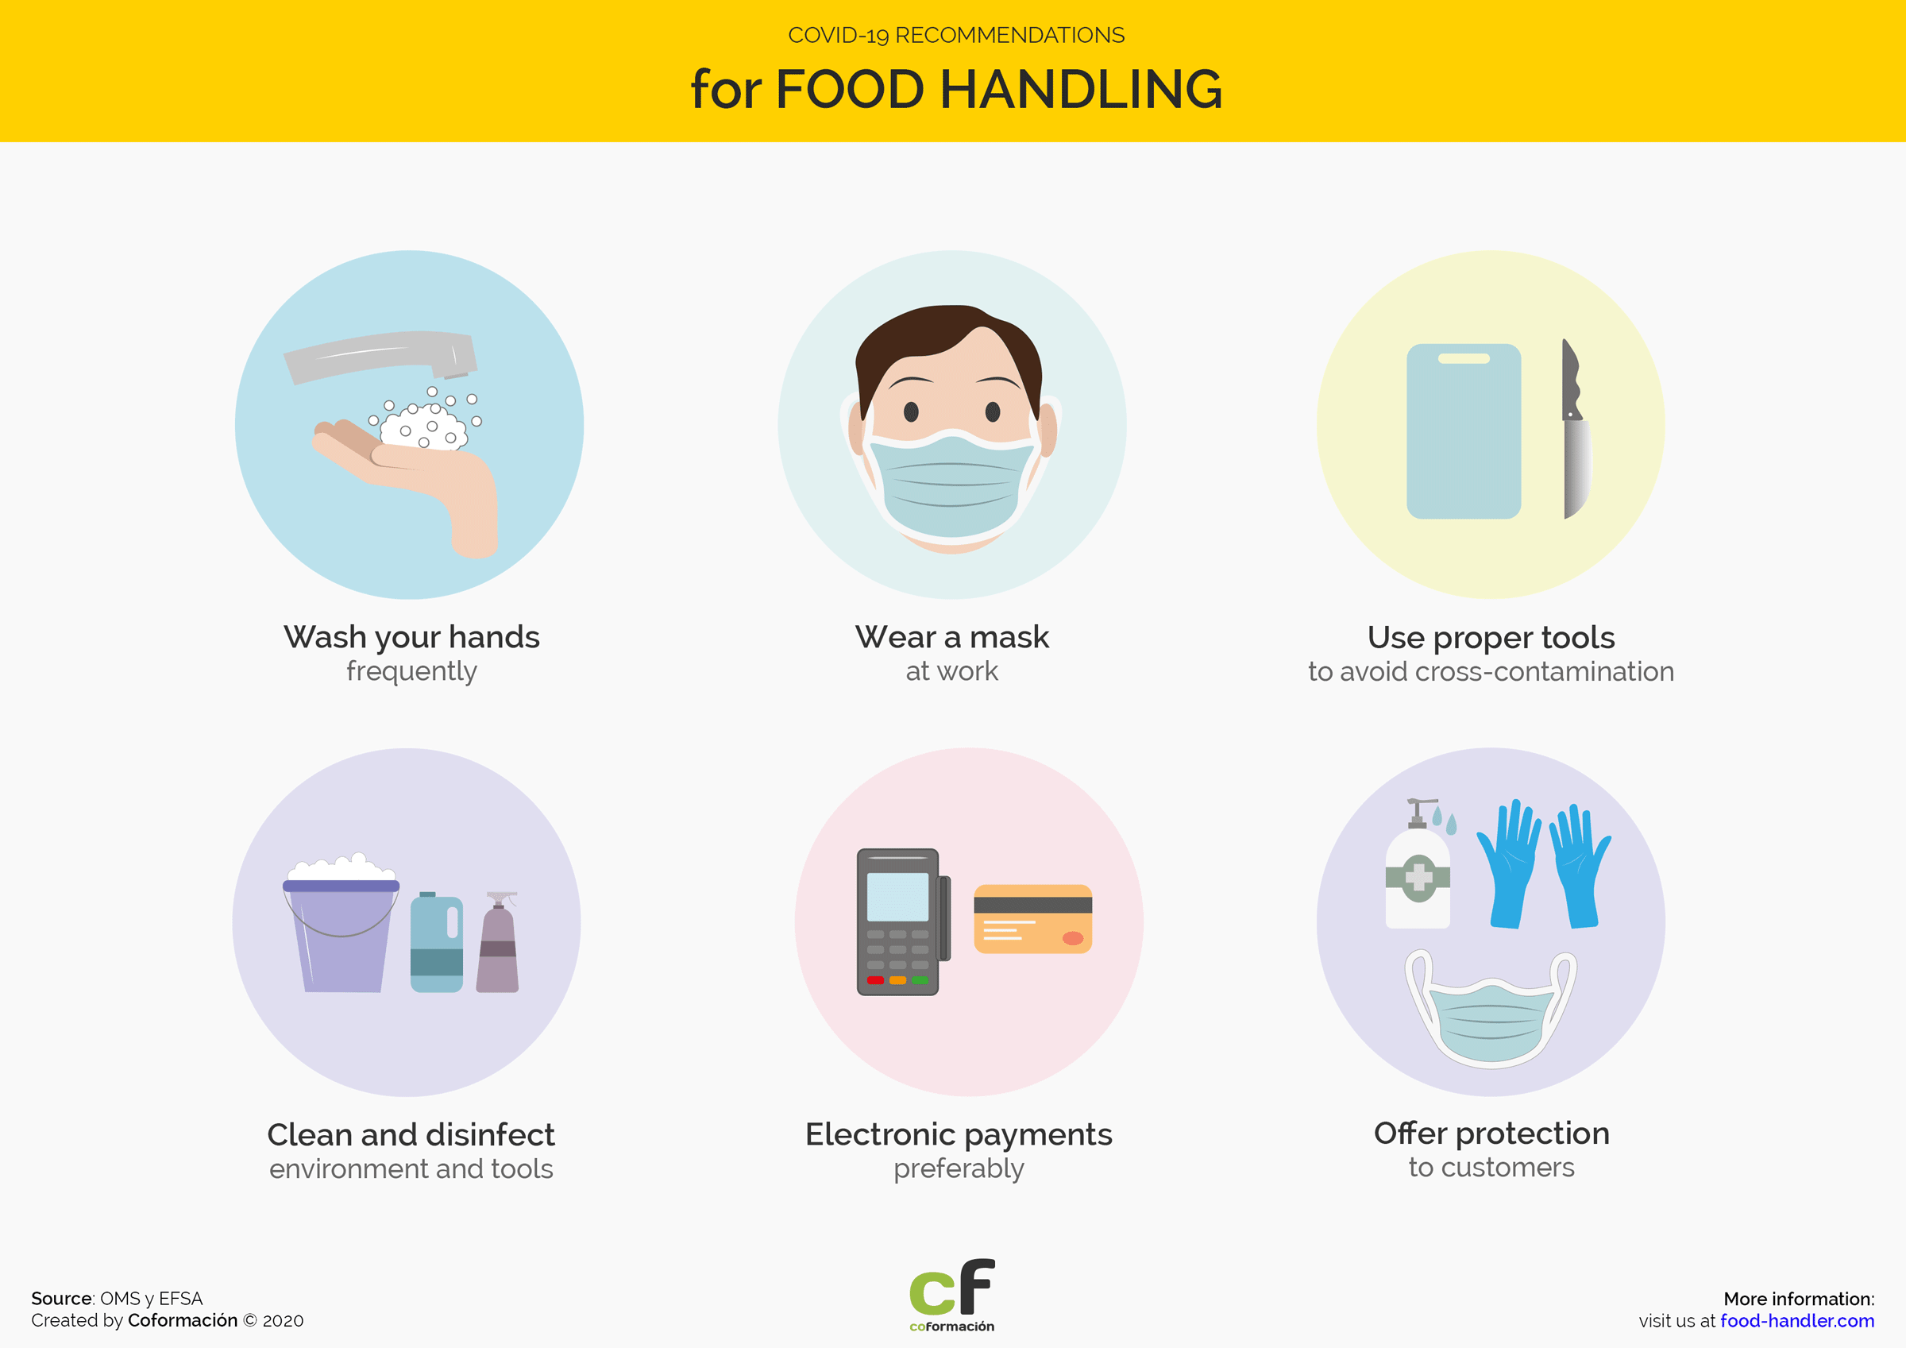

Measures applicable to workers and their environment
- When coughing or sneezing, use a disposable paper, which should be discarded after use, and wash your hands.
- Disinfect work surfaces frequently, as well as common contact objects (door knobs, appliances, buttons, utensils, etc).
- Always use personal protective equipment (such as masks, gloves, hairnets, specific footwear, etc.) Regarding the use of gloves, they should be changed frequently and hands should be washed after use and before putting on a new pair. Gloves should also be changed after contact with anything other than food (boxes, doors, windows, telephone, wastebaskets, etc.). We should not touch our mouth or eyes by wearing gloves.

Measures applicable to food
Just as we take extreme precautions with regard to ourselves and our environment, we must also establish a set of preventive measures in relation to food itself:
- Take special care with unpacked food. In cases such as salad bars, fresh food displays and bakery and confectionery foods, in addition to the general prevention measures outlined above, it is recommended:
  - Disinfect frequently those utensils and surfaces that are in direct or indirect contact with food, as well as self-service utensils used by customers.
  - Replace the gloves before and after touching the food.
  - Make water-alcoholic gel available to customers in a well-marked and visible place, both at the entrance and exit of the premises.
  - Wrap in plastic, paper or cellophane all bakery and confectionery foods.
  - Bulk food should always be displayed under Plexiglas cabinets, and bags and utensils should be available for customers to serve themselves.
- Leave the food (not refrigerated) that has just arrived outdoors for several hours.
- Dispose of disposable food packaging, such as cartons or bags, as soon as possible and place the contents of the discarded packaging in other safe packaging that has been disinfected.
- Clean and disinfect those foods whose packaging is essential.
- Choosing nearby and trusted food providers. The smaller the chain of intermediaries and transport, the lower the exposure to the virus.
- Be wary of suppliers who do not guarantee the safety of COVID-19 in their food production and transport processes.
- Preferring that customers make payments by card or other electronic methods When this is not possible, it is advisable to use disinfectant gel after contact with money.
Note about the author: This lesson has been carried out by José Liétor Gallego, Doctor (PhD) in Biology - University of Jaén (Spain), exclusively for our food handler course.
Top of Form
Bottom of Form

