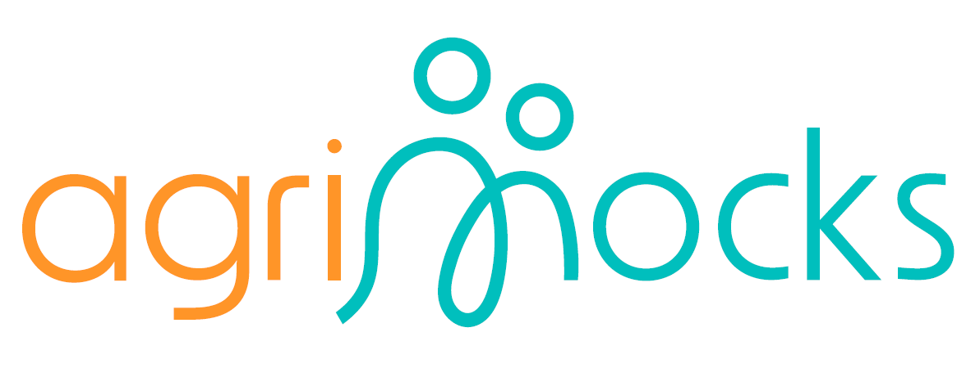

Friends of the Project (FoP): Concept and Roles

1. Introduction: What Are Friends of the Project?
The term “Friends of the Project” (FoP) refers to individuals or groups who support a project without being formally part of its consortium or partnership. These supporters—ranging from volunteers and donors to organizations and community leaders—align with the project's goals and contribute in meaningful ways to its success.
FoPs offer a wide range of support including expertise, time, resources, or moral encouragement. Their involvement strengthens project visibility, fosters collaboration, and helps extend impact beyond core stakeholders.

2. Why FoPs Matter to AGRI-MOCKS
The AGRI-MOCKS project aims to improve practical learning in agriculture, especially in regions like Africa where hands-on training opportunities are often limited for students and young people. FoPs can play a key role in addressing these gaps by:
- Supporting educational initiatives and outreach
- Strengthening links between academic institutions and youth organizations
- Facilitating cross-sector collaborations
- Raising public awareness around agricultural development
FoPs are especially valuable in building strategic bridges between education, research, community action, and policy-making.

3. How FoPs Contribute
FoPs can support AGRI-MOCKS in the following ways:
🔹 Capacity Building
- Collaborate with youth-focused organizations to integrate soft skills training into agricultural education.
- Enhance training programs through partnerships with institutions like ERASMUS Virtual Exchange.
🔹 Food Security
- Engage with organizations dedicated to food systems and support efforts to meet the nutritional needs of growing populations.
🔹 Climate-Smart Agriculture
- Help introduce sustainable farming practices that promote soil health, water conservation, and climate resilience.
🔹 Technology & Innovation
- Promote the adoption of agricultural technologies tailored to local contexts, particularly in African settings.
🔹 Networking & Visibility
- Use their platforms and connections to disseminate project results, share best practices, and broaden impact.

4. Summary: Key Characteristics of FoPs
- Not formal project partners, but trusted external collaborators
- Support via networks, knowledge, funding, and communication channels
- Include stakeholders such as:
  - Executive leaders
  - Policymakers
  - NGOs
  - Alumni
  - Farmers and end-users
  - Academic institutions
  - Media organizations
- Help expand the project's reach, amplify its message, and deepen its impact

5. Benefits of Being an AGRI-MOCKS Friend of the Project
By becoming a Friend of AGRI-MOCKS, supporters gain:
- An active role in shaping the future of agricultural education and rural development
- Early and exclusive access to project outcomes, materials, and opportunities
- Networking opportunities with a diverse and influential community of stakeholders
- Recognition for contributing to a project that fosters youth empowerment, climate action, and food security
Together, we are building resilient, knowledge-driven farming communities. Join us as a Friend of the Project and be part of that transformation.

6. Cooperation principles.
Their engagement is voluntary, that the FoP work is collaborative and that we expect teamwork and networking, that the FoP is a framework that characterizes an intersectoral approach, and that they should be open to each other, but also to other stakeholders and the public when it comes to the exchange of ideas and our project.


