The Maillard reaction

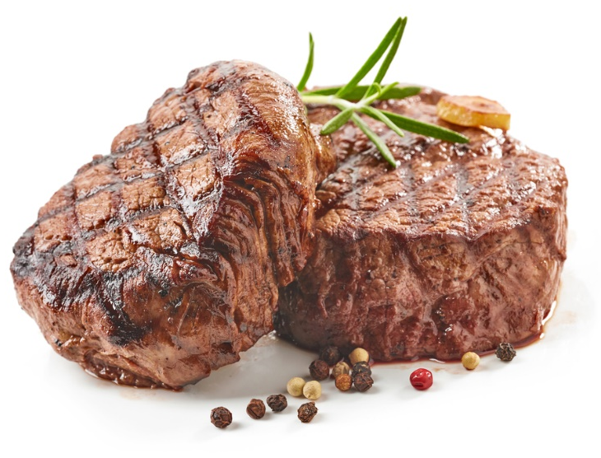
Learning
The aim of this session is to:
- demonstrate how the Maillard reaction can change the colour, smell and flavour of foods.

You will need:
- 1 thick sausage;
- frying pan;
- saucepan;
- 1 x 15ml spoon cooking oil;
- fish slice;
- slotted spoon;
- 2 white plates.

Instructions:
- Cut the sausage up into several rounds. Meanwhile, bring a pan of water to the boil and heat an oiled frying pan on the stove on a high heat.
- Add half the sausage slices to the boiling water. Then add the remaining slices to the hot frying pan.
- Cook both until the sausage slices in the frying pan are browned on all sides.
- Remove the sausage slices from the boiling water using a slotted spoon and place onto a white plate.
- Remove the other slices from the frying pan and place onto a separate white plate.
- Record the differences between the two. What do they look, smell and taste like?

Questions
Think about these questions after you have completed the experiment:
- Which meat smells more appealing?
- Which meat looks more appealing? Describe the differences in colour and texture.
- What chemical reactions have occurred to make the meat smell and taste the way it does?
- Name at least two other foods that also require the Maillard reaction to give them their browned characteristics.

