Gluten formation

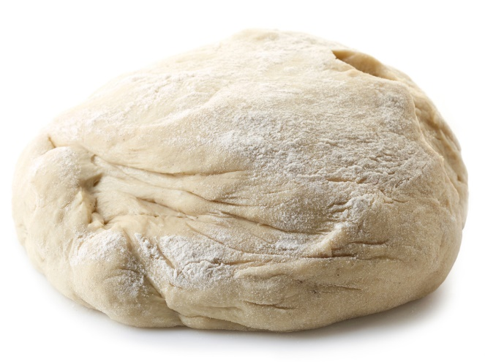
Learning
The aim of this session is to:
- demonstrate gluten formation;
- observe the amounts of gluten in different flours and explain uses.

You will need:
- 150g plain white flour;
- 150g strong white flour;
- 220ml warm water;
- 2 mixing bowls;
- baking sheet.

Instructions:
- Preheat the oven to 200oC or gas mark 6.
- Place the two different flours into separate mixing bowls.
- Add 110ml of water to each and mix until a dough is formed.
- Knead each dough for around 10 minutes. This will help to form the gluten strands.
- Place each ball of dough back in their separate mixing bowls and cover with water.
- Leave each ball of dough for 20 minutes. Then, knead the dough under the water to remove the starch.
- Drain away the ‘cloudy’ water and replace with fresh water.
- Continue to knead and replace the water until you are left with an elastic, sticky mass. This is the gluten.
- Place the gluten balls on a baking sheet and bake for 15-20 minutes.

Questions
Think about these questions after you have completed the experiment:
- Which flour produces a larger ball of gluten?
- Why might this be useful for this particular flour’s purpose?
- What would happen if the dough was not kneaded in step 3?
- Compare the baked gluten balls. Which flour produced the better result?
- Research the gluten-based food ‘seitan’. How is this food made? What could you add to this food in order to enhance its flavour?

