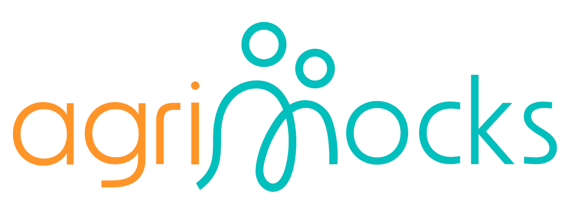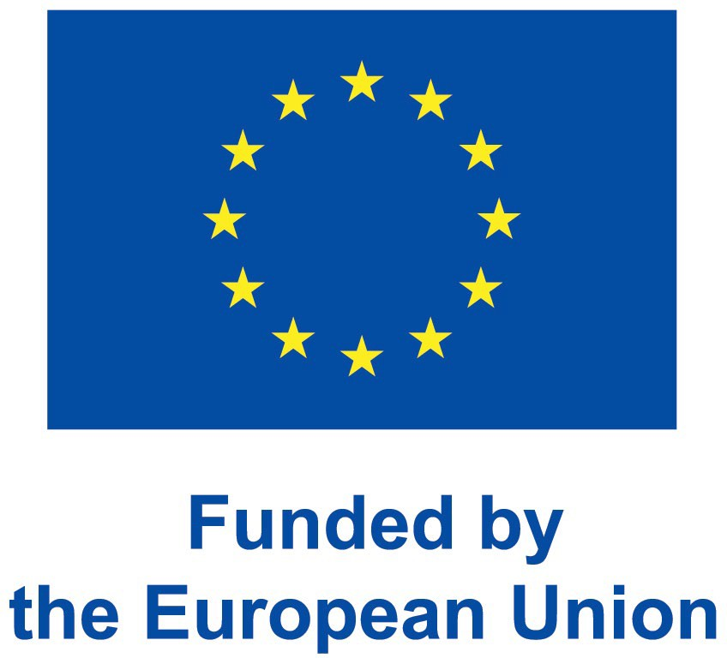
- Internship framework draft
Author: Anja Weber
October 2025

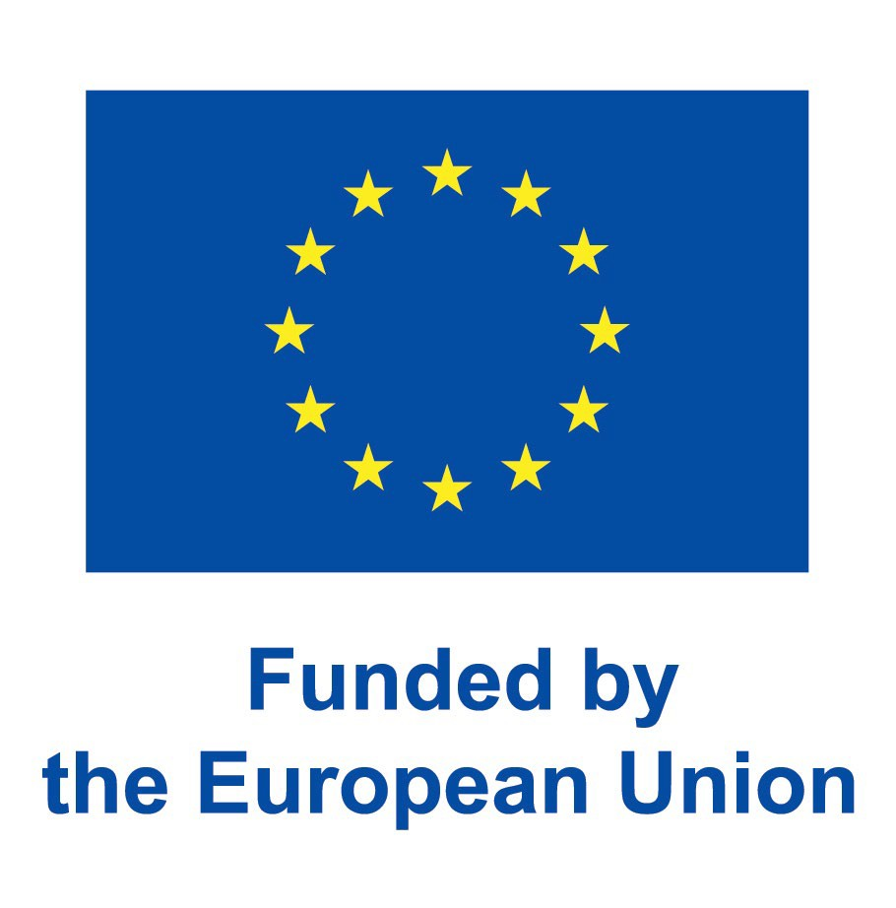

Table of contents
  - Programme Overview…………………..………..............slides 2 - 3
  - Learning Framework……………………………………………..slide 4
  - Competition & Community Projects………………………. slide 5
  - Course Outline…………………………………………………….slide 6
  - Roles & Responsibilities…………………………………….….slide 7
  - Learning Outcomes………………………………………………slide 8
  - Recognition & Certification…………………………………….slide 9
  - Required Resources…………………………………………...slide 10
  - Weekly Modules (Weeks 1–6)…………………..……slides 11 - 42
  - Awards & Next Steps…….…………………………………….slide 43
  - Weekly Flow Overview…………………………………………slide 44
  - List of needed Templates……………………………..........slide 45

Vision

To empower youth and students with hands-on entrepreneurial, civic, and innovation skills through a structured, virtual internship experience that connects learning with doing.

Duration
6 Weeks – combining self-paced MOOCs, live mentor sessions, and applied company play.







Core Components

Track 1 – Learning & Inputs
Participants engage in self-paced MOOCs complemented by mentor-led sessions focusing on key 21st-century competencies:
- MOOC Modules: business planning, entrepreneurship, project development, climate-resilient agriculture, sustainability & SDGs.
- Mentor Sessions: self-awareness, civic participation, innovation, intercultural teamwork, and career guidance.

Track 2 – Company Play (Applied Practice)
In parallel with the learning inputs, participants form “virtual companies” guided by mentors and real entrepreneurs. They assume functional roles (marketing, R&D, finance, HR, CSR, etc.) and work collaboratively on real-life challenges. Each week, company tasks are linked to the mentor sessions, e.g.:
  - After civic participation: design a CSR policy or initiative.
  - After business planning: create a mini business plan.

Capstone Component – Simulation Challenge & Competition
A 3-day intensive virtual company simulation (Week 6) powered by BizMetrics, where teams apply accumulated knowledge and experience to solve a complex, real-world business problem
Focus: decision-making, collaboration, innovation, and problem-solving under realistic conditions.




Learning Framework

For MOOC / Learning Inputs (=knowledge sessions & foundational tools)
Each module should include:
- Learning Objectives (3–4 bullet points, e.g. “Understand the Business Model Canvas”)
- Micro-Lectures or Readings (videos, PDFs, or links to open MOOCs)
- Interactive Task (short quiz, concept mapping, or a mini case study)
- Application Prompt (e.g. “Apply this model to your virtual company’s idea.”)
- Reflection Question (e.g. “What part of business planning did you find most challenging?”)

For Mentor-Led Sessions (= human connection and skill application)
Each session should include:
  - Topic & Purpose: Why this matters for employability or leadership.
  - Session Plan: (10 min introduction to topic & objectives; 25–30 min discussion or breakout activity; 15 min debrief & reflection
  - Integration Task: how it links to ‘Company Play.’ (e.g. After a session on innovation, teams brainstorm 2 ideas to improve their company product/service.)

For Company Play (= practice & virtual teamwork sessions)
For each week:
    - Define a real-world task related to the MOOC/mentor content.
    - Give teams clear roles and deliverables (e.g., report, pitch, infographic).
    - Provide a headline: clarity, creativity, teamwork, impact.
    - Encourage short team reflections (“What worked? What didn’t?”).


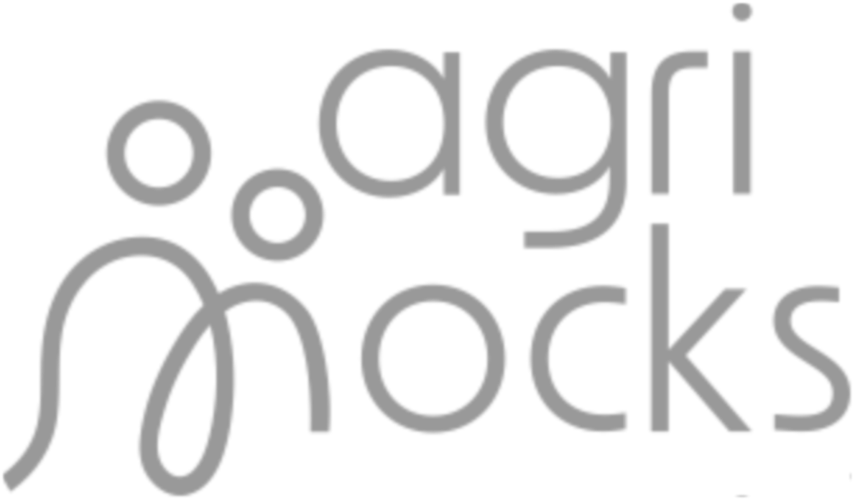

Competition & Community Projects

Parallel to the main programme (Weeks 4–6), participants develop community impact projects with a focus on climate and sustainability.
National projects compete across countries.



Proposed 6-Week Course Outline

Week | Theme | Key Activities
1. Foundations | Business Planning Basics & Team  Formation | Kick-off webinar; MOOC Module 1; mentor sessions on  self-awareness, intercultural skills, and career readiness; team setup and company onboarding.
2. Business & Innovation | Entrepreneurship in Rural Development | MOOC Module 2; mentor session on innovation and teamwork; company strategy drafting.
3. Civic Participation | Sustainability & SDGs | MOOC Module 3; mentor session on civic leadership; teams design CSR initiative.
4. Project Development | Project Design & Funding | MOOC Module 4; electives; mentor session on innovation and career planning; apply project design to company service/product.
5. Integration & Preparation | Simulation Readiness | Mentor session on simulation prep; community project  development; company outputs finalized and presented to entrepreneurs.
6. Simulation &  Competitions | Company Simulation  & Showcase | 3-day BizMetrics simulation; community project  competition; reflection webinar and evaluation.



Roles & Responsibilities

Participants:
engagement, attendance, teamwork, and deliverables.

Mentors:
guide reflection, connect learning to real-world skills.

Entrepreneurs:
provide company problem/case, give feedback.

Programme Coordinators:
facilitate communication, organize webinars, handle tech support.


Learning Outcomes

By the end of the programme, participants will be able to:

- Understand company structures, functions, and decision-making processes.
- Demonstrate teamwork, communication, and intercultural collaboration skills.
- Apply entrepreneurship and sustainability principles to real-world challenges.
- Develop and pitch community impact projects.
- Reflect on personal growth and career aspirations.



Recognition & Certification

Participants receive:
Digital certificates and badges acknowledging skills and achievements. Requirement: successful completion of all modules and participation in simulation.

Peer, mentor, and entrepreneur feedback
for growth and networking.

Optional academic credit (ECTS-aligned)
for eligible institutions


Required resources

For virtual delivery needed:

Learning platform MOOC (4 modules)
  - Business Planning Basics
  - Entrepreneurship in Rural Development
  - Sustainability & the SDGs
  - Project Design & Funding

Mentors & Entrepreneurs
Meeting platform for Company Play Competition set up


Kick off the internship journey by forming your virtual company, understanding business fundamentals, and developing self-awareness as a future professional.

Reflection Prompt:
“What kind of problem would you like your company to solve? Why does it matter to you or your community?”

Key Takeaway
“A strong company begins with self-awareness and a clear shared vision.
This week lays the foundation for everything you will build in the weeks ahead.”


Week 1
Foundations: Building Your Virtual Company

Learning Objectives

By the end of Week 1, you will be able to:
- Navigate the virtual co-working space and online communication tools effectively.
- Reflect on your strengths, values, and intercultural teamwork style.
- Collaborate with peers to form a virtual company, define roles, and understand how teams function.
- Explain the basic components of a business model (using the Business Model Canvas).

Self-Awareness & Intercultural Teamwork

Session Duration: 90 minutes (live or synchronous)
Purpose: To help participants discover their personal strengths, working styles, and how to collaborate across cultures.

Session Outline:
- Welcome & Icebreaker to build rapport (10 min) (e.g. “Two Truths & One Dream” game
- Introduction to the program and its structure (10 min plus time for questions)
- Group Activity (30 min) (e.g. Treasure hunt activity to identify strengths, or in breakout groups, share one personal strength and how it might contribute to a team project.)
- Mini-Lecture (10 min) (e.g. on Self-awareness, how to write a self introduction for a CV or application letter.)
- Link to company play: identify potential roles in your company (e.g., project lead, communications, finance; participants do an online personality test). (20 min)
- Debrief & Reflection (10 min) (e.g. Journaling task for each week: “What did I learn about myself as a team member? How can I contribute to our company’s success?”)

Materials: Slides, reflection worksheet, personality quiz link (e.g., 16 Personalities). Joining instructions for the MOOC to be sent out beforehand!
Activities – Mentor-lead Session

1

MOOC Module 1:
Business Planning Basics / Business Model Canvas
Focus: Understanding how businesses create, deliver, and capture value.
Estimated Time: 4–5 hours (self-paced)

Key Topics:
- What is a business model?
- The Business Model Canvas: 9 building blocks
- Examples from real startups and youth enterprises

Suggested Activities:
- Micro-Lectures or Readings (e.g. Watch introductory video on Business Model Canvas; Read “How to Turn an Idea into a Business Model” or a mini case study; PDF or online article).
- Interactive Task (e.g. short quiz self-check on business model basics)
- Application (e.g. “Draft your first company idea and fill in the ‘Value Proposition’ and ‘Customer Segments’ boxes on your Canvas template.”)
- Reflection Question (e.g. “What kind of problem would you like your company to solve? Why does it matter to you or your community?”

1
Activities - MOOC

Team Formation & Company Setup:

Start building your virtual company
— a creative learning lab for the next five weeks
4 Synchronous Sessions of 30 min each with mentor and entrepreneur

Activities:
  - Meet your assigned mentor and entrepreneur and learn about their company or challenge area.
  - Company Set-up (Choose a company name and define your company’s mission)
  - Role Assignments (learn about the different roles in a company and select a position suitable to your personality and preferences, building on personal strengths identified in the mentor session. Write an application letter for this position. Conduct short “mock interviews” for fun and learning.)

Deliverable:
Company name, mission and structure in place.

Materials:
Deck of individual Job Descriptions (1 paragraph each), Application letter template, Job Interview template

1
Activities – Company Play

Deepen your understanding of how innovative business models drive inclusive development, and apply that knowledge to shape your company’s first strategic plan.

Reflection Prompt:
“What local or community problem could your company address through innovation?”

Key Takeaway
“Innovation turns vision into momentum. This week, your company begins to move from concept to strategy — transforming ideas into structured action.”

Week 2
Business & Innovation: Turning Ideas into Strategy

Learning Objectives

By the end of Week 2, participants will be able to:
- Explain how entrepreneurship contributes to community and rural development.
- Identify types of innovation (product, process, social, and environmental).
- Translate learning into a first strategic plan for their virtual company.
- Strengthen collaboration and creative problem-solving skills within a team.

Innovation & Global Teamwork

Session Duration: 90 minutes (live or synchronous)
Purpose: Explore creative thinking tools and practice teamwork in developing an innovation mindset

Session Outline:
- Welcome & Icebreaker (10 min) (e.g. “Innovation sparks” game: each participant names one everyday object or situation that needs improvement.
- Mini-Input (10 min) (e.g. The Innovation Cycle: Inspiration → Ideation → Implementation; animated
video)
- Group Activity (30 min) (e.g. In breakout rooms brainstorm one innovative feature that could improve the entrepreneur’s company. Roughly map the company and improvement so on a Canvas).
- Debrief (20 min) (e.g. Share top ideas; discuss how innovation connects to sustainability and SDGs.)
- Integration Task (20 min) (e.g. Begin drafting your company’s First Strategic Plan outlining key goals and innovative elements.)
Materials: Slides, Innovation cycle video, Business Canvas template.

2
Activities – Mentor-lead Session

From Vision to Strategy
4 Synchronous Sessions of 30 min each with mentor and entrepreneur

Activities:
  - Strategic Brainstorm, Review your Business Model Canvas draft from the mentor-led session and align it with the entrepreneur’s problem solving needs.
  - Identify the goal you want to achieve during the program. Mentor Tip: Encourage evidence-based decisions – what need or opportunity backs each idea?
  - Functional Planning: Each team division (Marketing, Finance, Operations, R&D, Sustainability, etc.) defines 1–2 SMART objectives linked to the goal.
  - Mentor/Entrepreneur Feedback Session: The team presents its first draft strategy to the entrepreneur and receives feedback for revision if necessary

Deliverables:
2-page Company Strategy Brief (vision, goals, innovation plan, roles summary) and updated Business Model Canvas reflecting new strategic ideas in place.

Materials:
  - Slides on SMART objectives, 5-Finger Feedback templates, Strategy Brief template
Activities – Company Play

2

MOOC Module 2:
Entrepreneurship in Rural Development

Focus: How innovation and entrepreneurship address local challenges.
Estimated Time: 4–5 hours (self-paced)

Key Topics:
  - What makes an enterprise “innovative”?
  - Rural entrepreneurship and local value chains.
  - Sustainable business models for inclusive growth.
  - Innovation case studies from Africa and beyond.

Suggested Activities:
- Micro-Lectures or Readings (e.g. Watch YouTube Video on a topic like ‘Innovation for Local Impact’; Read online article about turning challenges into success, or a mini case study on ‘Grassroots Entrepreneurship’, PDF).
- Interactive Task (e.g short quiz self-check on entrepreneurship types and rural value chains.)
- Application (e.g. “List three ways your virtual company could innovate”)
- Reflection Question (e.g. Journaling task: “How did our team turn ideas into a plan this week?”; “What innovation are we most excited about developing further?”)
Activities - MOOC

2

Understand how responsible business practices and civic engagement strengthen communities — and design your company’s first CSR or advocacy initiative.

Reflection Prompt:
“Which SDG feels most relevant to your company’s purpose, and why?”

Key Takeaway
“Sustainable businesses are civic actors. This week, you learn that every enterprise can be a force for good — when innovation meets responsibility.”

Week 3
Civic Participation: Business for Impact

Learning Objectives

By the end of Week 3, participants will be able to:
- Explain the connection between business, sustainability, and SDGs.
- Identify ways companies can contribute to positive social and environmental change.
- Collaborate with teammates to design a CSR policy or initiative for their virtual company.
- Reflect on civic leadership and personal responsibility in driving impact.

MOOC Module 3: Sustainability & the SDGs

Focus: Linking entrepreneurship with sustainable development and civic participation.
Estimated Time: 4–5 hours (self-paced)

Key Topics:
  - The 17 Sustainable Development Goals: why they matter for business.
  - Corporate Social Responsibility (CSR) vs. social entrepreneurship.
  - Measuring impact: how to know your company is helping, not harming.
  - Youth and civic leadership for sustainable communities

Suggested Activities:
- Micro-Lectures or Readings (e.g. Watch a video on ‘Triple Bottom line’; Read “Business for People and Planet” or a mini case study of an African Entrepreneur; PDF or online article).
- Interactive Task (e.g short quiz self-check 5 questions on sustainability and social impact.
- Application (e.g. “Choose one SDG your company could align with. Describe how your company’s mission supports that goal.”)
- Reflection Question (e.g. Journaling task: “Which SDG feels most relevant to your company’s purpose, and why?”)
Activities - MOOC

3

Civic Participation & Leadership

Session Duration: 90 minutes (live or synchronous)
Purpose: To inspire participants to think of themselves as active changemakers and to understand leadership through civic action.

Session Outline:
- Welcome & Kick-off (10 min) (e.g. Quick poll: “What’s one social or environmental issue you care about?”)
- Mini-Input (15 min) (e.g. on “Civic participation in the digital age”; “How young people influence change”; “Examples of youth-led advocacy initiatives”; Youtube video or case study).
- Group Activity (30 min) (e.g. Teams discuss in breakout rooms one SDG or issue relevant to their company or brainstorm a CSR idea that aligns with their business).
- Debrief (20 min) (e.g. Teams present their top idea and receive feedback on feasibility, social value, connection to company mission, etc.)
- Reflection (15 min) (e.g. Participants share on “What kind of leader do I want to be in my company and community?”
Materials: SDG icons set, CSR Idea Template, leadership reflection sheet.
Activities – Mentor-lead Session

3

Designing a CSR Initiative
4 Synchronous Sessions of 30 min each with mentor and entrepreneur

Activities:
  - SDG Alignment: Choose one or two SDGs most relevant to the entrepreneur’s purpose.
  - Discuss “How can our company create value beyond profit? What kind of impact do I want my work to have on society?”
  - Define measurable goals (e.g., awareness raised, people reached, resources saved).
  - CSR/Advocacy Design: Develop a short plan for an initiative your company could run or support.
  - Include objectives, target audience, activities, and expected impact.
  - Presentation to Entrepreneur: Present your initiative in 5 slides. Get feedback on realism and potential value to the company.

Deliverables:
1-page CSR Brief, Presentation Deck (5 slides).
Mentor Tip: Emphasize shared responsibility — how every company role (finance, marketing, operations, etc.) contributes to sustainability.

3
Activities – Company Play

Learn how to design and fund impactful projects, while applying these principles to both your virtual company and your community project idea.

Reflection Prompt:
“What makes a project realistic and fundable — and how can our team ensure we’re solving the right problem?”

Key Takeaway
“Ideas only have power when structured into action. This week, you learn how to design projects that are clear, fundable, and ready to make an impact.”

Week 4
Project Development: From Ideas to Action

Learning Objectives

By the end of Week 4, participants will be able to:
- Outline the key stages of project design (needs assessment, planning, budgeting, and implementation).
- Identify funding sources and proposal writing techniques for small projects.
- Apply project management tools to their company’s next phase of development.
- Begin developing a community impact project aligned with climate resilience or sustainability themes.

MOOC Module 4:
Project Design & Funding

Focus: How to move from concept to implementation — designing fundable, sustainable projects.
Estimated Time: 5-6 hours (self-paced)

Key Topics:
- Introduction to project management tools (Logframe, Theory of Change, SMART objectives).
- Basics of proposal writing and budgeting.
- Funding strategies: grants, partnerships, and social investment.
- Monitoring and evaluation for accountability.

Suggested Activities:
- Micro-Lectures or Readings (e.g. Watch a video on ‘Project design’; Read a short guide on “How to Write a Winning Proposal”; PDF or online article).
- Interactive Task (e.g short quiz self-check on project cycle and budgeting).
- Application (e.g. “Draft a mini-project plan related to your company or community.”)
- Reflection Question (e.g. “What makes a project realistic and fundable — and how can our team ensure we’re solving the right problem?”)

4
Activities - MOOC

Career Guidance & Innovation in Practice

Session Duration: 90 minutes (live or synchronous)
Purpose: To connect project design principles to real career pathways and help participants understand how innovation and structured planning support employability.

Session Outline:
- Welcome & Kick-off (10 min) (e.g. Discussion: “Why employers value project management skills
- Mini-Input (15 min) (e.g. on the link between innovation and project development in modern careers; case studies/YouTube video: youth-led start-ups that turned ideas into funded projects.)
- Group Activity (40 min) (e.g. Use a Project Design Canvas to structure your company or community project idea. Identify stakeholders, objectives, and key resources.)
- Debrief (20 min) (e.g. Mentors and entrepreneur provide targeted feedback.)
- Reflection (15 min) (e.g. Journaling task: “How can I apply what I learned this week to my future career?”)
Materials: Project Design Canvas template, scase studies or video links, short career pathway slides

4
Activities – Mentor-lead Session

Project Application & Development
4 Synchronous Sessions of 30 min each with mentor and entrepreneur

Activities:
  - Apply the project design steps: define goal, outputs, outcomes, and needed resources to the innovation idea for your company (the entrepreneur’s problem solving idea).
  - Funding Simulation: Draft a 1-page mock “funding proposal” or pitch for your company project.
  - Mentor/Entrepreneur Review: Present your draft proposal for critique and refinement.

Deliverables:
Project Plan (2 pages), Mock Funding Pitch (2–3 slides).

Mentor Tip: Encourage creativity but realism — projects should be achievable and clearly connected to company goals.

4
Activities – Company Play

MOOC Module 4:
Project Design & Funding

Focus: How to move from concept to implementation — designing fundable, sustainable projects.
Estimated Time: 5–6 hours (self-paced)

Key Topics:
  - Introduction to project management tools (e.g. Logframe, Theory of Change, SMART objectives).
  - Basics of proposal writing and budgeting.
  - Funding strategies: grants, partnerships, and social investment.
  - Monitoring and evaluation for accountability.

Suggested Activities:
- Micro-Lectures or Readings (e.g. Watch a video on ‘Project design’; Read a short guide on ‘How to write a winning proposal’; PDF or online article).
- Interactive Task (e.g short quiz self-check on on project cycle and budgeting
- Application (e.g. “Draft a mini-project plan related to your company or community.”)
- Reflection Question (e.g. ““What makes a project realistic and fundable — and how can our team ensure we’re solving the right problem?”)

4
Activities - Community Project Development

Begin developing your independent Community Project
— applying your internship learning to a real-world challenge
& practice civic innovation while applying business and sustainability lessons.

Activities:
Define your idea and draft an initial project concept using the Design Thinking sequence:
- Identify community challenge (preferably linked to climate, environment, or youth empowerment).
- Ideate & design
- Plan implementation (small-scale, realistic)
- Present proposal

Deliverables:
Draft Community Project Concept (1 page). Initial stakeholder list and problem statement.

Reflection:
Journaling task: “What did I learn about turning an idea into a plan? What project am I most proud to be designing, and why does it matter to me?”

4
Activities - Community Project Development

Integrate learning from previous weeks, refine deliverables, and prepare for the 3-day simulation and community project competitions.

Reflection Prompt:
“How ready do I feel for the simulation? What personal skill or mindset shift am I most proud of this week?”

Key Takeaway
“This is your moment to connect all the dots — strategy, innovation, teamwork, and impact. Preparation is the bridge between learning and doing.”

Week 5
Integration & Preparation: Ready for the Real World

Learning Objectives

By the end of Week 5, participants will be able to:
- Integrate learning from business, innovation, and sustainability into a coherent strategy.
- Finalize company outputs in collaboration with mentors and entrepreneurs.
- Strengthen teamwork, communication, and presentation skills.
- Prepare community project proposals for competition and peer review.
- Build confidence for the final simulation challenge.

Simulation Preparation & Team Synergy
Session Duration: 90 minutes (live or synchronous)
Purpose: To help teams synthesize learning, review company deliverables, and build readiness for the simulation environment.

Session Outline:
- Welcome & Kick-off (10 min) (e.g. Recap program journey so far. Discuss what teams found most challenging or rewarding.)
- Mini-Input (15 min) (e.g. What to expect during the simulation: roles, time pressure, decision- making, and teamwork dynamics.)
- Group Activity (30 min) (e.g. Teams conduct a “simulation rehearsal”: one short scenario provided by the entrepreneur, where they must make a business decision in 15 minutes and defend it.)
- Debrief (20 min) (e.g. Mentors and entrepreneurs provide feedback on communication and leadership behaviour in the teams.)
- Reflection (15 min) (e.g. “How have I grown since Week 1, and how will I show it in the simulation?”, “What did this journey teach me about leadership, innovation, and collaboration?” ; “How has my understanding of work and my role in society changed?”. Encoutrage online submissions for presentation og highlights during te closing ceremony.)
Materials: Simulation brief, rehearsal scenario sheet, reflection template
Activities – Mentor-lead Session

5

Final Outputs & Entrepreneur Feedback
4 Synchronous Sessions of 30 min each with mentor and entrepreneur

Activities:
  - Portfolio Compilation: Assemble all deliverables: business plan, strategy brief, CSR initiative, and project proposal. Ensure coherence and clear roles/responsibilities.
  - Teams prepare a 10-minute “company progress presentation” for their entrepreneur. Include key learnings, product/service summary, and innovation highlights.
  - Feedback Session: Entrepreneur provides critique and shares his/her own learnings.

Deliverables:
  - Final Company Portfolio (PDF or Slide Deck).
  - Feedback Summary Sheet (1 page).
Reflection: Journaling task: “How ready do I feel for the simulation? What personal skill or mindset shift am I most proud of this week?”

Mentor Tip: Encourage concise, visually engaging presentations — show outcomes, not just activities.

5
Activities – Company Play

Prepare for Competition – Refinement and Pitch Preparation

Move community projects from draft to polished proposals ready for competition.
Activities
- Peer Review: Teams exchange project concepts and give feedback using a checklist (relevance, feasibility, innovation, SDG link).
- Mentor Consultation: Mentors guide teams on project logic, budgeting, and presentation flow.Pitch Development: Prepare a 3-minute video or slide deck summarizing problem, solution, and impact.

Deliverables:
Final Project Proposal (2–3 pages). Pitch Deck or Video Presentation.

Mentor Tip:
Keep messages simple and impact-driven: “What problem do we solve, how, and why does it matter?”

5
Activities - Community Project Development

Apply all accumulated knowledge, teamwork, and creativity to solve a simulation challenge — and celebrate your journey through competition and reflection

Reflection Prompt:
“What did this journey teach me about leadership, innovation, and collaboration? How has my understanding of work — and my role in society — changed?”

Key Takeaway
“You’ve experienced how real companies think, decide, and act. The simulation is not the end, but the beginning for your career, impact, and continued growth.”

Week 6
Simulation & Competitions: The Culminating Challenge

Learning Objectives

By the end of Week 6, participants will be able to:
- Apply business, innovation, and sustainability principles in a simulated company environment.
- Demonstrate leadership, collaboration, and problem-solving under real-world pressure.
- Present and defend solutions to entrepreneurs and mentors.
- Showcase community projects in national and international competitions.
- Reflect on their professional growth and future career goals.

3-Day Simulation
Platform: BizMetrics (Virtual Company Simulation Environment)
Purpose: Experience real-time effects of decision-making on company reul´ts

Day 1 – Briefing & Team Setup
Receive the entrepreneur’s challenge scenario and introductions.
Define priorities and assign simulation roles (CEO, CFO, HR lead, Marketing lead, etc.). Set initial strategy and company goals.

Day 2 – Decision Sprints
Teams complete multiple timed “business sprints”: making strategic, financial, and operational decisions in response to live updates from the simulation engine.
Mentors act as facilitators.

Day 3 – Final Presentation & Evaluation
Teams prepare a 10-minute presentation summarizing their analysis, decisions, outcomes, and lessons learned.
Evaluation by a panel of mentors and entrepreneurs.

6
Activities - Simulation

Community Project Competitions

Purpose: Showcase and celebrate youth-led innovations with community impact. Structure
At the end of week 6 each country cohort makes a 15 min presentation to a panel of mentors and international partners.

Deliverables
- Final Pitch Deck or Video (3 minutes max)
- Summary Sheet (problem, solution, beneficiaries, expected outcomes)

Judging Criteria
- Relevance to SDGs or local needs
- Creativity, problem solving & originality
- Innovation and feasibility (e.g. supported by data, realistic, etc.)
- Potential for measurable impact & sustainability
- Team collaboration and presentation quality (clarity, structure, visual appeal, time lkeeping)

6
Activities - Community Project Competition

Closing Session:
Reflection & Celebration
Duration: 90 minutes (live webinar)
Purpose: Consolidate the experience, celebrate achievements, and plan next steps.

Session Outline
- Opening (10 min) – Welcome and celebration highlights (from last week’s reflection).
- Group Sharing (25 min) – Participants share key takeaways or memorable moments
- Guided Reflection (20 min) (e.g. “What skills improved the most?”; “How can I apply this experience in my studies or career?”).
- Career Connection (15 min) – Mentors or entrepreneur link experiences to employability and civic leadership pathways.
- Closing (20 min) – Recognition ceremony: certificates, badges, and special mentions.
- Share link to final evaluation of the program. Filling the form releases certificates.
Materials: Reflection worksheet, evaluation form, celebration slides/video, certificates & badges.
Activities – Mentor-lead Session

6

Closing Message
“You are now part of a new generation of innovators — ready to think critically, act collaboratively, and build sustainable solutions for your communities and beyond.”

Excellence Awards for:
  - Top Performing Company (based on simulation results)
  - Best Community Project (innovation + impact)
  - Team Spirit Award (collaboration + positivity)

Post-Programme Opportunities:
  - Alumni network access
  - Mentorship matching
  - Internship or incubation referrals (where available)


Awards & Next Steps


Weekly Flow Overview

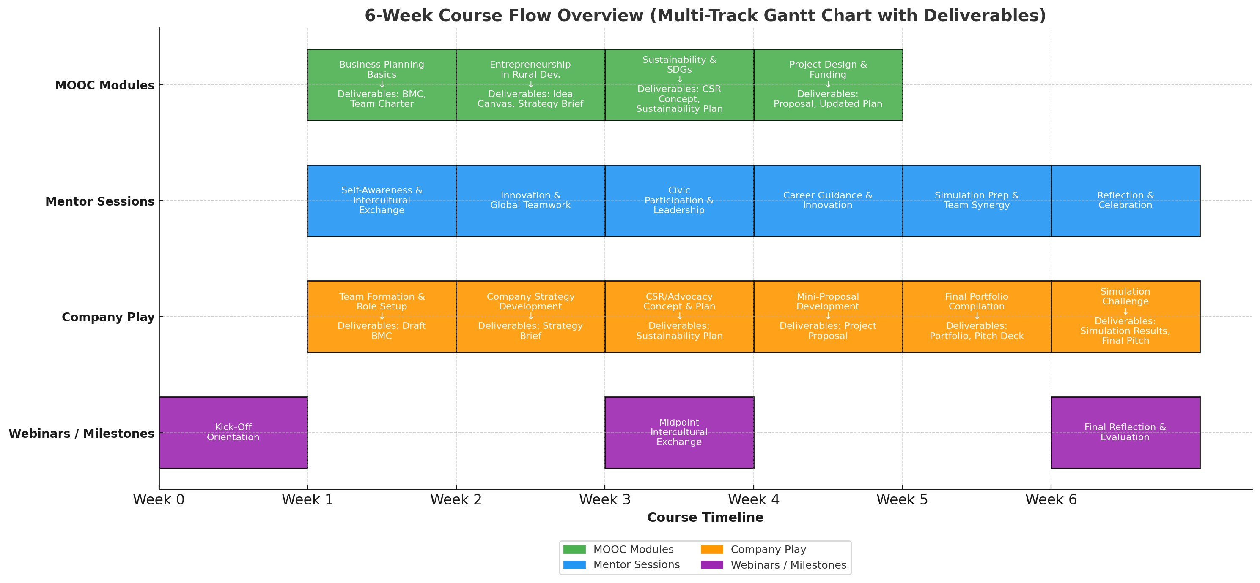

List of needed Templates
- Reflection Worksheets / Journal
- Joining instructions for MOOC
- Deck of individual Job Descriptions
- CV & Application Letter Templates
- Job Interview Template
- Business Model Canvas
- Idea Canvas
- SDG icons set
- Strategy Brief Template
- CSR Plan Template
- Project Proposal Guide & Project Design Canvas Template
- Pitch Deck Template
- Mentor Feedback Sheets or 5-Finger Feedback Template
- Awards, Badges & Certificates
- Evaluation Form

