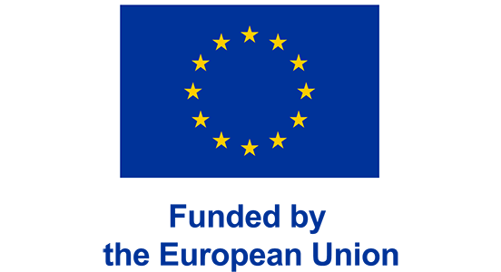

AgriMocks Project Social Media Administration Manual

Agri Mocks Social Media Administration Manual for Facebook, TikTok, Telegram, WhatsApp, and LinkedIn
This manual is designed to support the project's communication and engagement goals across platforms while keeping it professional, inclusive, youth-focused, and aligned with the values of Erasmus virtual exchange and intercultural collaboration.
- Project: AGRI MOCKS – Erasmus Virtual Exchange
- Audience: Higher Education Students, Youth Workers, NGOs, GOs and Agricultural Stakeholders.
- Regions: Europe & Sub-Saharan Africa
GENERAL PRINCIPLES & TEAM ROLES
1. Purpose of social media
The AGRI MOCKS project leverages social media to:
- Promote intercultural dialogue between youth in Africa and Europe.
- Communicate and Disseminate updates about e-internships, webinars, and learning modules.
- Share success stories, competitions, and digital innovations in agriculture.
- Amplify youth voices and build community engagement around green and digital transitions.
2. Brand Guidelines
- Visuals: Prioritize high-quality images of youth, agriculture tech, webinars, and events. Include EU Logo and logos of Erasmus+ and consortium partners and Disclaimer.
- Tone: Empowering, informative, inclusive, professional.
- Hashtags to use: #AGRIMOCKS, #TwinTransition, #AgriYouth, #VirtualExchange, #GreenSkills
3. Social Media Roles for Partners internal Prepose.
Role | Responsibility
Platform Moderator (Content Creator) | Develop posts, videos, graphics in a regular base.
Platform Moderator | Respond to comments/messages, remove inappropriate content
Scheduler/Publisher | Plan and publish content using different tools.
Analytics Reporter | Track engagement, reach, follower growth (monthly reports).
Platform Moderator | Foster interaction, tag partners, encourage sharing.
Each participating institution must assign at least one admin to manage and cross-verify social media activity weekly.

PLATFORM-SPECIFIC GUIDELINES
1, Facebook
- Use: Updates, events, youth stories, photos, competitions.
- Post Frequency: 1–2 times per two week.
- Best Practices:
  - Create Facebook Events for all public webinars and e-internship launches.
  - Encourage student/youth testimonials (video or text).
  - Use tagging (partner, partner universities, Erasmus+) and geo-targeting.
2, TikTok
- Use: Short, dynamic videos featuring Agri project, student stories, “day in the life,” simulation recaps. Partners and Project Beneficiaries
- Post Frequency: 1–2 times per month.
- Best Practices:
  - 15–60 second videos; use trending sounds + captions.
  - Showcase intercultural experiences and green/digital innovation.
  - Add #AGRIMOCKS and #AgriTok to reach youth discovery feeds.
3, Telegram
- Use: Central info hub for participants and alumni (via channel and groups) mainly for specific countries which dominantly use the platform like Ethiopia.
- Structure:
  - Main Channel for announcements and official updates.
  - Discussion Groups by cohort or country for peer engagement.
- Moderation Rules:
  - No spam, hate speech, political content.
  - Weekly pinned posts for important links/events.
4, WhatsApp
- Use: Cohort-based communication, quick updates, mentoring support.
- Setup:
  - One official broadcast list for each activity (e.g., e-Internship).
  - Group chats for moderated discussions and task coordination.
- Admin Tips:
  - Use emojis for clarity, send reminders 24h before events.
  - Avoid sending documents over 5MB; link to cloud storage instead.
5, LinkedIn
- Use: Highlight professional outcomes, academic partnerships, virtual internship achievements.
- Post Frequency: 1–2 per week.
- Best Practices:
  - Feature participants’ project results, awards, micro-credentials.
  - Share research outputs, policy reflections, partner spotlights.
  - Encourage tagging of institutions and youth contributors.
SECURITY, MONITORING & REPORTING
1. Partners Responsibility
- Each partner is required to share a brief description along with high-quality photos and videos of every activity conducted on AgriMock Project, for UFS and EDI.
2. Content Approval
- When a call is announced, all partners should share it within their networks. UFS and EDI will be responsible for posting it on the official AGRI MOCKS project social media platforms.
- Sensitive content (gender, identity, data) must follow GDPR (General Data Protection Regulation) and Erasmus+ ethical standards.
3. Monitoring & Response Time
- Response time to user requests: within 24 hours.
- Flag or report posts with harassment, misinformation, or cultural insensitivity.
4. Access & Security
- Use official institutional emails to register accounts.
- Enable two-factor authentication.
- Keep a shared password log (secure cloud drive, e.g., OneDrive or Google Workspace).
- Revoke access for inactive admins within 30 days of role change.
5. Reporting Timeline
- Social media metrics are reported to the project coordinator.
- Quarterly review meetings to optimize strategy and share cross-country insights.

