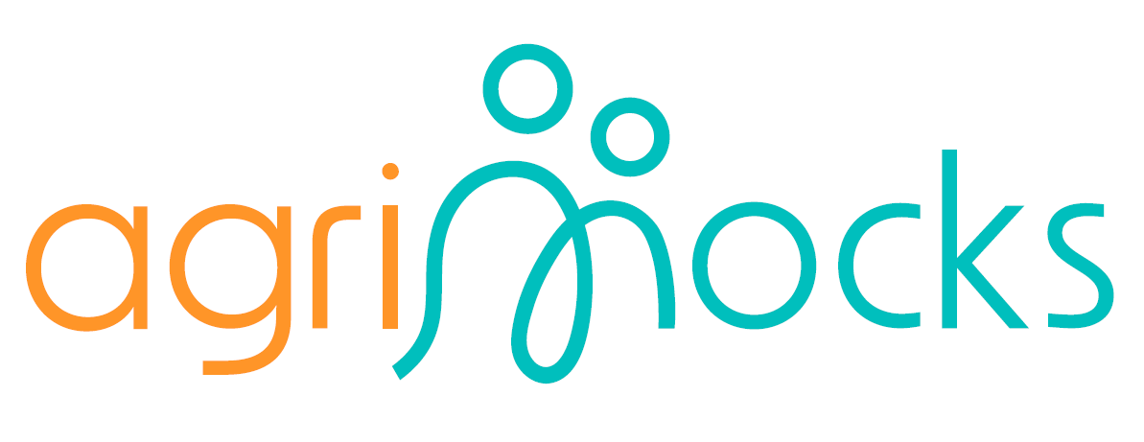

Framework Draft – E-Internship Programme
- Duration: 6 weeks
- Methodology:
  - Track 1 (Learning & Inputs): self-paced MOOC + mentor-led sessions (career, intercultural, civic, innovation). How do we assign and train mentors? We need to consider the mentors' digital literacy, educational background, and field of study.
  - Track 2 (Company Play): students/youth form “virtual companies,” guided by mentors and entrepreneurs, working on real-life tasks. must be delivered by someone with the experience with simulation program like Capsim
- Final Simulation: 3-day intensive “company capstone” where teams solve a complex challenge from an African entrepreneur.
- Outcome: participants understand how companies work, what roles exist, how decisions are made, and practice collaboration in a real-world inspired context.

A. Curriculum
- MOOC Modules: can we include Entrepreneurial Mindset, design thinking or design your venture ( business, prototype, product development) content to this module ( Business planning, entrepreneurship ( Behavioral aspect of entrepreneurship), project development, climate-resilient agriculture, sustainability & SDGs. : must be based on the context of the country ( Context based)
- Mentor-led sessions: self-awareness, civic participation, innovation, intercultural teamwork, career guidance.
- Company Play (parallel to inputs): role-play as “employees” in a virtual company environment. Each input session feeds into company practice.

B. Company Play

Runs throughout Weeks 2–5 in parallel with mentor sessions. (session that needs to completed in parallel with the company-play must be identified and structured)
- Structure:
  - Entrepreneur provides company setting & real-life problem(s).
  - Participants split into functional teams (marketing, R&D, finance, HR, operations, sustainability, advocacy, etc.):
  - Weekly tasks linked to mentor sessions:
    - Example: after a session on civic participation, company teams design a CSR/advocacy initiative.
    - After business planning input, teams draft a mini-business plan.
- Output: evolving portfolio of company deliverables that feed into final simulation.

C. Simulation Component (Capstone)
- 3-Day Intensive Company Simulation at the end of Week 6. ( how many hour per day?)
- Teams apply knowledge (from MOOCs) and experience (from company play) in a virtual company simulation provided by BizMetrics.
D. Competition
- Community Projects: developed in parallel (Weeks 4–6).
- Competitions:
  - National level: showcase best local projects.
  - International level: top projects compete across countries.

E. Recognition
- Digital certificates & badges.
- Peer and mentor and entrepreneur feedback.
- Optional academic credit (ECTS alignment). It doesn’t work in EDI context

F. Virtual Space & Webinars
- Virtual Co-working Platform:
  - Virtual company mode for student internship.
  - Virtual office mode for youth internship.
- Webinars: kick-off debate, midpoint intercultural exchange, final evaluation/reflection.

Proposed Course Outline (6 Weeks)

Week 1 – Foundations
- Kick-off webinar & debate.
- Introduction to MOOC module 1: Business Planning Basics (Business Model Canvas): This topic is suitable for individuals who already have a concept in mind. However, if they do not, the modules should be designed to help them generate a business idea. (Idea generation in Agriculture sectors)
- Mentor sessions: e.g. self-awareness, how to apply for a job, intercultural exchange. (The topic should align with the themes mentioned above)
- ( Company Play: team setup, role assignments (e.g. job descriptions, job interviews, introduction to entrepreneur & company case.

Week 2 – Business & Innovation
- Introduction to MOOC module 2: Entrepreneurship in Rural Development. ( content of the modules should be identified)
- Mentor session: innovation & global teamwork. ( The topics should must align Entrepreneurship in Rural Development.)
- Company Play: draft first company strategy (linked to MOOC learning).

Week 3 – Civic Participation & Advocacy
- Introduction to MOOC module 3: Sustainability & SDGs.
- Mentor session: civic participation & leadership.
- Company Play: teams design advocacy or CSR initiative.

Week 4 – Project Development & Electives
- MOOC module 4: Project Design & Funding.
- Electives (0.5 week, self-paced).
- Mentor session: career guidance & innovation.
- Company Play: apply funding/project design principles to company product or service.

Week 5 – Integration & Preparation
- Mentor session: simulation preparation.
- Community project development (climate focus).
- Company Play: finalise company outputs, present progress to entrepreneur for feedback.

Week 6 – Simulation & Competitions
- 3-Day Intensive Company Simulation: apply learnings to solve entrepreneur’s real problem.
- Community project competitions (national → international).
- Final reflection webinar & evaluation.
The virtual company provides a weekly structured experience in form of a continuous/progressive learning lab and acts as a scaffolded practice environment, where inputs feed directly into practice and the final simulation is the culminating challenge. The final simulation builds on company play outputs, adding realism and urgency

