
AGRI-MOCKS
101193598

INITIAL EVALUATION REPORT
Deliverable number and title: |  | D2.4 – Virtual co-working space (VR platform) for collaborative work of students and youth during e-internship
Date: | 27.02.2026 |  | Prepared by: | Yahya Adow Ibrahim

- INTRODUCTION
The evaluation of the deliverable was carried out in the period from 27.02.2026 to 05.03.2026 . The purpose of this procedure is to examine the quality, relevance and level of completion of the project deliverable. This evaluation combines fact-finding, descriptive assessment and attitudinal approaches.

FINDINGS
- A short description of the produced/achieved deliverable:
This deliverable is a Virtual co-working space (VR platform) for collaborative work of students and youth during e-internship. This Virtual platform for collaborative work of students and youth, has 2 modes, one for virtual companies for students, and another for office collaborative work of youth organizations.
The platform can be accessed at : http://www.sims.biz/
It offers the user chance to run their business and gain practical real world skills needed to run a business as the platform shows the prrofits,losses,expenditure and revenue in real time.

The existence of the VR platform (Virtual digital simulation) has been demonstrated in a number of separate videos that can be watched in conjunction with reading this document.

The deliverable for D2.2.3 virtual company should (be) –
- Environment where students can simulate working in virtual companies.
- Include features for teamwork, role-playing, and managing virtual business operations.
- Likely need tools like project management, communication, and task tracking.

- Participant Access to the Simulation Platform
Participants access the simulation platform (see annexure) through a structured, team-based login process managed by the programme facilitator. This approach supports collaborative learning while ensuring that access to the platform remains organised and secure throughout the programme.
At the beginning of each cohort, once the total number of participants has been confirmed, the facilitator organises participants into teams. Team sizes may vary depending on the number of participants enrolled in the cohort, but the objective is to create balanced groups that can work effectively together during the simulation activities.
Each team is assigned a unique set of login credentials (username and password) which provides access to their specific team environment within the simulation platform. These login credentials are distributed to participants by the facilitator prior to the start of the simulation sessions.
Participants are instructed to use only the credentials assigned to their team. These login details correspond to a specific team within the platform and should not be shared outside that team. This ensures that all decisions submitted within the simulation environment are clearly associated with the correct team and that the progress and results of each group can be accurately tracked.
The use of team-based login credentials enables participants to collaborate when making strategic decisions during the simulation. Team members may access the platform from different locations and devices, allowing them to discuss possible strategies together and collectively agree on decisions before submitting them within the system.
This structure also provides flexibility for facilitators when managing teams. If group sizes need to be adjusted, or if reassignment would support more effective collaboration, participants may be moved between teams by providing access to a different team login. This ensures that all teams remain balanced and that participants can contribute effectively to the group work.
Throughout the simulation exercise, each team continues to use its assigned credentials for all rounds of decision-making. This allows the platform to consistently record team decisions, performance indicators, and results for that specific group across the duration of the simulation.
Access credentials are distributed only to registered participants within each cohort and are managed by the programme facilitator. This ensures that access to the simulation environment is restricted to authorised participants and that the learning activities take place within a controlled educational setting.
The platform records team decisions and performance data for learning and reflection purposes only. Personal participant information is not required for team logins, and facilitators oversee access to ensure that the system is used appropriately throughout the simulation activities.
By structuring platform access in this way, the programme supports collaborative virtual learning, effective team management, and secure participation, while allowing facilitators the flexibility to manage teams and support participants throughout the simulation experience.

Instructions for Accessing the Business Simulation

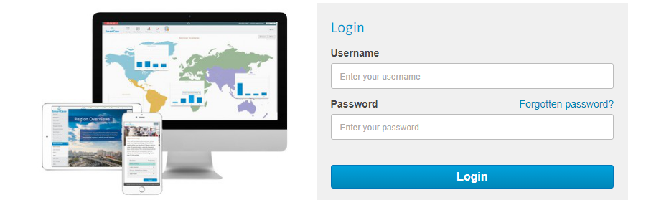

- Open your web browser
- Go to www.sims.biz
- Click on the Client Login button
- Enter username -
- Enter password -
- Click on the Login button
- Work through each round using the Task List on the left of the screen

2. When it comes to the fulfillment of the deliverable -related indicator(s), partially achieved.

Domain | Indicator number and title | Target  Value | Current  value  (insert)
D | Virtual platform for collaborative work of students and youth, with 2 modes, one for virtual companies for students, and another for office collaborative work of youth organizations. | 1 platform, 2 modes | 1 platform, 1 mode

4. The sources of verification ( e-form) : The evaluation of the deliverable was done via this Google Form : https://forms.gle/rhkRziTm8X9QumBi8

5. The CAs’ visibility rules (logo, disclaimer, etc.) have been respected in appropriate way.

6. The EU GDPR rules have been respected in appropriate way.

7. When asked about the strong aspects of this deliverable, the Project Quality Team said:

- That the platform uses relevant technology.
- Environment to simulate working, we have a concrete case with the VR Platform
- The flow and design of the deliverable, though this video was rushed.
- Clear instructions, appropriate narrative and approach, excellent visual material.
- Easly Understandable
- It's relevant and likely to meet the needs of specific target groups.

- Practical nature of the simulation, and it takes well into account differenct aspects of running a business

8. When asked about the weak aspects of this deliverable, the Project Quality Team said:

- ToT is needed to ensure effective delivery of platform.
- The explanation was rushed, perhaps slow it down considering the target market (unemployed youth).
- Design flaw of how the virtual exchange, or intercultural collaboration will take place

- CONCLUSIONS & RECOMMENDATIONS

ADD mode 2 for office collaborative work of youth organizations & guidance on how it functions.

EXPLAIN how intercultural collaboration will take place on the platform.

