



Career Guidance for TVET in Rwanda:
The Career Coaching Course

The Rwandan Workforce Authority and the City of Kigali piloting Career Coaching in 10 TVET institutions in Kigali from March 2015 to May 2016 supported by the GIZ Eco-Emploi Programme

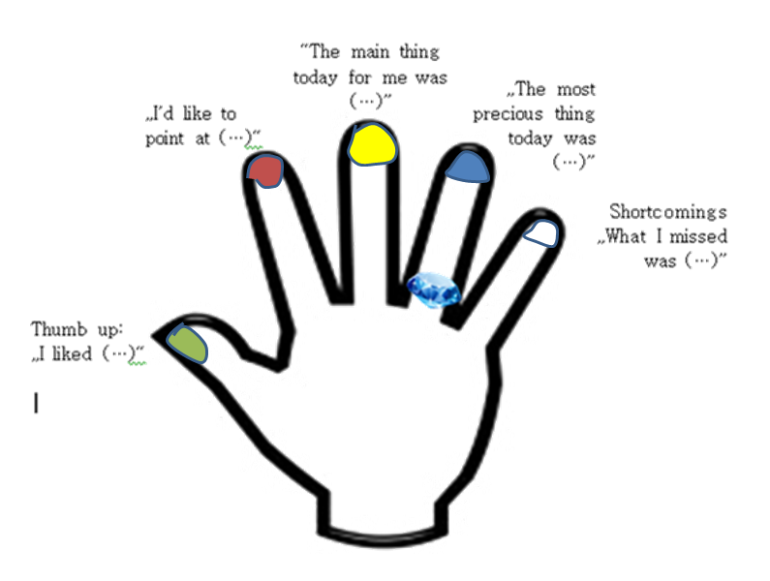

Final Report
Michaela Henn
31.05.2016

First Draft

Table of Contents
List of Figures, Tables, and Pictures 3
List of Abbreviations and Acronyms 3
1. Background and Partners 4
2. The Intervention Concept 4
3. Implementing Actors 5
4. CCC Pilot Implementation Process 7
5. The Career Coaching Course Programme 8
6. Evaluation Results: CCC Impact on Students and Coaches 9
6.1 How students see the CCC 9
6.2 How coaches see the CCC 10
6.3 Recommendations by students and coaches 11
7. Conclusions and Recommendations 11
7.1 CG Instrument and Capacities available in TVET 11
7.2 Standardization and Quality Development 11
7.3 Integration into the TOT Framework 12
7.4 Aligning with MINEDUC CG Framework Fehler! Textmarke nicht definiert.
7.5 Network of CG Professionals 12
8. Annex 13
8.1 List of Available Documents & Reports 13
8.2 Attendance Monitor Coaches 14
8.3 Students’ response on CCC impact (questionnaire) 15
8.4 Students’ response on CCC impact (questionnaire) 16

List of Figures, Tables, and Pictures
Figure 1: Concept Note’s Approach of Developing CG services in TVET 4
Figure 2: Implementing Partners and Objective 5
Figure 3: List of Pilot TVET Institutions and pioneering Career Coaches 6
Figure 4: Career Coaching Pilot Implementation Plan 7
Figure 5: CCC Elements (green) and Units (orange) 8
Figure 6: Students' responses 10
Figure 7: Attendance Monitor Coaches Pilot Phase 14
Figure 8: Impact as seen by students (Source: Evaluation Report, p. 7) 15

List of Abbreviations and Acronyms
AIPER | Association Islamique Pour la Promotion a l'Education au Rwanda
CCC | Career Coaching Course
CEN | Centre for Education Network
CG | Career Guidance
CoK | City of Kigali
EDPRS II | Second Economic Development and Poverty Reduction Strategy
EPP | Employment Promotion Programme (GIZ Programme in Egypt)
ESSP | Education Sector Strategic Plan (2013-2018)
GIZ | Deutsche Gesellschaft fuer Internationale Zusammenarbeit (GmbH)
GS ADB | Groupe Scolaire Ancien du Don Bosco
GSMK | Groupe Scolaire du Mont Kigali/ Association des Parents Adventiste pour la  Contribution à L’éducation
IAP | Industrial Attachment Programme
IPRC | Integrated Polytechnic Regional Centre (Kigali)
KESC | Kigali Employment Service Centre
NEP | National Employment Pact
PPT | Power Point Presentation
RWF | Rwanda Francs
TVET | Technical and Vocational Education and Training
TSS | Technical Secondary School
VTC | Vocational Training Centre
WDA | Workforce Development Authority
S5/ S6 | Senior 5/ senior 6 (school grade)
SJITC | Saint Joseph Integrated Technical College

Background and Partners
Globalization, regional integration and the Rwandan government’s policies on economic development, employment and technical and vocational education and training (TVET) are changing the structure and the development of the Rwandan labour market quickly and continuously. The ‘informal system’ of career advice and guidance (provided by family, neighbours, social networks, peers and teachers) is seen as no longer up to the current economic and labour market developments in Rwanda and Career Guidance (CG) is climbing up the government’s agenda.

The Workforce Development Agency’s (WDA) responded to the “need for a specialist formal career advice and guidance system” with its TVET Career Guidance Framework and related Implementation Plan providing a set of principles and long-term goals to support technical schools to make career education and guidance an “integral and essential part of the education they provide” (TVET CG Framework, 2013; Preamble, p.i). The Kigali Employment Service Centre (KESC) of the City of Kigali (CoK) is the first public job centre in Rwanda. It has built up extensive experience and expertise in providing career guidance, counselling, placement services, occupation information sessions, and labour market relevant training since its launch in May 2013. The initiative of WDA and the CoK was supported from the outset by the GIZ Programme ‘Promotion of Economy and Employment (Eco-Emploi)’. Collaboration partners aimed at developing a comprehensive career guidance course programme for TVET students to be implemented by WDA in the Rwandan TVET sector on a broader scale after the testing-phase from March 2015 to May 2016.

This report summarizes the process and the results of the CCC pilot (March 2015 – May 2016).

The Intervention Concept
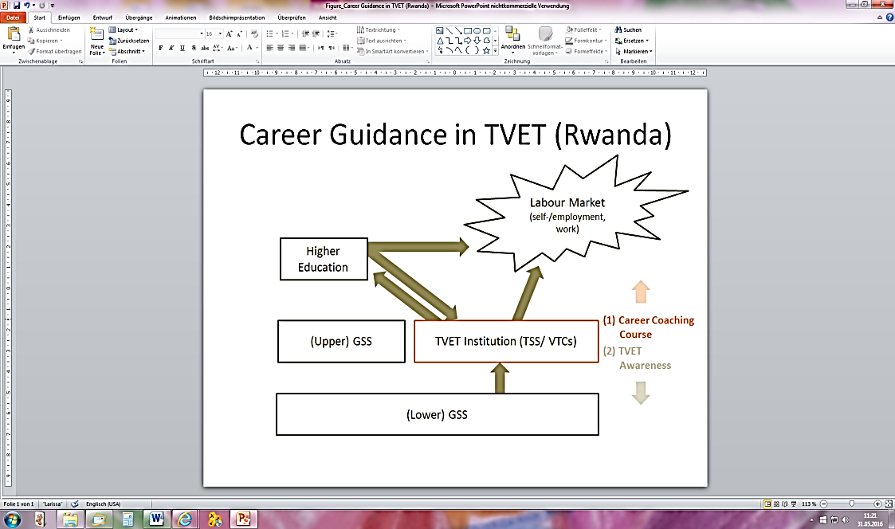
WDA and the City of Kigali (with KESC) jointly developed and tested CG services for TVET with the support of GIZ Eco-Emploi. The three partners signed a concept note in March 2015. The initial focus (1) of the initiative was placed on the outward transition of graduates from TVET-institutions (TSS’ and VTCs) into the labour market or into Higher Education and from there into the labour market. The second focus (2) was placed on supporting the transition of students from Lower General Secondary Schools (GSS) into TVET with awareness activities. Due to time constraints and limited capacities and resources the implementation of TVET Awareness was postponed to a later project phase.
Figure 1: Concept Note’s Approach of Developing CG services in TVET

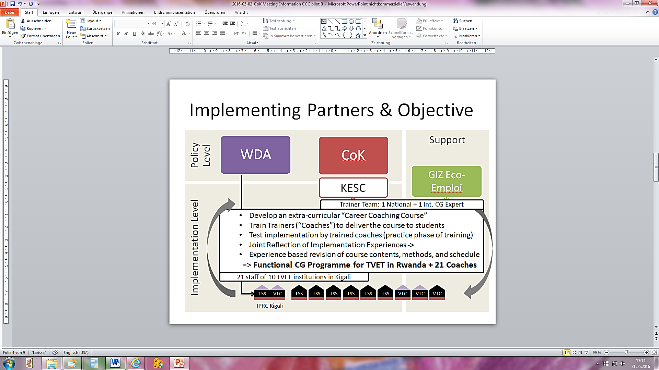
The objective of the initiative was to develop and test-implement school based career guidance programme tailored to the Rwandan TVET system and to create first capacities to (test-) deliver the programme and to further develop it. A close collaboration with ten selected pilot TVET-institutions was established; amongst them the IPRC Kigali. Each institution nominated two to three teaching staff. 21 staff took part in a series trainings, practical implementation phases, and reflection and stakeholder workshops between March 2015 and May 2016.
Figure 2: Implementing Partners and Objective

Implementing Actors
Aline Umutoni, Employment Counsellor at KESC, took part in a Career Guidance (CG) training that was conducted by Mrs Michaela Henn in summer 2014 for the GIZ Employment Promotion Programme (EPP) in Egypt. Based on this experience Mrs Umutoni constructed a short programme to fit into the KESC’s portfolio of services. It is offered as “Opportunity Scouting” to KESC clients. Michaela Henn (for GIZ) and Aline Umutoni (for the CoK) were on a technical level responsible for piloting the Career Coaching Course. They planned and delivered the trainings, supervised the implementation and conducted reflection workshops in close collaboration with all partners.
The participating pilot TVET-institutions and their teaching staff (trained “Career Coaches”) are not only implementing the programme as practical part of their training for developing practical competencies. As experts for TVET in Rwanda they constituted the most important source of feedback that allows for continuously revising and adjusting the course programme (contents, methods, time line) to fit into the Rwandan TVET context. Hence the first generation of coaches was not only testing, but co-developing the course programme towards a national standard. They have been seen as “national pioneers” and today constitute the professional network for the further development of CG in TVET in Rwanda.
TVET Institution |  | Career Coaches | Type
1 | IPRC Kigali TSS | - Mutaganira Fidele (IAP Officer bridging TSS & TTC & KCT)  - Vincent Nzanzimana (coordinator IPRC TSS)  - Akayezu Delphine | Public TSS
2 | IPRC Kigali VTC | - Uwimana Amani (IPRC VTC coordinator)  - Epslon James Ngendahayo (main coordinator of all coaches)  - Christine Niyotwambaza | Public VTC
3 | Saint Joseph ITC NYAMIRAMBO | - Mugabire Apollinare  - Ruremesha Josette Mutuyubutatu | Private TSS
4 | TSS Gatenga (Don Bosco) | - Niyigena Marie Aimee  - Nshimiyimana Jean Nepo | Private TSS
5 | CFJ Le bon Pasteur/ VTC Umushumba Mwiza | - Nikuze Marie-Claire (Claire), (social affairs officer of all coaches)  - Tuyisenge Willi Leonce | Private VTC
6 | GSMK Apace | - Habimana Jean Pierre (Peter)  - Mukaminega Liliane | Private TSS
7 | GS ADB Nyarutarama | - Karanganwa Ephrem  - Murekatete Julienne | Private TSS
8 | AIPER Nyandungu | - Tuyisenge Jean Paul  - Karenga Assumani (Asman) | Private TSS
9 | SOS Technical School | - Basomingera Chrispin (Chris)  - Evelyne Mutesi | Private TSS
10 | VTC Gacuriro | - Mugabo Jean Claude  (+ assisting teacher Mucyo Aimable) | Public VTC
Σ | - 10 TVET institutions (Kigali): 3 VTCs + 7 TSS’, public and private (including the IPRC in Kigali)  - 21 Career Coaches (+ 1 Assistant); 8 (38%) female
Figure 3: List of Pilot TVET Institutions and pioneering Career Coaches
Trainings, Reflections, and Workshops were always attended and supervised by WDA officers. After the retirement of Mr. Gerard Karamutsa his tasks and duties were transferred to Mr. Gordon Bamwine in addition to his responsibilities for entrepreneurship development within WDA. Eva Ouma (formerly Juenemann), Jasmin Siebold and Marion Becker organized and supported the implementation on the part of GIZ Eco-Emploi.

CCC Pilot Implementation Process
The pilot ran through different stages until its completion and evaluation in May 2016. Programme contents and methods have been informed by GIZ’s experiences in Egypt. Intervention approach combined four types of activities: (1) Training: Proposed contents were trained in April and in November 2015; training was always immediately followed by (2) practice implementation phases during which trained coaches in teams of two test-implemented (“piloted”) the programme with altogether ten classes of approximately 25 volunteering students in each of the ten pilot TVET-institutions. Coaches shared and discussed implementation experiences during (3) Reflection Workshops with each other, with WDA, and with trainers in July 2015, November 2015, and April 2016. CCC programme (methods, contents, time slots, sequence and duration) have been revised according to implementation experiences and discussion results/ recommendations. Progress and results, issues and requests have been discussed during (4) Stakeholder Workshop with related school management and stakeholders (KESC, CoK, WDA). By May 2016 the CCC pilot has finished all implementation steps as planned with the exception of the final closing event that is planned to take place in June 2016.
Time | Implementation Steps | Status
14.-22. April 2015 | Training module A (“Discovering Your Strengths”/ “Self-Understanding”) and  parts of module B (“Exploring the World of Work”); concluding with a stakeholder workshop with trained teachers, school headmasters, WDA, CoK/ KESC, trainers and GIZ Eco-Emploi on 22nd April 2015. | 
May – October 2015 | Pilot implementation module A.
10.-12. July 2015 | Reflection workshop on implementation experiences: Revision of contents, activities and methods according to implementation experiences and results; technical backstopping with the trainers (Michaela Henn and Aline Umutoni).
July – October 2015 | Continued CCC implementation (remaining parts of module A and first parts of module B).
23.-24. Nov. 2015  25. Nov.-01.Dec. 2015  02.December 2015 | Reflecting and Revising CCC implementation (July to October 2015)  Training module C at IPRC Kigali: Exploring the World of Work; Exploring Learning Opportunities, Decision Making & Transition Planning  Stakeholder Workshop with headmasters @ IPRC Kigali
January -March 2016 | Pilot implementation module C.
April 2016 | Reflection module C, evaluation of Career Coaching Course
June 2016 | Presentation of outcomes to policy makers and stakeholders during the final public event that is officially closing the pilot phase. | planned
Figure 4: Career Coaching Pilot Implementation Plan

The Career Coaching Course Programme
Career guidance in TVET seeks to support prospective labour market integration of TVET-graduates. Its objective is to impart career management skills to technical students in TSS and VTCs to empower students to make informed career decisions and deal with a tense and difficult labour market situation for youths in Rwanda.

The Career Coaching Course (CCC) is designed as extra-curricular TVET-institution-based programme for S5/S6-students in TSS and for VTC trainees delivered by trained teachers (“Career Coaches”). TSS and VTC schedule are slightly different. The chart below presents the TSS programme. It consists of five main elements (green framed boxes) plus an additional information registration session to inform and enrol interested students on a voluntary basis. The 16 units (orange) are referenced to one of the five main elements: Foundations of CG, Self-Awareness, Preparing for Industrial Attachments, Exploring the World of Work and Learning Opportunities, Decision Making & Transition Planning. To date (May 2016) the programme for TSS’ comprises 16 units of altogether 27 sessions of two hours each (in total 54 hours in class, in addition to preparation time and events).

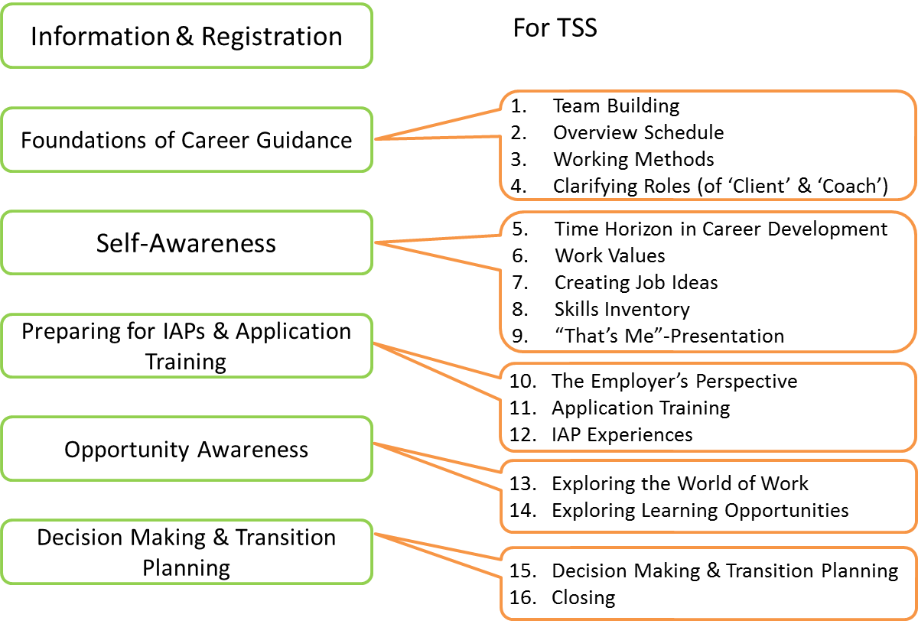
Figure 5: CCC Elements (green) and Units (orange)
The CCC for VTCs is going to be shorter and to have a slightly different order of sequence to fit into the January to September training time frame and to the ending with IAPs. A respective programme is under development.

Evaluation Results: CCC Impact on Students and Coaches

To assess the impact of the CCC on a) students and b) coaches evaluation research has been carried out by the Monitoring and Evaluation staff of GIZ Eco-Emploi, Mr. Leverien Nzabonimpa and Mrs. Germaine Uwajeneza in May 2016 (a separate evaluation report is available). Evaluation research was based on:
- Questionnaire to students, full coverage, 185 responses;
- Three Focus Group Discussions (FGDs) with altogether 29 randomly selected students (out of 145 who indicated their interest to take part);
- Two Focus Group Discussions with all 14 coaches who attended the final Reflection Workshop in May 2016.
320 questionnaires have been distributed to 10 TVET-institutions. 50 questionnaires (of one TVET institution) were not returned in time and hence not analysed. 185 questionnaires have been returned for analysis - a very remarkable response rate.

How students see the CCC
111 male (61%) and 71 female (39%) student participants predominantly between 15 and 24 years of age reported to have enjoyed the course very much (64%) or much (32%). It was seen by 68% of respondents as “very useful” and by additional 29% as “useful”; only 4% considered the usefulness as “average” and no single vote for “not so useful” or “not at all useful”. Most participants (46%) experienced the course programme as “easy” (19% “very easy”; 26% “okay”, 7% “difficult”, 3% “very difficult”). Satisfaction with the CCC is at remarkable 66% (“very satisfied”) and additional 29% of responding participates found it “much” satisfying. 59% of responding students said the course resulted in a “clear, precise” vision of their future working life; another 33% said their personal vision of their future working life was “rather clear, precise”. 81 % of respondents said to know for sure (26%) or fairly well (55%) what to do next after graduation.
Students clearly liked and enjoyed the course very much and benefited from it. When asked about the impact of the course on them against 12 given statements, students said the course programme (…)
Rank (according to “fully agreed” percentages) |  | % of Reponses that |  | sum ‘agreed or ‘fully agreed’
 |  | “fully agreed” | “agreed” | sum ‘agreed or ‘fully agreed’
1) | (…) helped them gain self-confidence | 70,7% | 24,5% | 95,1%
2) | (…) helped them find new friends | 69,6% | 23,9% | 93,5%
3) | (…) taught them how to make important decisions | 65,9% | 25,8% | 91,8%
4) | (…) helped them to understand themselves better | 64,1% | 28,3% | 92,4%
5) | (…) provided them with new skills | 62,7% | 31,4% | 94,1%
6) | (…) increased their understanding of the labour market | 61,3% | 32,6% | 93,9%
7) | (…) helped them plan what to do after graduation (91,8%) | 60,7% | 31,1% | 91,8%
8) | (…) encouraged to explore opportunities for learning & working | 59,6% | 28,4% | 88,0%
9) | (…) taught them how to apply for a job | 59,6% | 32,2% | 91,8%
10) | (…) inspired them to invest more time in learning | 56,5% | 28,8% | 85,3%
11) | (…) increased their ability to influence their future lives | 54,1% | 42,1% | 96,2%
12) | (…) taught them how to search and register for higher education or further training | 43,4% | 31,9% | 75,3%
Figure 6: Students' responses
Students were given the possibility to add additional response (“Is there something that you took from the course and that has not mentioned yet? What is it?”). Students added 164 statements (see Annex for full account of students’ responses to this open question). These were partly confirming the pre-phrased statements above (about the increased self-confidence, the better understanding of the labour market, the discovery of their interests and talents and the increased self-understanding) and partly adding new aspects:
Students elaborated on communication and presentation skills (10 responses), other new skills (such as thinking, job creation, video shooting, English language, designing a project, time management, innovation and creativity, working in teams, decision making, planning, being patient, …). One additional category that was mentioned very often was about the team spirit among students and between students and coaches (24 responses). Another rather surprising category that was mentioned 16 times was about the entrepreneurial spirit the CCC inspired. One FGD participants reported about three students having established their own ICT Company. Another participant reported having taken part in a singing competition and having launched two gospel songs on YouTube.

How coaches see the CCC
Changes on students observed by coaches are confirming students’ assessment above and bring in even more aspects: CCC develops students’ spirits of research for gathering information. Students value and appreciate their differences. Some students improved their marks. In particular VTCs reported about lower drop-out rates and better performance during compulsory industrial attachments.
Coaches also reported on changes they observed on themselves:
- Coaches enjoy improved relationship and cooperation with other teacher colleagues, with students and with the school management.
- They feel more valued by school leadership (e.g. more often sent as school representatives to meetings); Some coaches have been given more responsibilities (i.p. teaching the course to other people)-
- Coaches see themselves taking more attention to details (observing students during classes); they have gained additional knowledge in teaching practice; coaches are more innovative; are more accountable; CCC enabled the coaches to make critical assessments. The coaches learnt to value students’ ideas and to be flexible in real life.
- Coaches engaged full-heartedly in career guidance delivery and found themselves even as parents giving proper advice to their children. They are proactively raising awareness about CCC (vis-à-vis colleagues, parents). Some taking the course way beyond their duties and offering it to their communities or other schools.
- Coaches see the impact on students which made them love their job as teachers and coaches even more; they are more deeply anchored in their current career; coaches appreciate that students support them during CC class making their work easier.

Recommendations by students and coaches
- Many coaches recommend to stronger involve parents into the CCC activities and to do CG awareness raising in community meetings.
- Students and coaches would like to see the CCC as part of the regular curriculum.
- Coaches and students recommend to disseminate CCC to other schools and districts (or nation-wide) and also beyond TVET (in particular to lower secondary education before TVET).
- Involve school management for establishing induction week in S4 and for supporting coaches’ work.

Conclusions and Recommendations

CG Instrument and Capacities available in TVET
Monitoring and evaluation suggest that the CCC is a suitable CG instrument for delivering career education to TVET students (TSS) and trainees (VTCs). Coaches’ competences to deliver the course (and CG in general) are well developed. The instrument is ready for use and a first generation of pioneering coaches is ready and willing to implement and to take the course further on to other schools, districts and even to other education sectors. The pilot phase is concluding successfully.
Students react extremely positive to the new service, which is not a surprise: For one, answering according to ‘social desirability’ is a well-known phenomenon in social research and might be particularly pronounced in Rwanda. Secondly, CCC differs from regular teaching and is excitingly combined with fun and adventure. For students who are about graduating TVET the topic is, thirdly, of immediate personal relevance. Students enjoy the change and dealing with the topic. Nevertheless evaluation results suggest that the CCC is contributing significantly to the personal and professional development of students and coaches and is imparting employment relevant skills and attitudes.

Standardization and Quality Development
The CCC pilot implementation came with many changes to the original implementation plan: Some sessions had to be skipped; others have not been conducted in the initially planned way. In spite of the very good evaluation results it is recommended to further consolidate and standardize the CCC:
- To support implementation with a manual (implementation guide) for TSS’ and a variation of it for VTCs with a one-year training programme from January to September (plus IAPs).
- Students’ working materials should be translated into Kinyarwanda.
- An integrated Monitoring and Evaluation system to measure ‘successful’ implementation and establishing a benchmark for coaches and for supervision. One monitoring indicator for TSS could be the number of students per class who manage to find themselves industrial attachments (as opposed to being placed by an IAP officer) and/ or feedback of employers regarding the performance of students in IAPs.
- Exploration and integration of related services and information, such as Labour Market information and occupational information, information on TVET training and labour market relevant non-formal training opportunities etc.

Integration into the TOT Framework
- In collaboration with WDA TOT Unit and WDA Curriculum Development Unit
  - Support WDA institutionalizing CCC as teachers’ specialization (Senior and Master Trainers) within the TOT Framework and as cross-cutting curriculum (for students)
  - Design related assessment and certification procedures
- support WDA’s establishment of “Focal Points” in TVET institutions in close collaboration with GIZ Eco-Emploi TVET component
- Include CG as topic in training of school managers
- A continued collaboration with the first generation of Coaches is useful for the further development of materials (during second round of implementation) and for the development of WDA trainings on the CCC.
- Some of the current coaches might be interested to continue professional development and to become CCC Master Trainers (training new coaches).

Elaboration of Dissemination Strategy
- The ESSP monitors WDA’s training of CG specialists for TVET institutions across the country. The CG Awareness raising and information campaign could be supported to select future pilot schools.
- WDA, students, coaches, and project staff are favouring a broader dissemination of CCC to cover more schools and more districts in Rwanda. A sound dissemination strategy should be developed with to balance available financial and human resources with intended output quality.

Network of CG Professionals
- Network and exchange with other CG providers (Bright Future Cornerstone, Tumba College of Technology, etc.)
- Renew partnership with City of Kigali to continue collaboration with KESC’s employment counselor, Aline Umutoni
- Use existing capacities to develop services for people with disabilities.

Closure Event
- A formal closure event with handing over of certificates and with the participation of all involved stakeholders and partners would be a good framework to publicly appreciate the pilot coaches’ great efforts and achievements.
- This event would open up the opportunity to also inform other education sectors (basic education, higher education) and further potential partners (institutions and development partners) about the Career Guidance approach in TVET.

Annex

List of Available Documents & Reports
- Joint Concept Note of WDA, City of Kigali and GIZ Eco-Emploi (March 2015)
- 1st Career Coaching Training and the 1st Stakeholder Workshop from 14th to 22nd April 2015 @ IPRC Kigali (Report)
- 1st Reflection Workshop 10th – 12th July 2015 @ Muhazi (Report)
- 2nd Reflection Workshop of 23rd and 24th November 2015 @ Muhazi, 2nd Training from 25th November to 1st December 2015 @ IPRC Kigali and 2nd Stakeholder Workshop on 2nd December 2015 @ IPRC Kigali, (Report)
- 3rd Reflection Workshop of 07.-08. May 2016 in Muhanga (Report)
- Draft Job Description Career Coach
- Career Coaching Course Pilot Project in TVET Schools Arpil 2015 – May 2016: Draft Evaluation Report (May 2016)

Attendance Monitor Coaches
 | Name (addressed as ….) | TVET-Institution | 1st Training April 2015 | 1st Stakeholder WS April 2015 | 1st Reflection July 2015 | 2nd Reflection Nov. 2015 | 2nd Training Nov/Dec 2015∗ | 2nd Stakeholder WS 02.12.2015 | 3rd Reflection WS May 2016
 | Gerard Karamutsa | WDA
1 | Gordon Bamwine | WDA (Entrepreneurship) |  |  |  |  | 1
2 | Karenga Assumani (Asman) | GS AIPER NYANDUNGU
3 | Tuyisenge Jean Paul | GS AIPER NYANDUNGU |  |  |  |  | 3
4 | Ruremesha Josette Mutuyubutatu | SJITC Nyamirambo
5 | Mugabire Apollinaire | SJITC Nyamirambo
6 | Habimana Jean Pierre (Peter) | GSMK / APACE |  |  |  |  | 4
7 | Mukaminega Liliane | GSMK / APACE |  |  |  |  | 4
8 | Niyigena Marie Aimee | Gatenga TSS
9 | Nshimiyimana Jean Nepo | Gatenga TSS
10 | Nsanzimana Vincent | IPRC Kigali (TSS) |  |  |  |  | 4
11 | Akayezu Delphine | IPRC Kigali (TSS) |  |  |  |  | 3
12 | Mutaganira Fidele | IPRC Kigali Industrial Liaison
13 | Uwimana Amani | IPR Kigali (VTC) |  |  |  |  | 3
14 | Christine Niyotwambaza | IPR Kigali (VTC)
15 | Epslon James Ngendahayo | IPR Kigali (VTC)
16 | Basomingera Chrispin (Chris) | SOS Technical HS Kagugu
17 | Evelyne Mutesi | SOS Technical HS Kagugu |  |  |  |  | 2
18 | Karanganwa Ephrem | GS / ADB |  |  |  |  | 2
19 | Murekatate Julienne | GS / ADB |  |  |  |  | 3
20 | Nikuze Marie Claire | VTC Umushumba Mwiza/ Bon Pasteur
21 | Tuyisenge Willi Leonce | VTC Umushumba Mwiza/ Bon Pasteur
22 | Mugabo Jean Claude | VTC Gacuriro |  |  |  |  | 2
23 | Mucyo Aimable | VTC Gacuriro |  |  |  |  | 4
 | Patrick Ngadijimana | Tumba College Tech.
Figure 7: Attendance Monitor Coaches Pilot Phase

Students’ response on CCC impact (questionnaire)

Career Coaching Course … | Fully agree | Agree | Partly agree | Don't agree | Dis-agree | Don't know | N
… increased my capability to influence my future life | 99 | 77 | 7 | - | - | - | 183
...helped me gain self-confidence | 130 | 45 | 9 | - | - | - | 184
...inspired me to invest more time in learning | 104 | 53 | 21 | 4 | 2 | - | 184
...gave me new skills | 116 | 58 | 11 | - | - | - | 185
...helped me to understand myself better | 118 | 52 | 14 | - | - | - | 184
...increased my understanding of how the labor market works | 111 | 59 | 9 | 1 | 1 | - | 181
...encourages me to go out looking for learning and working opportunities | 109 | 52 | 15 | 3 | 1 | 3 | 183
...was useful for learning how to make important decisions | 120 | 47 | 15 | - | - | - | 182
...helped me to plan what to do after graduation | 111 | 57 | 15 | - | - | - | 183
...made me find new friends | 128 | 44 | 11 | - | 1 | - | 184
...taught me how to apply for a job | 102 | 55 | 11 | 1 | 2 | - | 171
...taught me how to search and register for higher education or further training | 79 | 58 | 32 | 4 | 4 | 5 | 182
Figure 8: Impact as seen by students (Source: Evaluation Report, p. 7)

Students’ response on CCC impact (questionnaire)
N= 125 students responding with 162 answers to Question #14:
“Is there something that you took from the course that has not been mentioned yet? What is it?”
Category | Students’ Quotes (in writing/ questionnaire)
Self-Confidence  (18) | - To be selfconfident that you are capable  - The course helped me to know what I am capable of and how to address whatever kind of issues  - Being selfconfident  - I get confidence and now I have commitment  - Not having fear  - To be confident  - (…) to have selfconfidence (…),  - It helped me to be confident  - It strengthened my confidence and speaking in public  - Encouraged me to be self confident (…)  - Public speaking and selfconfidence  - Selfconfidence  - Self confidence  - Selfconfidence  - To have confidence  - It help me to have self confidence  - It helped me to gain more confidence  - [Enouraged me] to become self-confident
Inspiration  Through Field Visits  (4) | - I explored more in the field visits undertaken on what people achieved through exploiting their talents  - We undertook a study visit in TVET Expo in which we learnt many things relating to innovation  - Through the field visit that we did observed many things achieved by people as results of using their talent  - TVET Expo
Discover & use individual Talents  (15) | - I learnt through the course how to discover my talents  - Taught how we can accomplish 2 different talents at the same time  - After getting its meaning I found it good to know yourself your talent and how to facilitate its expression  - I learnt how to develop my talent and make it more profitable in my daily life  - Selfwaareness to be able to know our self about your talents or what you you have that you did not discover  - I learnt what we call treasure hunt that helped you to know what you possess as treasure  - discovering my talent  - To know how I can achieve my talent  - How the talent will be achieved  - It has helped me to find the talents  - To discover my talent  - I discovered what my talent is  - I studied how to discover my talent  - Valuing my talent  - It helped me to find my talent and work hard for better future
Team Spirit  (24) | - May be it is about working together that is what our coacher taught us that working together helps us to achieve our goals and strategies in our life  - Yes about the unity between the members of career coaching course group  - Networking how to live with others  - Showing different talents to be close to my colleagues and my trainer  - The course taught me how to live in harmony and work together with others and not be selfish  - The best way of knowing each other through ticktack  - I learnt to live in harmony with other students in career coaching course  - How I can live with others in career coaching  - Loving each other  - Unity between us  - Better relationship with peers  - It helped me to build trusting relationships with peers  - Establish unity among us  - Building trustful relationship with pees and classmates  - (…) and how to live peacefully with others  - We learnt how to live in positive relationswith others  - Living positive relations with others  - To live in harmony and peace with others  - Living peacefully with others  - Building trustful relationship with others  - Building good relationships with others  - Building trutful relationships with others  - It put students together and become more united  - I learnt how to live with other (…)
Entrepreneurial Spirit  (16) | - So many like creating own job  - I got to know how I can create my business  - Yes I was taught how to create new business new things that it interested me and to know the required things in your business  - We learnt about selfemployment that will help us to struggle for survivor as S6 leavers  - They taught us to how create job and be hopeful for a certain future If I complete studies I will start my business  - Starting own business relying on my talent  - own business  - To start own business  - To start own business  - We learnt how to start own business  - It is about creating own business from what you like  - Selfemployment  - Selfemployment  - How I can start my business  - How can start your selfemployment without having a capital
Understanding how the labour market functions  (12) | - Yes I like that kind of words and behaviour to use for interviews  - How to search or create a job  - It helped to acquire more knowledge about labor market integration  - Yes of course because I was taught how to write application letters (….)  - To integrate the labor market  - How to behave in front of employers  - Successful interview guidance  - Jobsearch strategies  - We learnt about internship and job search  - We learned about internship job search  - Interview  - Successful interview guidance  - Knowing your responsibilities and your rights
Having a Vision/ plan for the future  (7) | - I discovered what I will do in the future  - I learnt to think about my future and now I have a target I know who really I am what am I capable of after exercises we had in this course  - Planning for the future  - Trying to have a dream in your life  - It helped me to discover what I will do in future (…)  - I learnt about my career and achieving my mission  - [Career guidance has been important for] as well as making the foundation of y bright future
Decision Making  (5) | - I learnt how to make and maintain a decision  - How I can choose one thing that can lead me to my vision  - How to make decision to be confident and to work hard  - Yes Career Guidance has been important in my decision making (…)  - Yes I have seen many things among those there are to make our own decision (…)
Endurance/ Determination  (8) | - Taught me to never give up and to follow what i think it better for me  - It encouraged me not to fail to try  - I know to how to use my career in order to achieve my goal  - Another important thing that I took from the course is that of being patient in struggles goal oriented and committed to a better future  - I learnt to be patient in case of weakening responses  - It taught me to work hard and find opportunities and future planning  - Being patient messages working in groups  - Working hard
Work-related skills and attitudes  (29) | Communication and presentation (10)  - public speech learn how to speak  - How to behave in front of people  - know how to explain something how to express yourself regarding some topics To create or exchange my ideas with other persons  - I got to know how to speak publicly  - To know how to listen to your colleague in a good manner  - Speaking in Public  - Speaking in public  - Yes I have learnt how to present yourself in front of people  - Discussing with others  - Discussing with others
Work-related skills and attitudes  (29) | Skills (7)  - It made me think straight and quickly  - To know how to care effectively for your clients  - I also learnt that after completing my studies I cannot go took for job but I have to create my own job according to my wish  - Video shooting  - The use of English  - Designing a project  - Time management
Work-related skills and attitudes  (29) | Work and learning habits (“virtues”) (6)  - To develop your skills in the works  - To make your work in order  - Working without focusing only on money but gain new skills and honest  - We were encouraged that every job can generate a profit if it is done with commitment  - (…) and how to be well disciplined in the outside and job environment  - I learnt how to work in the group
Work-related skills and attitudes  (29) | Career Development (4)  - We learnt to choose either career or job faculties to follow  - It helped me to know how to create a job by following my career instead of applying for job  - Innovation and creativity  - I learn how to choose my career and to have a open mind  - How to know my career  - To know your career
Self-Understanding  (6) | - To know who really I am  - To know examine your self  - Yes career guidance helped me to know who I am  - To know your self and what you can do  - [I learnt ] to know myself  - knowing myself
Specific exercises or parts of the course:  (5) | - The ticktack game  - Recreational activities playing games and and playing musics  - How we created game before we started to study or before we started coaching course  - Games  - I learnt some games
Nothing (8) | No other one; Nothing; ; Not; No; All important lessons are already stated; Everything has been mentioned; No; Nothing
Other (7) | - It helped me to learn from others experience  - Not spending much money  - What I have to add is that we have to build our country because we got more information For example I my talents and I have to build our society  - have learnt how to live in the society  - Kudacika intege  - Other thing I took from this course is how I can make friends and who can be the disciples where you are going to visits  - It helped me very much and i will use it every way to help others

Job Profile Career Coach (1st Draft of 3rd March 2015)
Target Group | Tasks
Students | The Career Coach (…)  - Informs students and parents (information event, information leaflet)  - Registers students to extra-curricular Career Coaching Course (CCC)  - Delivers the CCC (all units, all sessions, with the given methods, and in line with the proposed schedule of 2,0 hours per week (or more)  - Monitors students’ attendance closely  - Makes information available to students on  - CCC objective and contents (leaflet)  - Other services related to employment and offered by the TVET institution (entrepreneurship, incubator, IAPs, internships, placement, occupational information as available)  - External services related to employment (KESC and other private or NGO placement providers, non-formal training providers, formal trainings, higher education, NGO services, scholarship programmes …)  - Information on upcoming events (like TVET Expo, company visits, job fairs, …)  - Collects typical learning outcomes of specific exercises for (a) experience exchange during reflection workshops with trainers and (b) for professional development within the network of coaches  - Organises and – if applicable – registers students for relevant trips and site visits, such as the TVET-Expo or company, higher education institutions or visits to other CCC-implementing TVET-institutions
Parents/ caretakers | With the support of the school management (and possibly using the time of parents’ meetings), the career coach (…)  - Informs parental caretakers about the CCC’s objectives, schedule, registration procedure and requirements (information event, information leaflet, contact information)  - Encourages parents to get involved (give positive feedback during Treasure Hunt exercises, That’s me presentation, World of Work exhibition, company contacts for exploration sessions where parents’ involvement is recommended)  - Encourages parental care-takers to support students with meals and transport
Fellow teacher colleagues | The Career Coach (…)  - Informs TVET institutions’ staff and management about CCC  - Invites fellow colleagues to visit and observe sessions  - Invite interested fellow colleagues to assist the CCC sessions. (Assisting teachers may be awarded priority access for potential new trainings)
IAP Officer | The Career Coach (…)  - Closely cooperates with the TVET-institution’s IAP staff, in particular for the joint preparation of industrial attachments.  - Reports back to IAP staff the results of the reflection session with students on their personal experiences and conclusions from the IAP experience (where applicable)
KESC | The Career Coach (…)  - Cooperates with the Kigali Employment Service Centre (KESC) for application training (prior to IAP placements)  - May refer clients to KESC for advanced application training or other services such as placement, occupation information sessions, entrepreneurship or other career related trainings  - May request national trainer’s technical support during pilot phase on all issues referring to the course contents, methods, and materials (who is collaborating with the international trainer)
Own Professional Development | - Takes part in the trainings, implements pilot course (practice phase of training) and takes part in the reflection workshops (for exchange of experiences and adjustment of course)  - Networks and exchanges with other coaches on a regular basis
Development of CCC | - Takes students’ learning results to reflection workshops for exchanging experiences and adjusting course materials and methods with national and international trainers  - Exchanges implementation experiences and results with trainers who incorporate experiences for revising/ adjusting the course materials, methods, and schedule  - Is available for sharing experiences with WDA/ CoK/ GIZ  - Engages in Monitoring and Evaluation
Office Management | - Collects, updates, and provides information on internal and external services to students  - Administers and updates calendar of upcoming events  - Receives, is in charge, and keeps equipment (computer, printer, internet, camera…) available to be used by CCC participants during predefined working hours  - Is available for meetings with parents and partners

Please see the ‘Vision 2020’, the Economic Development and Poverty Reduction Strategy (EDPRS) II, the National Employment Pact (NEP), and the Education Sector Strategic Plan (ESSP) 2013-2018 for further details.
WDA (July 2013): Framework fort he cooperation in provision of Career Development Services for TVET providers in Rwanda. Draft Report by Elizabeth Mwangi (Consultant)
WDA (March 2014): Program to implement the Career Education and Development Framework in TVET schools. Compiled by Elisabeth Mwangi.
Career Guidance Training for Teachers from Technical Schools in Cairo (30.08.-04.09.2014, in Ain El Soukhna/ Egypt) conducted by the GIZ Employment Promotion Programme (EPP). Responsible EPP manager: Mr. Emad Helmy, Head of EPP’s Career Guidance Component.
∗ Number of attendance days out of 5 training days: If attended more three days of training or more , the colour is green; two days or less is marked in orange
TVET Expo and Unit „Exploring the World of Work”
„Treasure Hunt“ is the name for ccc-exercises that support students to discover their talents, interests, and skills
„Messages“
Like the industrial liaison officer, IAP officer or other staff in charge of industrial attachments.
Career coaching training is comprised of three elements: (a) up to three times intense training sessions (of up to five days each) with national and international trainer, (b) implementation of trained contents, and (c) reflection of implementation experiences.

